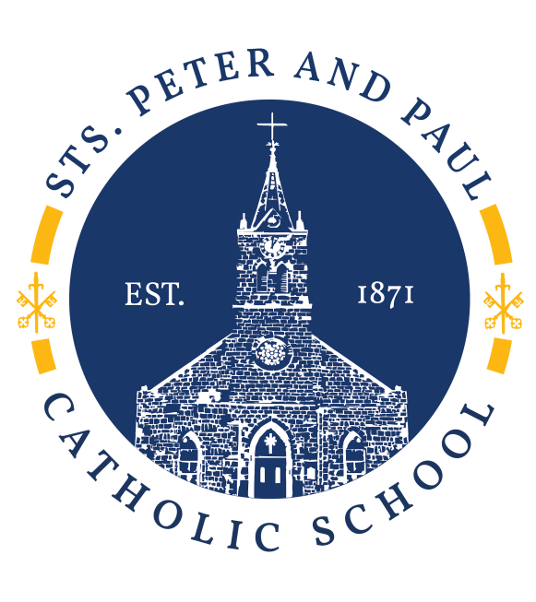

Sts. Peter & Paul Catholic School
Parent and Student Handbook
of
School Policies and Guidelines
2019-2020
School Year

The mission of Sts. Peter and Paul Catholic School is to provide a superior Catholic education and develop Christian leaders.

The Principal retains the right to amend this handbook for just cause. Parents will be given prompt notification when changes are made.

Table of Contents

Welcome Letter 9
School Calendar 10
GENERAL INFORMATION 11
History of Sts. Peter & Paul Catholic School 11
Sts. Peter & Paul Catholic School Mission Statement 11
Goal 11
Sts. Peter & Paul Catholic School Philosophy Statements 11
Accreditation 12
Policy Statements 12
Admissions Policy 12
SCHOOL ORGANIZATION 13
Pastor 13
School Council 13
Principal 13
Dean of Students 13
Director of Admissions, Finance and Human Resources 14
Panther Den Coordinator 14
Administrative Assistants 14
Teachers 14
Teacher Assistants 14
Library Manager 14
Counselor 15
Health Coordinator 16
PTC (Parent Teacher Club) 16
Parent Volunteers 17
ADMISSIONS/WITHDRAWALS 18
Minimum Age Requirements 18
Records Required 18
Registration 19
Admission of Students from Schools within the Archdiocese 19
Admission of Students from Public and Other Non-Public State Approved Schools 19
Admission of Students from Home Schooling and Non-Accredited Schools 19
Admission of Students from Foreign Schools 19
Admission of Students with Special Needs 20
Dual Enrollment 20
Placement Tests 20
Supply Lists 20
Student Records 20
Orientation 21
Student Ambassadors and Mentors 21
Transfer/Withdrawal 21
STUDENT UNIFORM CODE 22
Daily Uniform 22
GIRLS: 22
BOYS: 22
Uniform for Mass Days 23
GIRLS: 23
BOYS: 23
OUTERWEAR: 23
PHYSICAL EDUCATION/ATHLETICS: 24
SHOES 24
Grooming 24
Uniform Neatness 24
Spirit Dress Days 25
Changing Clothing After-School 25
ATTENDANCE 26
Definition of Tardy and Absence 26
Excessive Tardiness 27
Notification of Absence 27
General Absence Policy 27
Excused Absences 27
Unexcused Absences 27
Planned Absences 27
Early Departure 28
Make-Up Homework and Tests for Absences 28
Leaving Campus 28
Office Notification of Change in Daily Student Pick Up 28
CAMPUS INFORMATION 28
Daily Schedules 28
Drop Off/Pickup 28
Drop Off/Pickup Maps 29
Early Release Days 30
Inclement Weather 30
Travel Between School and Parish Buildings 30
Change of Address 30
Custody of Children 30
Visitors on Campus 31
Photo and/Or Interview 31
STUDENT EXPECTATIONS/ACTIVITIES 32
Reverence at Mass 32
Student Service 32
Water, Food, Drinks, and Chewing Gum 32
Cell Phones / Smart Watches and Electronic Devices 33
Toys, Spinners and Personal Items 33
Student Use of Office Telephone 33
Personal Sports Equipment 33
Class Parties/Birthday Wishes 34
Textbooks 34
Backpacks 34
Student Delivery of Homework, Glasses, Lunches and Medication 34
Lost and Found 34
Field Trips 35
School Sponsored Dances (Grades 5, 6, 7 & 8) 35
Student Council 35
Posters, Flyers and Other Written Communications 36
CAMPUS RECURRING EVENTS 36
COMMUNICATION RESOURCES 37
ParentsWeb 37
Weekly Folders 37
Student Planner 38
Yearbook 38
School Publications 38
School Sponsored Social Media 38
Media 39
HEALTH/SAFETY 39
Illness/Injury 39
Medication 39
Medication Administration Off School Grounds 40
Storage of Medication 40
Communicable Disease 40
WELLNESS POLICY 40
Guidelines For Implementing the Wellness Policy 41
Physical Activity 42
Exclusion and Inclusion Guidelines 43
Health Files 44
Medical Exemption from Immunization 44
Screening Tests 44
Wellness 44
Asbestos 44
Safety Drills 45
Crisis Plan 45
CRISIS MANAGEMENT PLAN 45
Members of the Crisis Management Team 45
Role of Crisis Management Team 45
Campus Health Officer 45
Safety and Security Assessments 46
Emergency and Crisis Response 46
Training 46
ENTERING AND LEAVING CAMPUS 46
Visitor Tracking System (Raptor) 46
EQUIPMENT AND SKILLS 47
AED'S 47
CPR 47
Access To And From Second Floor 47
Emergency "Go Bags" 47
Flood and Emergency Alert Awareness 47
DRILLS AND PROCEDURES 48
School Emergency Drills 48
Lockdown 49
Lockout 50
Evacuate 51
Firedrills 52
Tornado Drills 52
Suspected Child Abuse 53
GENERAL ACADEMIC INFORMATION 54
Expectations of Teachers 54
Order of Communication 54
How to contact a teacher 55
How to schedule a conference with a teacher 55
Meeting Identified Needs of REACH Students 55
Homework 55
Testing 55
Receiving Credit for Homework Assignments and/or Projects 56
Kindergarten – 8th Grade 56
SPIRITUAL PROGRAMS 56
Religious Studies 56
Liturgy 57
Sacramental Preparation 57
Retreats 57
Human Sexuality Education 57
Mass Buddy Program 57
CURRICULUM AND INSTRUCTION 58
Curriculum Documents 58
Curriculum Objectives 58
Curriculum Requirements 58
Local Curriculum Development 58
ACADEMIC ASSESSMENT 59
Parent/Teacher Conferences 59
Progress Reports 59
Report Cards and Grading Periods 59
Grade Reporting 60
Testing Program 60
STUDENT RECOGNITION 61
Honors (Grades 3-8) 61
Quarterly Honors 61
● High Honors Honor Roll 61
● Honors Honor Roll 61
● St. Michael’s Campus Student Leadership Award 62
End of Year Honors 62
● The Christian Leadership Award 62
● The American Legion Award 62
● High Honors Honor Roll all 4 Quarters 62
● Honors Honor Roll all 4 Quarters 62
● Academic Excellence Award 62
PROMOTION AND RETENTION 63
Minimum Attendance Standards for Grade Level Promotion 63
Retention / Summer School 63
Academic Probation 64
EIGHTH GRADE GRADUATION 64
Graduation Requirements 64
A diploma is withheld from a student for the following reasons: 64
Graduation Ceremony 64
Scholarships 65
TECHNOLOGY 65-66
EXTRACURRICULAR AND CO-CURRICULAR ACTIVITIES 67
Description and Participation 67
Extracurricular Qualification Guidelines 67
Extracurricular Eligibility Rules for Sts. Peter & Paul Catholic School 68
Age Eligibility for the Archdiocesan Interscholastic League (AIAL) 68
Return of Equipment 68
Safety 68
Transportation 68
Weather Policy 68
Athletic Fees 69
Pep Squad 69
Cheer 69
CYO Sports 69
Other Extracurricular Activities 69
STUDENT CODE OF CONDUCT 70
Core Virtues 70
Responsibility 70
Respect 70
Honesty 70
Perseverance 70
Self-Discipline 71
Humility 71
Compassion 71
Charity 71
BULLYING PREVENTION 71-73
DISCIPLINE MANAGEMENT SYSTEM 74
Level I Offenses 74
Level II Offenses 75
Level III Offenses 75
Administration Consequences May Be Issued 76
Student Discipline Record 77
Academic Honesty 78
Plagiarism 78
Copy Right Law 78-82
Notification of Disciplinary Action 83
In-School Suspension 83
Disciplinary Probation 83
Suspension 83
Expulsion 84
Search and Seizure 84
Contraband 84
Closed Campus 85
Release of Students to a Law Enforcement Officer 85
Pregnant Students 86
Abortion 86
Harassment 87
Investigating Claims of Harassment 87
Substance Abuse Policy 88
PARENT PARTICIPATION 89
FINANCIAL & SERVICE OBLIGATIONS 90
Tuition 90
Registration Fees 90
After School Care 91
FAMILY SERVICE HOURS 91
Hours Required 91
Non-Completion Fee 92
Service Hour Logs 92
Ways to Earn Service Hours 93
Fundraisers 93
FINANCIAL EXPECTATIONS 94
After School Care 95
Cafeteria Charges 95
GRIEVANCES 96
Duties and Process of Grievance Council 96
Grievance Procedures for Expulsion or Termination issues 96
Grievance Process for Non-Expulsion/Non-termination issues 97
CODE OF CONDUCT 98-116
Code of Conduct Acknowledgement Receipt 117
STS. PETER & PAUL CATHOLIC SCHOOL HANDBOOK ACKNOWLEDGEMENT 118
St. Peter and Paul Catholic School Handbook Agreement 119

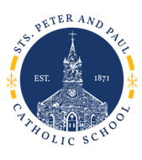

Welcome to Saints Peter and Paul Catholic School!

​There are so many reasons to choose a Catholic school for your child's education! Catholic schools have high academic standards, along with offering a values-centered education in a safe school environment. Catholic schools truly believe parents are the primary educators, and we encourage and appreciate parent involvement in our school. Our teachers are qualified professionals who are deeply committed to the gospel message and to bringing out the best in their students in knowledge, skills and values.
​At Saints Peter and Paul Catholic School we are committed to the strong Catholic formation of our students. We prepare our students for leadership in our diverse world by educating the whole child-spiritually, emotionally, socially, morally, physically, and intellectually. "Our children are our future; we must teach them well and then let them go."

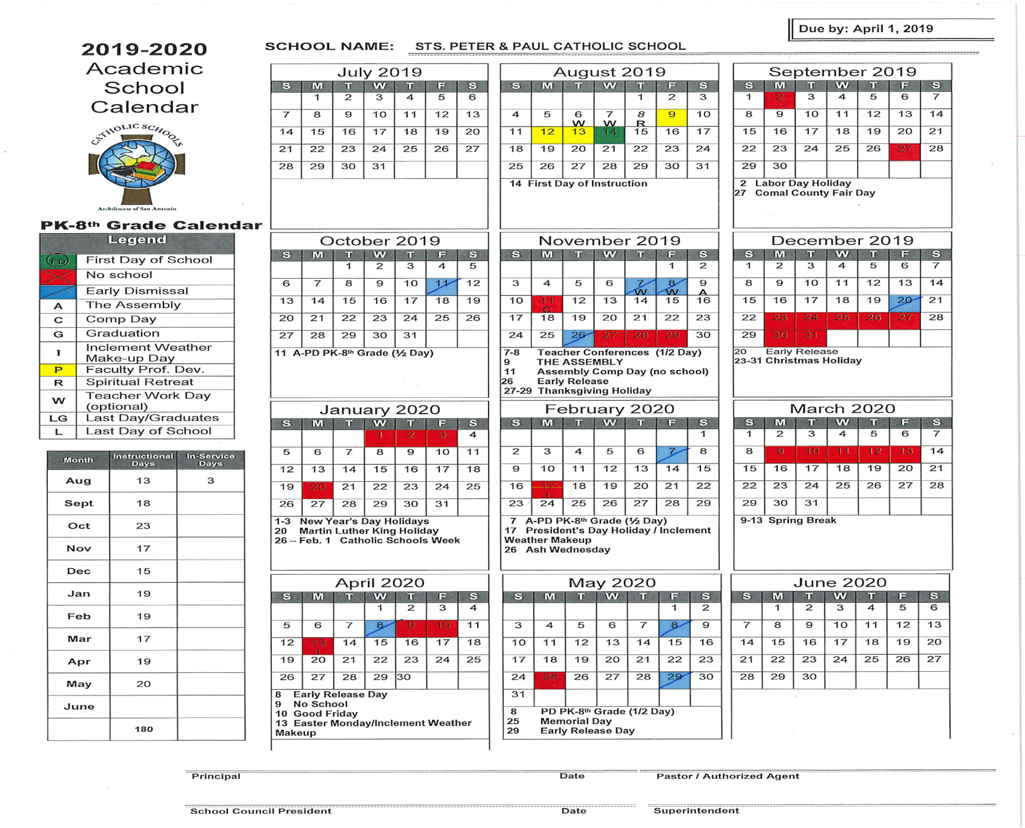

GENERAL INFORMATION
History of Sts. Peter & Paul Catholic School
Fr. Menzel founded Sts. Peter & Paul Catholic Church at its current location in 1849 and the School opened in 1871 under the auspices of the Sisters of Divine Providence. The following are a few major milestones of our school:
  - 1901 - A new brick school is built.
  - 1958 - The present parish school is dedicated.
  - 1984 - The entire school is staffed by laity.
  - 1985 –Reverend Patrick J. Flanagan Educational-Recreational Center is built.
  - 2009 – The Good Shepherd Center and St. Joseph’s Center is built.

Sts. Peter & Paul Catholic School Mission Statement
The mission of Sts. Peter and Paul Catholic School is to provide a superior Catholic education and to develop Christian leaders.

Goal
Sts. Peter and Paul Catholic School is committed to strong Catholic formation of our students. We prepare students for leadership in our diverse world by educating all dimensions of the whole person – spiritual, emotional, social, moral, physical, and intellectual.

Sts. Peter & Paul Catholic School Philosophy Statements
We believe in an integral approach to education that strengthens the spiritual, emotional, intellectual, moral, physical and social needs of our children.
We believe that the parish is responsible for the Catholic formation of its young people. Therefore, the school sees itself as one avenue the parish uses to pass on its faith and tradition to its children.
We believe in the goodness and uniqueness of each person. Therefore, each teacher, staff member, parent and child is treated with charity and respect.
We believe that truth is rooted in values and principles founded in Christ's teachings. Therefore, Christ's teachings are integrated within all course content.
We believe that knowledge and values are taught within the context of the community. Therefore, the school continues to foster a community of faith consistent with and in union with the faith community of the parish.
We believe that Catholic formation is critical. Therefore, classes in Catholic teachings are included in the curriculum.
We believe that parents have the primary responsibility as educators of their children. Therefore, the school is supportive of the parents' role and shall build effective communication with each parent.
We believe that children have the responsibility to participate in the faith life of the community. Therefore, opportunities to become involved in the liturgical, social and political life of the community are provided within our school activities.

We believe that Catholic education is a critical part of the Church's ministry. Therefore, we support and encourage the development of Catholic education in the Archdiocese and beyond.
We believe that the school plays a vital role in the parish. Therefore, every effort is made to ensure the schools continued growth and development.

Accreditation
The Accreditation Commission of the Texas Catholic Conference Education Department recognizes Sts. Peter & Paul Catholic School as an Accredited School. The Texas Catholic Conference Accreditation Commission is the official accrediting agency for Catholic Schools of Texas. The Texas Education Agency recognizes it as such. The Texas Catholic Conference last visited Sts. Peter & Paul Catholic School in October 2014 and the school is fully accredited.

Policy Statements
The policies and guidelines established by the Archdiocese of San Antonio are followed.
Every aspect of Sts. Peter & Paul Catholic School is subject to regular evaluation, and new program areas are established only after thorough study and evaluation of the availability of resources to fund the endeavor and of the parish's need for the program.
Teachers, staff and students at Sts. Peter & Paul Catholic School project Christian attitudes at school and in the community.
Catholic children, who attend Sts. Peter & Paul Catholic School, and their parents/guardians are asked to attend Sunday Mass and, in general, participate in the parish life of their respective parishes.
Sts. Peter & Paul Catholic School is, first and foremost, a Catholic school. The religious formation of students is at the very heart of the school’s mission. The parents or guardians of students who are not Catholic should realize that their child will be required to participate in the full educational program, including the taking of religion courses during which Catholic doctrine will be taught and expounded upon. Likewise, students will be expected to participate in the prayer and liturgical life of the school to the fullest degree that such participation is permitted by canon law and church teaching.
Students and their parents or guardians will be expected to demonstrate a respect for the teachings of the Church, her liturgical practice, and her sacramentals.
The parents or guardians of students enrolled at Sts. Peter and Paul Catholic School must demonstrate a willingness to comply with school policy, particularly as it is described in this handbook and implemented by the school’s administration. A deliberate or persistent disregard, whether stated or demonstrated, for school policy could be grounds for a family being required to withdraw their child from Sts. Peter and Paul Catholic School.
The parents or guardians of students at Sts. Peter and Paul Catholic School are expected to demonstrate a spirit of cooperation with the school’s staff and administration.
Specific procedures and policies are printed and distributed annually in the Sts. Peter & Paul Parent/Student Handbook. Throughout the year as situations arise, the principal, in consultation with the School Advisory Council, may amend this handbook as necessary.

Admissions Policy
Sts. Peter & Paul Catholic School admits students of any race, national origin or gender to programs and activities with all rights and privileges. Equal opportunity and access is provided to students without regard to race, national origin or gender. All admissions are subject to approval by the principal

SCHOOL ORGANIZATION
Pastor
As pastor and leader of the Sts. Peter & Paul Parish, the pastor is also the leader of Sts. Peter and Paul Catholic School. The Archbishop, the Archdiocesan Schools Office and the Texas Catholic Conference Education Department (TCCED) have entrusted authority to him. The pastor is responsible for fostering, nurturing, guiding and coordinating all of the ministries of the parish. He delegates the administration of the school to the principal, who administers the school in accordance with archdiocesan policies and guidelines. The pastor and principal cooperate and offer mutual support in matters of educational policy and practice. As leader of the decision-making process in the parish, the pastor’s authority includes the approval of all recommendations made by the principal and/or school council. The pastor plays a primary role in the development and implementation of the school’s budget.
Selection of the principal includes the recommendation of a search committee appointed by the pastor. The principal is hired by the pastor, in consultation with the Superintendent of Schools in the archdiocese, and as per a ministry agreement from the Catholic Schools Office.

School Council
The School Council’s authority is derived from the pastor. The School Council’s mission is to consult with the principal and pastor in areas of school business: policy, development, strategic planning, and finance. The School Council consists of the pastor, the principal, and nine parents/parishioners, and the PTC president. School Council meetings are held monthly and are open to all interested parents.

Principal
The principal is the chief operating officer of the school and has responsibility for coordinating its day-to-day operation. The principal is responsible for setting policy, approving procedures, reviewing programs, evaluating faculty, governance of student discipline, supervising staff and staff development, and determining all matters of admission, expulsion, release of student records, and graduation. The principal also oversees the curriculum of grades PK3-8th grade, curriculum alignment of PK-3 through 8th grade, and curriculum development in Fine Arts. The principal formulates and oversees the budget and handles all areas of personnel, including hiring and dismissal.

Dean of Students
The Dean of Students assists the principal in the implementation of the school’s instructional program and in guidance and supervision of teachers. Other activities, as determined by the principal, may be assigned. The Dean of Students assists the principal in the day-to-day operations of the school. He/She also assists with student discipline in keeping with the school’s Code of Conduct, assists with the procurement of substitutes as needed, coordinates student safety and facilities, and other activities, as determined by the principal.

Director of Admissions, Finance and Human Resources
The Director of Admissions, Finance and Human Resources is responsible for managing the school’s accounts receivable and payable and all related financial matters. The director is also responsible for carrying out human resource functions, maintaining personnel records, managing payroll, and assisting employees in accessing the benefits to which they are entitled. In addition, the director handles registration and all related financial matters. Other activities, as determined by the principal, may be assigned.
The Director of Admissions, Finance and Human Resources coordinates school functions related to community building and fundraising. All potential fundraisers need to be proposed to the Director of Admissions, Finance and Human Resources and approved by the principal. The director oversees the management of the school’s family service hour program. The Director of Admissions, Finance and Human Resources also manages student field trips. Other activities, as determined by the principal, may be assigned.

Panther Den Coordinator
The Panther Den Coordinator identifies students with learning differences who would benefit from Panther Den services and coordinates their instruction. She oversees the development and implementation of instructional accommodations to assist student learning and serves as the liaison between Sts. Peter and Paul and New Braunfels Independent School District. Other activities, as determined by the principal, may be assigned.

Administrative Assistants
The Administrative Assistants facilitate parent and school communication. They each assist with providing basic services such as daily students and visitors arrival and departure, submitting lunch count, recording attendance and assisting with daily student health issues. In addition, each has specialized administrative tasks assigned to them by the principal.

Teachers
Teachers at Sts. Peter & Paul Catholic School all have a degree, highly-qualified, and professional individuals. The classroom teachers are the heart of the school and are primarily responsible for ensuring that students at Sts. Peter & Paul Catholic School have a well-organized environment conducive to learning. Teachers are charged with maintaining classrooms in a professional manner and maintaining communications with parents to ensure student success. Other activities, as determined by the Principal, may be assigned.

Teacher Assistants
Teachers assistants are assigned specific areas of responsibility appropriate to their assignments. These assistants perform assigned duties under the direction of the classroom teacher. Other activities, as determined by the Principal, may be assigned.

Library Manager
The chief responsibilities of the library manager include the organization and management of the library and media services of the school, serving as a resource person to locate learning resources for teachers and students, and providing a program of library orientation and library skills for all grades. Other activities, as determined by the principal, may be assigned.
Counselor
Counselors’ Responsibilities
When a fully certified school counselor is employed, the administration, faculty, parents, and community should expect the counselor to carry out eight basic responsibilities competently and in a professional and accountable manner. The eight responsibilities are:
• Program Management
• Guidance
• Counseling
• Consultation
• Coordination
• Student Assessment
• Professional Behavior
• Professional Standards
Responsibility Domains
The following eight domains constitute the responsibilities of the professional school counselor. These domains form the basis of the Performance Evaluation Form that is included in the TEMPSC-II. Program
Management Domain - Counselors collaboratively plan, implement, evaluate and advocate for a comprehensive, developmental guidance program that includes the four components (1) Guidance Curriculum, (2) Responsive Services, (3) Individual Planning, and (4) System Support specified in the Texas Education Code (§33.005). Counselors collaborate with others to determine the relevant balance among the four components to meet student and community needs. Program management requires organizing personnel, physical resources, and activities in relation to defined needs, priorities, and objectives in order to maintain the program’s contribution to the total educational program. Counselors use program management competencies in the System Support component of a comprehensive, developmental guidance and counseling program.
Guidance Domain - In providing guidance, counselors proactively assist all students to develop and apply skills for maximum educational, career, personal, and social growth during school years and beyond. Counselors use guidance competencies to provide developmentally appropriate activities through the Guidance Curriculum and Individual Planning components of a comprehensive, developmental guidance and counseling program.
Counseling Domain - Counseling is an intervention made available to all students and applying to those whose developmental needs, personal concerns, or problems affect their continued educational, career, personal or social development. Counselors use counseling competencies in the Responsive Services component of a comprehensive, developmental guidance and counseling program.
Consultation Domain - Counselors, functioning as consultants, advocate for students and provide professional expertise to help faculty, staff, administrators, parents, and other community members understand individual behavior and human relationships. Counselors interpret relevant information to these persons concerning the development and needs of students. The counselor consults with others to increase the effectiveness of student education and promote student success. Counselors may use consultation competencies in any of the four components of a comprehensive, developmental guidance and counseling program.
Coordination Domain - Counselors as coordinators bring together people and resources in the home, school, district, and community to support students’ optimal academic, career, personal, and social development. Working with students’ parents or guardians, and/or school personnel, counselors coordinate referrals to other resources as appropriate. Counselors may apply coordination competencies in any of the four components of a comprehensive, developmental guidance and counseling program.
Student Assessment Domain - In student assessment, counselors interpret standardized test results and other available student data to promote sound decision making among students and others involved in students’ development. Counselors also promote understanding of ethical and legal uses and limitations of assessment. Counselors apply student assessment competencies in the Individual Planning, Responsive Services, and System Support components of a comprehensive, developmental guidance and counseling program.
Professional Behavior Domain - Professional school counselors accept responsibility for self-directed professional development through continuous efforts to improve their competence in meeting and exceeding standards in performing their jobs. Professional behavior also entails the expectation that counselors have responsibility to improve the inclusivity of the school environment and to maintain collaborative inter-professional relationships. Professional school counselors demonstrate professional behavior in all components of a comprehensive, developmental guidance and counseling program; however, accountability for time dedicated to these activities applies to the System Support component.
Professional Standards Domain - Professional school counselors adhere to professional standards in all components of a comprehensive developmental guidance and counseling program. Time dedicated to activities that promote understanding and application of professional rules, policies, regulations, and guidelines is accounted for in the System Support component of a comprehensive, developmental guidance and counseling program.

Health Coordinator
The health coordinator manages the school clinic, keeps health and immunization records current, assists students who are ill, conducts annual weight/height measurement of all students, guides sight and hearing and scoliosis screenings. At the end of the year, the health coordinator files the comprehensive health report to the Catholic Schools Office and the state department of health. Other activities, as determined by the Principal, may be assigned.

PTC (Parent Teacher Club)
The purpose of the Sts. Peter & Paul School PTC is to foster a close union between parents and teachers, and to coordinate activities for the welfare of the school. Parents/guardians of students attending Sts. Peter & Paul School are considered active members of this club. The funds raised through their endeavors are used to enhance the quality of education. PTC meetings are held at various times during the school year. Notification of meetings are posted through the school website and ParentsWeb.

Parent Volunteers
Sts. Peter & Paul School parent volunteers are a very valuable resource. Parents help in classrooms, assist with school programs, monitor the school cafeteria and participate with co-curricular activities. Parents are encouraged to sign up for volunteer opportunities at the school and to ask teachers about classroom needs. All volunteers who work in the school building must complete OVASE training, undergo a criminal background check and sign and return the Code of Conduct Acknowledgement form prior to volunteering in any capacity on campus. When any parent or visitor comes on campus they must stop by the school office to receive a Raptor pass which they must wear while they are on campus. Room Parents are volunteer parents whose task it is to assist their child's homeroom teacher. Some of these activities include organizing classroom parties, making phone calls, and arranging for workers at the various school activities. Room parents are appointed by the homeroom teacher.

ADMISSIONS/WITHDRAWALS

Minimum Age Requirements
Sts. Peter & Paul Catholic School complies with the minimum age requirements set by the Texas Catholic Conference Education Department. These minimum requirements are as follows:

- For admission to Pre-Kindergarten 3, the student must be three (3) years of age on or before September 1st of the year they are enrolling. Students must be toilet trained prior to the beginning of classes.
- For admission to Pre-Kindergarten 4, the student must be four (4) years of age on or before September 1st of the year they are enrolling. Students must be toilet trained prior to the beginning of classes.
- For admission to Kindergarten, the student must be five (5) years of age on or before September 1st of the year they are enrolling.
- For admission to First (1st) grade, the student must be six (6) years of age on or before September 1st of the year they are enrolling.

An exception may be made by the principal if the child has been enrolled in an accredited school in another state prior to transferring to a school in Texas or has attended a full term in a kindergarten program in another state that admits children who are under five years of age into the kindergarten program

Records Required
For a child to be considered for acceptance into Sts. Peter & Paul Catholic School, the following records must be submitted:
- Official Birth Certificate.
- Health Record: Immunization Record, Illness Record, and Acknowledgement of participation in the school health program.
- The student’s official cumulative academic record from his or her previous school.
- Standardized test scores (grades 1-8.)
- Student's Social Security Card.
- All documentation requested on the Sts. Peter and Paul Catholic School Online Application for Admission.

Enrollment is not complete until all required documents are received, reviewed, and found in order by the school.

Registration
Registration for the upcoming school year begins in January. Registration information is completed by online enrollment through RenWeb. Registration is based on a first-come, first-served basis with priority being given in the following order: current students, siblings of current students, parishioners and new families. The application fee and registration fees are non-refundable. The failure of a parent or guardian to submit the required forms or fees by the deadline established by the school’s administration could result in a student’s place being forfeited for the coming school year.

Admission of Students from Schools within the Archdiocese
The transfer of a student from one Catholic school to another within the Archdiocese can occur only after consultation between the principals of the two schools involved.

Admission of Students from Public and Other Non-Public State Approved Schools
The determination of whether or not to admit a student transferring to Sts. Peter and Paul Catholic School from public and other state approved non-public schools is made by the principal and based on testing, observation, records from the previous school, and other assessments. The decision to admit a student is made if it is deemed in the best interest of both Sts. Peter and Paul Catholic School and the student. Once a student is admitted, the principal, in consultation with the student’s parents, determines the placement of that student.

Admission of Students from Home Schooling and Non-Accredited Schools
The determination whether or not to admit a student to Sts. Peter and Paul Catholic School from a home school or non-accredited school is made by the Principal. The Principal shall consider any academic records that can be presented by the parent or the previous school to assist in determining the student’s mastery of the Sts. Peter and Paul Catholic School curriculum. The decision to admit a student is made if it is deemed in the best interest of both Sts. Peter and Paul Catholic School and the student. Once a student is admitted, the Principal, in consultation with the student’s parents, determines the placement of that student.

Admission of Students from Foreign Schools
The principal must determine admission of students transferring from foreign schools to Sts. Peter and Paul Catholic School. The principal shall make the determination whether or not to admit a student from a foreign school based on testing, observation, assessments, and records from the student’s previous school. The decision to admit a student from a foreign school is made if it is deemed to be in the best interest of both Sts. Peter and Paul Catholic School and the student. Once a student is admitted, the principal, in consultation with the student’s parents, determines the placement of that student. All government required documents relevant to admission by the school and parent/guardian must be completed. Copies must be kept on file at the school and Department of Catholic Schools.

Admission of Students with Special Needs
Sts. Peter and Paul Catholic School affirms the dignity of all persons and recognizes the diversity of talents that exist in our world. Sts. Peter and Paul Catholic School seeks to make Catholic education available to as many students as it can, including those with learning differences or special needs. The determination whether or not to admit a student with learning differences or special needs to Sts. Peter and Paul Catholic School is made by the principal. The principal shall consider the academic records from the student’s previous schools, medical records, observation, and other assessments when reaching a decision regarding admission. In the case of a student with special needs, the primary consideration will be whether or not Sts. Peter and Paul Catholic School is capable of meeting the student’s needs within its current configuration and resources The decision to admit a student with special needs is made if it is deemed in the best interest of both Sts. Peter and Paul Catholic School and the student. Once a student is admitted, the principal, in consultation with the student’s parents, determines the placement of that student.

Dual Enrollment
Sts. Peter and Paul School will not enter into a dual enrollment arrangement with non- accredited schools for any portion of the day.

Placement Tests
Any student applying for acceptance in grades K-8 may be required to take a placement test prior to acceptance at Sts. Peter & Paul Catholic School.

Supply Lists
Parents will receive a list of supplies to be purchased for the upcoming school year.

Student Records
A cumulative record is maintained for each child from his/her entrance to his/her exit from Sts. Peter & Paul School. The record complies with the Texas Education Agency and the requirements for the Archdiocese of San Antonio. Sts. Peter & Paul School recognizes the parents’ and students’ rights to privacy; thus, school records are accessible only to school officials and teachers of Sts. Peter & Paul School who have a legitimate interest, state and local officials who have need for access of records under the law, research organizations who will not identify students or parents, or parents / legal guardians of the student. Records are released to other individuals only with the consent of the parents / legal guardian of a student.
If a child withdraws from or leaves Sts. Peter & Paul Catholic School, records will be mailed or faxed directly to the child's new school, upon receipt of a request for those
records. Parents are not permitted to ‘hand-carry’ original records to a new school. Sts. Peter and Paul Catholic School reserves the right to withhold a student’s records until all of a family’s financial obligations to Sts. Peter and Paul Catholic School have been met.
Any parent wishing an explanation or interpretation of the student's cumulative record can make a written request to the principal; students 14 years or older can make a written request for an explanation or interpretation of his/her cumulative record.

Orientation
The school hosts a Meet the Teacher night prior to the first day of school, and, in addition to meeting the teacher and dropping off classroom materials, many stations are set up to explain the general guidelines and procedures of the school. All parents are encouraged to attend.
Student Ambassadors and Mentors
Each classroom has both mentors and student ambassadors. Mentors are selected for their welcoming spirit and are assigned to students who are newly enrolled in their classroom. They assist new students in learning the culture and learning expectations of the school and how to move from place to place on campus. This role continues for at least a minimum of a week but it continues until the new students have the level of confidence to function without anxiety on campus.
In addition each class has a student ambassador. This is a teacher appointed position, and may be varied throughout the year. This student greets guests who come into the classroom and inform them of current activities. This allows the teacher to continue instruction until a logical stopping place has been reached, and at that point the teacher relieves the student ambassador and interacts with the classroom guest.

Transfer/Withdrawal
Parents may transfer students into or withdraw students from Sts. Peter & Paul Catholic School at any point during the year. In order to transfer to Sts. Peter and Paul Catholic School, all of the school’s admission requirements must be met. When a student transfers from Sts. Peter & Paul Catholic School during the school year, parents are asked to make an appointment for an exit conference with the Principal at least five days prior to withdrawing. This allows the school time to ensure that all financial charges are cleared, and all library and textbooks are returned.
It is a privilege to be a part of the Sts. Peter & Paul Catholic School community; the right to deny admission or request withdrawal of any student/family that does not meet the academic, behavioral, and/or financial obligations as outlined within this handbook resides with the administration.

STUDENT UNIFORM CODE

Sts. Peter and Paul Catholic School values and needs the support of parents in upholding the dress and grooming guidelines. All students at Sts. Peter & Paul Catholic School are required to wear the school’s adopted uniform from the first day of school until the last day of school, unless participating in a school sanctioned Spirit Dress day.
Uniforms are purchased at FlynnO’Hara. Because uniforms look alike, all articles of clothing should be marked with the student's name; as ink markings eventually wash out, it is best to use ‘sew-in’ labels.

Daily Uniform

GIRLS:
Girls in Pre-Kindergarten-3 through the 5th grade are expected to wear the gray long or short sleeved polo, plaid jumper, or plaid skort in any combination. Girls in the School of Grammar (PK3-Grade 5) are to wear black or navy shorts under all jumpers and skirts. The length of skorts, skirts, and jumpers with arms at sides, need to be to the bottom of the longest fingertip all the way around. All shirts and blouses are to be worn tucked-in. Girls are only permitted to wear solid white or gray cable knee-hi socks, crew socks, or solid tights. In cold weather, girls may wear khaki uniform pants purchased from FlynnO’Hara, but not on Mass days. They may also wear solid color leggings in white, black, or grey under their plaid jumper or skort. Tights and leggings not purchased through FlynnO’Hara must be of the same style and fabric as those offered by FlynnO’Hara.

Girls in grades 6th – 8th grades are permitted to wear the royal blue polo in long or short sleeve, with the plaid skort, or the plaid skirt in any combination. Students in the School of Logic (Grades 6-8) need to wear black or navy shorts under their skirts. The length of skorts, skirts, and jumpers with arms at sides, need to be to the bottom of the longest fingertip all the way around. The royal blue polo shirts are to be worn tucked-in. Girls are only permitted to wear solid white or gray cable knee-hi socks, crew socks, or solid tights. In cold weather, girls may wear khaki uniform pants purchased from FlynnO’Hara, but not on Mass days. They may also wear solid color leggings in white, black, or grey. Tights and leggings not purchased through FlynnO’Hara must be of the same style and fabric as those offered by FlynnO’Hara.

BOYS:
Boys in the younger grades are encouraged to wear the elastic pants. Boys in Pre-Kindergarten-3 through the 5th grade are required to wear the long or short sleeve gray polo shirt in combination with the khaki shorts or pants. Shirts are to be worn tucked-in. Boys must wear a black or brown leather belt with any shorts or pants having belt loops. Boys are only permitted to wear solid white or solid black crew socks.

Boys in grades 6th through 8th are required to wear the royal blue long or short sleeve polo shirt in combination with the khaki shorts or pants. Shirts are to be worn tucked-in. Boys must wear a black or brown leather belt with any shorts or pants having belt loops. Boys are only permitted to wear solid white or solid black crew socks.

Uniform for Mass Days

GIRLS:
Girls in Pre-Kindergarten-3 through 5th grade are required to wear the plaid jumper with the blue “Peter Pan” blouse. The length of skorts, skirts, and jumpers with arms at sides, need to be to the bottom of the longest fingertip all the way around. Girls are only permitted to wear solid white or gray cable knee-hi socks, crew socks, or solid tights. In cold weather, girls may wear leggings in solid white, black, or grey under their plaid jumper or skort. Tights and leggings not purchased through FlynnO’Hara must be of the same style and fabric as those offered by FlynnO’Hara.

Young ladies in the 4th and 5th grades have the option of removing the bib on the jumper or purchasing a plaid skirt to be worn with the blue “Tulane” (Peter Pan) blouse or the blue over-blouse. The “Tulane” (Peter Pan) blouse is to be worn tucked-in. The over-blouse does not have to be tucked-in. (Girls in 4th and 5th grades are required to wear a tie on Mass days with the blue over-blouse. In cold weather, girls may wear tights/leggings in solid white, black, or grey under their plaid jumper or skirt. Tights/leggings not purchased through FlynnO’Hara must be of the same style and fabric as those offered by FlynnO’Hara.

Girls in grades 6th through 8th are required to wear the blue over-blouse and tie with the plaid skirt. The length of skorts, skirts, and jumpers with arms at sides, need to be to the bottom of the longest fingertip all the way around. Girls are only permitted to wear solid white or gray cable knee-hi socks, crew socks, or solid tights. In cold weather, girls may wear leggings in solid white, black, or grey. The plaid skirt must cover leggings. Tights/leggings not purchased through FlynnO’Hara must be of the same style and fabric as those offered by FlynnO’Hara.

BOYS:
Boys in Pre-Kindergarten-3 through the 5th grade are required to wear the blue oxford cloth shirt and plaid tie from FlynnO’Hara in combination with the khaki pants. Shirts are to be worn tucked-in. Boys must wear a black or brown leather belt with pants that have belt loops. Boys are only permitted to wear solid white or solid black crew socks.

Boys in grades 6th through 8th are required to wear the blue oxford cloth shirt and plaid tie from FlynnO’Hara in combination with the khaki pants. Shirts are to be worn tucked-in. Boys must wear a black or brown leather belt with pants that have belt loops. Boys are only permitted to wear solid white or solid black crew socks.

OUTERWEAR:
Students may purchase a Sts. Peter & Paul Catholic School black polar fleece jacket or grey sweater through FlynnO’Hara. The school polar fleece jacket or sweater can be worn in classrooms. Other jackets may be worn before or after school and to lunch or recess but are not to be worn in the hallway, classrooms or Mass.

PHYSICAL EDUCATION/ATHLETICS:
Dressing out for PE is an option for students in 6th through 8th grades. Girls who choose not to dress out are required to wear shorts under their uniform skirts. Gym shorts need to be solid black and have at least an eight (8) inch inseam. T-shirts worn must be either grey, royal blue or a Spirit shirt. All shoes worn during physical education must be non-marking shoes.

SHOES:
The shoe requirement for the Sts. Peter and Paul Catholic School uniform is described and illustrated below. High top shoes are not permitted. Shoes worn to school as part of the uniform are required to meet these standards. Students are permitted to bring running or athletic shoes from home for physical education. The athletic shoes worn during physical education are required to have non-marking soles. It is recommended that the younger students wear velcro shoes.
Girls
- All white or all black solid shoes (velcro or tie)
- Black & white or navy & white saddle oxfords
- No wedge heels, open toes, open backs, boots, or high tops
- All shoes must have a non-marking sole

Boys
- All black shoes (velcro or tie)
- All shoes must have a non-marking sole

Grooming
High standards of grooming are very important, not only at Sts. Peter & Paul, but in the real world as well.
- Hair is kept neat, clean and away from the face. Hair is not dyed in colors nor cut in faddish fashion; ponytails for boys are not permitted. Boys’ hair shall not touch their shirt collar nor shall their hair extend below their eyebrows.
- Boys experiencing the growth of facial hair must shave.
- Combs and hairbrushes are left in student lockers (Grades 5-8) or backpacks.
- Tattoos, temporary or permanent, are not worn.
- Body piercing is not allowed.
- Deodorant, if needed.
- Students do not wear facial makeup, nail polish or artificial nails during school hours.

Uniform Neatness
High standards of neatness in dress are a part of our life at Sts. Peter & Paul School.
- Uniforms are to always be clean, tidy, in good repair and fit the student.
- Girls’ hair bows should not be too large or distracting. They may only be in school colors: blue, white, gray, or black (solid or in combination). Hair bows should be no more than three (3) inches in height or five (5) inches in width.
- One 18” necklace with a religious medal is permitted, worn inside the shirt, one watch (not accessible to the internet), and one pair of stud earrings or small hoop earrings (for girls) are permitted.

Violations of dress code are considered a matter of discipline. Consistent violation of dress code could result in detention, and/or suspension. Parents and students must be willing to cooperate with the school by complying with the Uniform Code in order to remain enrolled in the school.

The principal or the principal’s designee has the authority to determine whether a student’s appearance and attire are in conformity with the school’s dress (uniform) code. The principal’s judgment in these matters is final. The administration may call the parents or guardians of students who are dressed inappropriately and require that a change of clothing in conformity with the school’s standards be brought to school.

Spirit Dress Days
Throughout the year, there will be days when students are not required to wear our uniforms to school. These are “Spirit Dress” days. Spirit Dress days will take place on the last Friday of each month. If the last Friday is a holiday, the change of date will be announced. On these days, clothing worn is to be in good taste and should not distract from the learning process. In poor taste are baggy pants, T-shirts with inappropriate advertisements (alcohol, sex, tobacco, drugs etc.), bandanas, midriff, halter, spaghetti straps, strapless, exposed back, sheer or tank top shirts or dresses, and jeans with holes or frayed edges. Shorts are acceptable, however, cut-offs, spandex or Lycra, form fitting bicycle shorts, wind shorts, shorts with frayed or unhemmed edges or shorts with holes are not acceptable. Shorts are to be no shorter than four inches above the center of the knee. Students may not wear leggings. Students can wear uniform bottoms with a Spirit shirt if they would like. Students may wear shoes other than those specified in the guidelines above on these days. Any potentially dangerous unnecessarily distracting shoe should not be worn. Sandals, flip-flops, and shoes with wheels should not be worn. On “Spirit Days” students are to wear shirts that either show their school spirit or the spirit of our faith.
When swimwear is appropriate for a field trip or event, swimsuits must be one-piece and modest. The field trip sponsor shall judge what constitutes immodest swimwear.

Changing Clothing After-School
Sts. Peter & Paul students represent our community at all times and especially when in uniform. Students should arrive at and leave from school wearing the required (full) uniform. Students in the sports program are permitted to change out of their uniform for sports practice and competitions. Students in the After School Program may wear their school or PE shorts during hot weather, but remain in full uniform otherwise.

ATTENDANCE
General Policy: All students are expected to be punctual. Punctuality is defined as being at one’s desk and being prepared to start class when it is scheduled to begin. Failure to arrive punctually is disruptive to the teaching and learning process. Out of respect for all of those involved in the process, we request that students arrive at school on time and not leave prior to dismissal.

Students arriving after 7:50 a.m. must stop by the school office for an admission form.

Attendance Expectation
It is the expectation that students arrive at school on time. It is integral to learning responsibility. Students are considered tardy if they are not on campus prior to 7:50 A student arriving after that time must receive a tardy slip from the Administrative Assistant in order to be admitted to class.
Parents are encouraged to make medical and dental appointments outside of the normal school hours.
If a student becomes ill during the school day , the school will contact the parent or guardian designated to pick up the child.

Definition of Tardy and Absence
Any student who arrives at school after the start of class or who arrives prior to missing less than two hours of school in a given day will be marked tardy. Students who are signed out of class prior to the end are also considered tardy.

Parents are encouraged to teach their children both responsibility and consideration by having them at school for the full duration of the day. When a child is tardy, their arrival in the classroom creates a disruption as they put away materials as other students are learning. In addition, loss of instructional time for students who have arrived on time occurs as the teacher has to go over instructions in order to have the tardy student understand current classroom activities. A student who is tardy impacts negatively upon the instructional effectiveness for the entire classroom. For this reason, parents are strongly encouraged to leave home with sufficient time to have their children in class as class begins and remain there until the end of the day.

Students who miss between two and four hours in a given day will be considered absent for one half (1/2) of a school day. Any student who misses more than four hours in a given day shall be marked absent for the full day.

Excessive Tardiness
The school understands that the circumstances of life sometimes get in the way of punctuality. As a result, there are no consequences for the first eight (8) times a student is tardy or leaves campus early. Beginning the ninth time (cumulative throughout the year) that a student is tardy or leaves early, however, the student’s family will be charged two dollars ($2) per tardy per student. If a pattern of excessive tardies continues, beginning the fifteenth time (cumulative throughout the year) that a student is tardy or leaves early, the student’s family will be charged five dollars ($5) per tardy per student. If a child leaves early due to a medical appointment, there will be no charge if the child presents a note from the medical provider verifying the appointment. These charges are deducted through the family’s FACTS account.

Notification of Absence
Whenever a student is absent, the parents are to report the absence to the school office by 9:00 a.m. on each day of the absence. Prior to returning to school a note must be turned in to the front office.

General Absence Policy
Upon returning to school following an absence, the student must bring a statement, signed by a parent or guardian, to the school office within 3 days of the absence explaining the reason for the absence. This note may be brought to the office upon the student’s return to school.

Failure to bring a valid note signed by a parent or by a doctor within three school attendance days of returning to school will result in an absence being marked unexcused.

Excused Absences/School Sponsored Events
A student’s absence will be designated as an excused absence for a personal illness, sickness or death in the family, funerals of relatives or close friends, quarantine, an authorized school function, attendance at an educational experience approved in advance by the principal (for example, stock shows or activities planned by the parish youth ministry), an appointment with a physician, or because a student was prevented from attending school as a result of a natural disaster.

Unexcused Absences
Any absence that does not meet the criteria for an excused absence will be designated as an unexcused absence. If the parent questions an absence being marked as unexcused the parent may petition the principal about the absence. The decision of the principal in this matter is final.

Planned Absences
Any request for a planned absence should be received in written form in the school office at least five days prior to the absence. Students will have to make up class work upon return. Homework will not be given prior to the absence.

Early Departure
Students who need to be picked up for early departure and for appointments must be picked up at the Good Shepherd Center. A parent or guardian must sign them out before they will be allowed to leave. Students who leave early for reasons other than illness or an appointment with a healthcare professional will be marked tardy.

Make-Up Homework and Tests for Absences
When a student is absent, upon return to school the student must request missed assignments. Students will be allowed a reasonable time to make up work and tests during an excused absence. Usually one day is allowed for each excused day missed. However, if a long-term assignment was due to be turned in on the date of the student’s absence, the assignment will be due on the first day he or she returns to school. Any student who fails to complete a make-up assignment on time is subject to the standard consequences. A student who fails to complete the work altogether will receive a zero for each incomplete assignment.

Leaving Campus
Students do not leave the campus at any time without being escorted by a school employee, parent or guardian. Students are not released to an adult other than their parent or guardian unless they are listed on the child's emergency card, or the parent has granted permission for this to occur.

Office Notification of Change in Daily Student Pick Up
There are times when changes have to be made to normal pickup arrangements. These changes must be communicated to our office staff prior to 3:00. At 3:05, as we end our day in prayer, announcements are made to students concerning such changes.

CAMPUS INFORMATION

Daily Schedules
Sts. Peter & Paul Catholic School year has 180 instructional days. Students are scheduled for a specified amount of time in each subject area, following TCCED guidelines. Changes are occasionally made with approval of the principal. After the second week of school, finalized student schedules are available through RenWeb.

Drop Off/Pick-Up
Students may be dropped off from the designated car line beginning at 7:30 a.m. and students may not be dropped off unless the school gate is open. Upon arrival, School of Logic students are permitted to gather in the playground area. All other students proceed to their designated supervised area in the school gym. Students are allowed in their classrooms beginning at 7:45 a.m. School begins at 7:50 a.m. for all students. On the 1st Monday of the month, a general assembly is held in the gym prior to going to classrooms. The day ends for Pre-kindergarten at 1:00 pm or 3:15pm for some Pre-Kindergarten through 8th grade. All students not picked up within fifteen (15) minutes of their designated dismissal time will be placed in the after school program. Appropriate charges will be made to the parent’s account for this service.
Early morning drop-off is available for a fee, starting at 7 am, in the glassed-in-porch. (Enter from church parking lot)
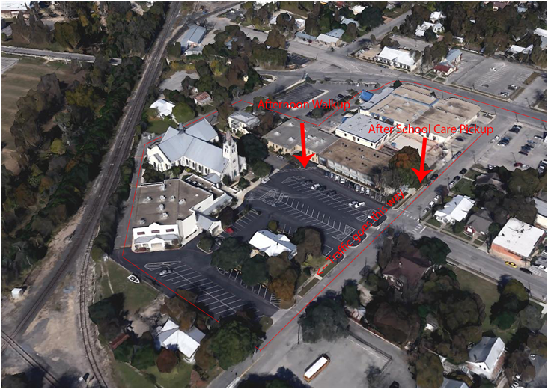
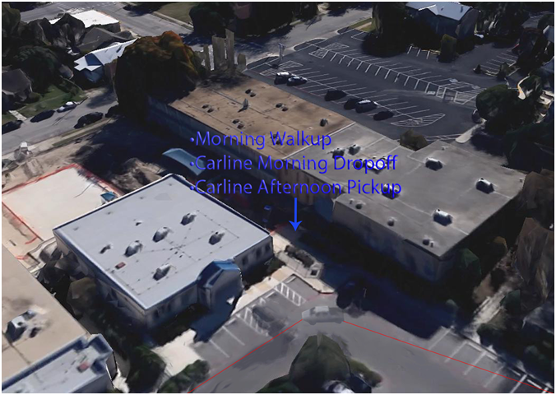

Early Release Days
All students are dismissed in Pre-Kindergarten through 8th grade at 12:00pm. These dates are noted on ParentsWeb, on the school website and on the yearly calendar. Lunch is not served on these days.

Inclement Weather
During inclement weather, local radio and television stations normally announce school closings. The principal will send a notification through the parent alert system and it will also be posted on the school website. STS. PETER AND PAUL CATHOLIC SCHOOL WILL NOT BE IN SESSION WHEN NEW BRAUNFELS INDEPENDENT SCHOOL DISTRICT CANCELS SCHOOL. Our school will not be named separately. Missed days are generally made up in accordance with the Archdiocesan school policy and makeup dates due to inclement weather are listed on our school calendar. Listen for OFFICIAL ANNOUNCEMENTS MADE ON TV AND RADIO STATIONS.

Travel Between School and Parish Buildings
Students do not travel between the school and parish center buildings without adult supervision.

Change of Address
For the safety of each student, it is imperative the school be informed of any change of address or phone number(s). This may be done directly through each family’s Renweb account or directly through the front office. Current emergency information for every child is critical in the event a child becomes ill or injured while at school. Sts. Peter & Paul Catholic School will not release any students address without a parents permission.

Custody of Children
Sts. Peter & Paul Catholic School abides by the provisions of the Buckley Amendment regarding the rights of the non-custodial parents. In the absence of a court order to the contrary, the school provides a non-custodial parent with access to the academic records and to other school related information regarding the child. A non-custodial parent must give a 24-hour notice to the school before receiving the requested information. It is the responsibility of the custodial parent to provide the school with an official copy of the court order when a court order specifies no information is to be given to the non-custodial parent or the non-custodial parent may not pick up the child or see the child. All divorced parents are required to provide the school with a judge stamped copy of the custody section of the divorce decree. Unless otherwise noted, only individuals listed on the child’s emergency contact form are allowed to remove the child from the campus.

Visitors on Campus
Visitors may enter the school by way of the administrative offices at the Good Shepherd Center on Seguin St. when picking up children for appointments, or bringing latecomers to school. All visitors are required to sign in at the front desk, present a driver’s license and receive a badge to identify them. Parent conferences may not be held before or after school unless previously scheduled. After school, parents wait outside in a designated area or in the car line for student pick-up.
Student visitors are not encouraged. When there is a visitor at school, students are distracted and learning suffers. The Administration gives permission in cases when a student is visiting from another part of the world and can provide a learning experience for a class. Administrative permission is required for any visitors in classrooms.
Visitors or those on duty may not approach or discuss a personal matter regarding their child or another child with any other person. Separate conferences are required for these matters.

Photo and/or Interview

Throughout the year pictures and videos are taken of the students at Sts. Peter & Paul Catholic School. In order to publish the photos, a release form must be on file. The publicity generally appears in the local area newspapers, ads and commercials and could be used in Archdiocesan related publicity. This release also includes pictures in the school yearbook as well as in-house school publications. Parent approval is required at time of registration.

STUDENT EXPECTATIONS/ACTIVITIES

Reverence at Mass
Every student at Sts. Peter and Paul Catholic School is expected to behave in an especially respectful and reverent manner at any school Mass. Students are to keep their attention focused on the sanctuary and to refrain from fidgeting or distracting others. Please make sure to place the kneelers up quietly and place books back quietly.

Student Service
To prepare our students for living out our mission of being good Christian leaders, all students are expected to complete service hours. In grades PK-5 this service is completed under the leadership of the teachers, and at the School of Logic (grades 6-8) service is completed independently as well as a group. Service activities range from improvement of the school campus (environmental clean up) to the local and out to the greater community. Service opportunities selected by the teachers are always age-appropriate. Each grade level will be assigned service projects throughout the year.
The service requirements are
- Students in Grade 6 = 10 service hours per year
- Students in Grade 7 = 15 service hours per year
- Students in Grade 8 = 25 service hours per year

Water, Food, Drinks, and Chewing Gum
For the health of our students, all students are encouraged to stay well-hydrated in the classroom. To promote this, students are encouraged to have water bottles in the classroom. To ensure the safety of all students, we require that water bottles be transparent plastic, no glass. If the plastic water bottle is covered by a sleeve, we request that students have a slot on the cover to permit staff to confirm that the liquid within is indeed water.

For safety and sanitation reasons, students are not allowed to have food, drinks, candy or chewing gum in hallways, lockers, or common areas of the school. Chewing gum is not to be chewed on campus due to its potential damage to school property. As with all students found in violation of school policy, violation of this policy has consequences. The food or drink will be confiscated and staff members have the option to dispose of the items after confiscating them.

Clearly, another exception to this rule is food or drink brought to school for lunch, a teacher designated snack time, or food that students are taking with them on extracurricular activities during or after school. The food brought for those purposes should be consumed at the designated or appropriate time.

Cell Phones / Smart Watches and Electronic Devices
Students at Sts. Peter and Paul Catholic School may bring no electronic devices to school other than a cell phone. Cell phone use is closely monitored during the day for the safety of all students. Cell phones may not be used by students at anytime while on school campus, unless supervised by an office staff member.

All cell phones brought to school must be turned in to their homeroom teacher at the beginning of the day, and these will be returned to the student at the end of the day. Smart Watches are prohibited due to their ability to text and email during instructional time, but Fit Bits with texting disabled and similar activity trackers are permissible.

A staff member who encounters a student in violation of this electronics policy will confiscate the cell phone or device and turn it into the school office. The first time this action is taken, it will be turned in to the school office, and the student’s parent will be required to come to the office to retrieve the device and the student will be issued a detention. If the event should happen a 2nd time an in school suspension will occur. Anytime after that there will be a 3 day in school suspension and the cell phone can no longer be brought to school. Due to the cost of electronic devices parents need to know that the school and its staff members will not be held liable for lost or damaged devices that result from the execution of this policy. For this reason, it may be best to not have these devices at school.

Toys, Spinners and Personal Items
If toys are brought for "Show-and-Tell" they are given to the teacher or kept in the student’s backpack until the appropriate time. Other items that are not to be brought to school without the explicit permission of a teacher include: electronic games, magazines, trading cards, and similar personal items which have the potential for disturbing instruction.

Student Use of Office Telephone
The office telephone is a business phone, however, it may be used by students during the day for important parent contacts. Student use of the phone frequently is highly discouraged. To use the office phone, students must have permission from a teacher or member of the office staff. Students are never allowed to use a faculty members phone or the students own personal phone while on campus.

Personal Sports Equipment
Students are not to bring to school personal sports equipment, such as basketballs, footballs and soccer balls for utilization during recess times. School provided sports equipment is provided for student enjoyment. Should such equipment be needed for an after-school sports activity, it is to be placed in the extra sports bag mentioned above and stored during the school day.

Class Parties/Birthday Wishes
Class parties are held at Christmas, St. Valentine’s Day, and at the end of the school year. Other class parties are held only with the permission of the Administration.
Invitations to a student's birthday party may be given out in the classroom only when EVERY STUDENT IN THE CLASS RECEIVES AN INVITATION or IF EVERY BOY RECEIVES AN INVITATION or IF EVERY GIRL RECEIVES AN INVITATION. If
only a few students are to receive an invitation, they may not be handed out at School. This includes before school, during school hours, after school, at sports practice, etc.
The school does not permit birthday parties on the campus. Parents may send cupcakes or cookies on the day of the child's birthday, but no drinks or cakes please. These will be served at the teacher’s designated time, either in the classroom or outside. Please do not send balloon-grams, flowers, etc. for delivery at school.

Textbooks
Textbooks are purchased by the school and issued to students. Each student is responsible for the set of books provided for his/her use. Students may not write in non-consumable textbooks nor deface them in any way (including using contact paper on the covers). Students should take proper care of the textbooks that are issued to them as students will be held financially responsible for books that are damaged or lost.
At times students study selected novels as a class. When this is to happen parents are notified so that they can decide whether to purchase the novels independently or have the school purchase them and charge them to their FACTS account.

Backpacks
The school has limited classroom and locker space. As a result, students are asked to bring only one book-bag/backpack to school. The backpack should not have wheels. Students involved in sports may bring an extra sports bag that will be stored in a designated area during the school day.

Student Delivery of Homework, Glasses, Lunches and Medication
Recognizing that effective instruction requires minimal interruptions, every effort is made to minimize classroom disruptions. This includes the making of announcements or deliveries. The only exceptions are announcements or deliveries related to glasses or medication. Lunches brought to school will be placed on the reserved table in our school cafeteria for student retrieval as they enter for lunch. Homework or instructional materials brought to school will be placed in the teacher’s mailbox, but not brought to the classroom. Through this, we are not only minimizing disruptions but encouraging student responsibility.

Lost and Found
Parents are strongly encouraged to label all clothing items. Because all uniform pieces look alike, without labeling, lost items are often unclaimed. When found, uniform pieces are placed in a specific area in the glassed in porch. Smaller found items such a jewelry and glasses are housed in the office area until claimed. Items that are left in the lost and found for more than a week after each semester ends will be donated to the Thrift Store, the Saints Peter and Paul Catholic School uniform exchange, or discarded.

Field Trips
Field trips within our city and to nearby points of interest are scheduled by classroom teachers throughout the school year. These trips are designed to supplement the classroom curriculum and to introduce students to the resources of the community. Going on a field trip is a privilege, not a right. Students may be denied the opportunity to attend a school-sponsored trip based on a history of misconduct or one single event. Parent participation in field trips is left to the discretion of each teacher. Parents receive a notice at least five school days before each field trip. The parent signs the form and returns it to the teacher no later than the day before the scheduled field trip. Without the parent signature, the child remains at school supervised by another classroom teacher.
The school bus will be utilized as the vehicle for excursions, and when necessary, private vehicles may be used with the following stipulation

- The driver of the private vehicle is 21 years or older with an official driver’s license;
- The driver of the private vehicle prior to the day of the excursion must provide proof of liability insurance and a current driver’s license and must fill out the appropriate forms from the Archdiocese; and
- Each child/occupant has a seat belt.

Parents who accompany teachers and children on field trips are needed for SUPERVISION. Do not compromise supervision by bringing other children along. In order for the safety of our children, all chaperones must be up to date on the OVASE training, background check and Code of Conduct that is required by the Archdiocese of San Antonio. This is required for all volunteers.

School Sponsored Dances (Grades 5, 6, 7 & 8)
Several times a year dances are held. The opportunity to participate in this activity has the advantage of teaching students the social graces needed in our society. These dances are chaperoned by parents and have the approval of the Principal. Only students who attend Sts. Peter & Paul Catholic School/Parish are allowed to attend unless otherwise noted.
Our students abide by the student code of conduct to remain at a dance. If a student refuses to abide by the rules set forth for school dances they are asked to call home to be picked up. The Principal may deny the student permission to attend future dances.

Student Council
Students in the 8th grade may run for an office on the Student Council. To run for office, a candidate must meet or exceed the school-outlined behavioral expectations. Elections are held in the spring for the next school year. Council can raise monies for special projects or dances as approved by the Principal and the Class/Club Sponsor (teacher).

Posters, Flyers and Other Written Communications
Posters, flyers, and other written communications may be posted at Sts. Peter and Paul Catholic School only with the approval of the Principal. They should always be in good taste and neatly designed. Those who post written communications are responsible for removing them after the event, which they advertise, is completed.

CAMPUS RECURRING EVENTS
Below is a month-by-month breakdown of annual events. Specific dates are announced through RenWeb and the school website, and additional events are added throughout the year.

August | September
PTC Back to School Night | Grandparent’s Day
 | Individual Student Pictures
 | Western Day
 | Standardized Testing (NWEA)
October | November
Fall Festival | Veteran’s Day Program
 | Parent Teacher Conferences
 | Thanksgiving Holidays
December | January
Christmas Program | Catholic School Week Events
Christmas Parties | Registration Opens
Christmas Holidays | Class Parties
 | Standardized Testing (NWEA)
February | March
 | Spring Break
April | May
Easter Holidays | Kindergarten Graduation
Standardized Testing (NWEA) | 8th Grade Graduation
PTC Elections | May Crowning
 | Sports Banquet

COMMUNICATION RESOURCES

ParentsWeb
ParentsWeb is the tool utilized by Sts. Peter and Paul to strengthen home-school communication. All parents must create a ParentsWeb account to use this tool, and once this has been done, parents may login to see a wealth of student specific school-related information. Teachers post daily lesson plans and homework so parents can be aware of daily classroom instructional focus in each subject area and homework to be completed daily. In addition, by utilizing gradebook in RenWeb parents can see their child’s academic progress the instant the information is posted.

This is a vital tool for all of our parents.

To create a ParentsWeb account
- Go to www.renweb.com
- Select the Login button
- From the dropdown menu that appears, select ParentsWeb Login.
- Select Create New ParentsWeb Account.
- Enter our District Code—stpp-tx.
- Enter your email address and submit this information.
- A password will be sent to your email address.
- Open the email and follow the instructions.
- Should you ever forget your Username or Password, there is a link that you select from the Login page to reset this information.
To access an existing account
- Go to www.renweb.com
- Select the Login button
- From the dropdown menu that appears, select ParentsWeb Login.
- Enter our District Code—stpp-tx.
- Enter your email address and password.
- Select the ParentsWeb option and submit.

A ParentsWeb app is also available in the App Store.

Weekly Folders
Folders are sent home weekly with the youngest child in each family when there is information. The weekly folder should be returned to the homeroom teacher the following day. Contents vary by grade level, but it is important that parents check these regularly in order to be well-informed of campus and/or community events.

Student Planner
In grades 2nd -8th, a student planner is used as a tool to assist students and parents in meeting each student’s academic objectives. These are purchased through the school for $5.00 each (charged to FACTS account) and will be handed out the first week of school. Should a replacement be needed, they can be purchased through the school office for $5.00 each (charged to FACTS account).
- There is room for parent/teacher to initial work on a daily basis if necessary.
- Students should bring the student planner to each class. It should be taken home each evening to assist in the timely and effective completion of assignments and foster home-school communication.

Yearbook
A yearbook is published each school year. Yearbooks are ordered by completing forms sent home for that purpose (usually after the first of February).

School Publications
- School Website - www.school.sppnb.org
- Social Media - Facebook (Sts. Peter & Paul Catholic School)
- Any school group social media communications must be approved by the administration. A school personnel must be included in the group.

School Sponsored Social Media
Schools may maintain official school social media accounts to promote the school and provide information to enrolled families, prospective parents and the wider community. The school social media accounts are under the authority of the school and the school Principal. The Principal must designate a person who is responsible for monitoring and updating the school’s social media accounts.
Schools shall have written authorization from the parent/guardian before posting photos or videos of students.

Definitions
Social media is defined as any form of online publication or presence that allows interactive communication, including, but not limited to social networks, apps, blogs, internet websites, internet forums, and wikis. Examples of social media include, but are not limited to, Facebook, Instagram, Twitter, Snapchat, Vine, Whatsapp, YouTube, Google+, and Flickr. Additional social media may be developed in the future that could be covered by this policy.

Media

Members of the media will not be allowed on school property unless authorized by the Principal after presenting appropriate valid identification. The Principal shall notify the Superintendent if members of the media come onto school property. The Principal shall receive the approval of the Superintendent and Archdiocese Communications Office prior to any information released or communicated to the media.

HEALTH/SAFETY

Illness/Injury
If a child is ill or injured, a member of the staff cares for the child. The office staff is equipped for administering emergency first aid. When emergency medical treatment is necessary, the parent is contacted. If a parent is not available, the child is taken by EMS to the emergency room of the hospital indicated on the child’s "Emergency" information on file. Please keep your TELEPHONE NUMBER, AN EMERGENCY NUMBER, and AND THE NAME AND NUMBER OF YOUR CHILD'S DOCTOR CURRENT. When a child becomes ill at school the parent is contacted to take the child home. If the parent cannot be contacted, the person(s) listed on child's emergency card is contacted.

Medication
Students are not allowed to carry medication on their person, including non-prescription medications At the direction of the student’s physician, an exception may be made in the cases of diabetic medication and supplies or rescue medication, including a rescue inhaler or a single dose epinephrine auto injector. Only medication necessary for a student to remain in school is given during school hours. Medication is brought to the office by the parent/guardian. If the medication is liquid, it should be accompanied with a calibrated medication dispenser that has legible numbers on it. Only medication prescribed by a licensed physician, physician assistant, nurse practitioner or dentist and labeled by a registered pharmacist is administered during school hours. Only office staff or their designee dispenses medication. ‘Over-the-counter’ medication (including but not limited to sunscreen, bug spray, acetaminophen, ointments, cold tablets, and cough drops) can only be given by a parent or office staff. Please include dosage and instructions for medications and is only given during school hours. The Medication Permission Request Form(Form 8201A) must be completed by the parent/guardian and the health care provider in order for any medication, including “over the counter” medication to be given by school personnel.
Student medication must be in its original container clearly labeled with the following information:
  - Student Name
  - Physician/Dentist name
  - Date
  - Name of medication
  - Dosage
  - Directions for Administration
  - Duration of Administration
Over-the-counter medications must be accompanied by a signed Medication Permission Request Form, in their original, unopened container and display the student’s name. Over-the-counter medications must be the smallest available size to meet the student’s medical needs.
Medication will be dispensed by a designee of the principal. Medication that has expired is not administered. School personnel return unused medication directly to the parent. By physician’s written direction, a student may be allowed to carry and self-administer inhaler medication, diabetic medication and supplies or rescue medication.. Otherwise, students are not allowed to possess any medication while on the school campus, including but not limited to over-the-counter medication.

Medication Administration Off School Grounds
Daily and rescue medications shall be sent on field trips with the teacher. All medications must be labeled according to Policy 8201 and be accompanied by a copy of the signed medication permission form.
The field trips organizer must carry a cell phone on their person at all times during the field trip in case of emergency

Storage of Medication
Schools must store medication in a locked cabinet or drawer. Medication requiring refrigeration must be stored in a locked refrigerator.

Communicable Disease
    - Immunizations required by the State Department of Health must be observed.
    - Students should remain at home when they exhibit the first symptoms of a disease.
    - When a student in school is suspected of having a communicable disease, he/she should be separated from other students until he/she can be sent home

WELLNESS POLICY:
GUIDELINES FOR IMPLEMENTATION

Preamble
Our Catholic tradition teaches us that our bodies are the temples of the Holy Spirit and need to be respected and nurtured as such. As educators we must do all in our power to advance this tradition of respect and care for our bodies both for ourselves and our students. Unfortunately, our sedentary and consumerist culture and lifestyle cause us to neglect and abuse these sacred temples that are our bodies.
The first to suffer from this neglect are our students. The cycle of unhealthy food choices and inadequate physical activity on the part of adults has serious consequences for our children. The results are obvious. Currently, obesity among our children and youth is at epidemic levels and often leads to serious health problems.
Our Catholic schools are committed to being part of the solution to this multifaceted problem. We commit ourselves to equip the students under our care with the awareness, knowledge, skills and attitudes necessary to make lifelong healthy choices. Our schools will strive to create environments that promote healthy eating choices and more focused physical activity. Our cafeterias, classrooms, and all school related activities will provide clear and consistent messages that encourage respect and care for our bodies as God’s gifts to us.

Guidelines for Implementing the Wellness Policy

Nutritional Guidelines for All Foods on Campus
- All foods made available on campus will comply with the current Texas Public School Nutrition Policy and/or USDA Dietary Guidelines for Americans. This includes vending machines, a la carte, beverage contracts, fundraisers, concessions stands, student stores, school parties and celebrations.
- Classroom snacks feature healthy choices. Emphasis will be on serving fruits and vegetables as the primary snacks and water as the primary beverage.
- Foods and beverages sold at fundraisers should include healthy choices and age appropriate selections.
- Schools will not use foods or beverages, especially those that do not meet nutrition standards, as rewards for academic performance or good behavior, nor withhold food or beverages as punishment.
- Schools should place limits on celebrations that involve food during the school day.

Eating Environment
- Dining areas should be clean, pleasant, and attractive.
- Lunch periods are scheduled as near the middle of the school days as possible.
- Students will have at least 10 minutes to eat after sitting down for breakfast and 20 minutes after sitting down for lunch.
Nutrition Education
- Nutrition education will not only be part of health education classes, but will also be integrated into other areas of the curriculum such as math, science, language arts, social studies, and religion.
- Nutrition education will promote fruits, vegetables, whole grain products, low-fat and fat-free dairy products, healthy food preparation methods, and health-enhancing nutrition practices.
- The school cafeteria serves as a “learning laboratory” to allow students to apply critical thinking skills taught in the classroom.

- Nutrition education will include sharing information with families that encourage them to teach their children about health and nutrition and to provide nutritious meals for their families.
- Students will be encouraged to start each day with a healthy breakfast.
- Students will receive instruction on media literacy with an emphasis on food marketing.
- Training will be provided for teachers and other staff.

Physical Activity
- Physical activity will be integrated across the curriculum and throughout the school day. Schools will consider research and national and state standards in allotting time for physical activity. Teachers will provide short physical activity breaks between lessons or classes, as appropriate.
- Physical education class will be the environment where students learn and practice physical activity and exercises that will be of value to them and promote lifelong physical fitness.
- Schools should provide a daily recess period, which is not used as a punishment or a reward. Consideration will be given to planning recess before lunch since research indicates that physical activity prior to lunch can increase the nutrient intake and reduce food waste.
- Information will be provided to families to help them incorporate physical activity into their students’ lives.

Exclusion Guidelines—  Stay At Home | Inclusion Guidelines –  Return to School
Oral temperature of 100 or above | Fever free unmedicated for 24 hours
Vomiting, nausea or severe abdominal pain  (if occurs during school hours child must be picked up) | Symptom free for 24 hours
Marked drowsiness or malaise | Symptom free
Sore throat, acute cold or persistent cough | Symptom free
Red, inflamed or discharging eyes | Written physician release
Acute skin rashes or eruptions | Written physician release
Swollen glands around jaws, ears, neck | Written physician release
Suspected scabies or impetigo | Written physician release
Any skin lesion in the weeping stage | Covered and diagnosed as non-infectious
Earache | Symptom free
Pediculosis | Lice and Nit Free
Other symptoms suggestive of acute illness | Written physician release
TCCED, 2004

PEDICULOSIS (HEAD LICE)
Students found to have head lice shall be excluded from school immediately. Students shall be free of live lice and nits before re-admittance to school.
School personnel, including but not limited to the school nurse or health coordinator, involved in the detection of head lice should be appropriately trained. The importance and difficulty of correctly diagnosing an active head lice infestation should be emphasized.
The school nurse or health coordinator is responsible for notifying the parent(s) or guardian(s) of the student who has lice. Letters of notice for parent/guardian of a student with lice and classmates are available in the TCCED Health Manual. In order to prevent a widespread problem and to avoid the spread of misinformation, parents should be instructed on how to recognize nits and given tips on treatment and prevention.
Students found to have lice are to be treated with lice shampoo and returned to school with proof of treatment( box of lice shampoo and copy of receipt of purchase). A parent/guardian shall accompany the student to the school office. The student may remain at school only if they are found to be lice and nit free.

Health Files
Sts. Peter & Paul School maintains a health file on each child that contains a record of immunization, vision and hearing screenings, pertinent medical information, and the child’s doctor's name. Health records are treated as confidential; they are available to the Administration, nursing staff and professional staff. The student's immunization record is transferred to the receiving school when requested.

Medical Exemption from Immunization
An exclusion for medical reasons (not for reason of conscience) will be considered if a parent/guardian presents a written request to the principal with the appropriate documentation. The principal, in consultation, with local school administration, will make the final decision, and this must be done with the approval of the superintendent of the Archdiocese of San Antonio. The students health form is kept electronically in the schools management system Renweb.
In accordance with state law, the parent/guardian must present a statement signed by the child’s physician (M.D. or D.O.), duly registered and licensed to practice medicine in the United States who has examined the child, in which it is stated that, in the physician’s opinion, the vaccine required is medically contraindicated or poses a significant risk to the health and well-being of the child or any member of the child’s household. Unless it is written in the statement that a lifelong condition exists, the exemption statement is valid for only one year from the date signed by the physician. If not a lifelong condition, it is expected that the child will be vaccinated as soon as the medical condition improves and the child’s physician judges that it is safe to do so.
If the parent is requesting the exemption from more than one immunization, the same documentation must be requested for each.

Screening Tests
Visual and auditory screening tests are given to children each year in accordance with the State of Texas requirements. . These tests are required by the state of Texas. Screening for scoliosis is done starting in 5th grade. This is a required screening by the state of Texas. It is encouraged that a parent have screening done by a physician. Documentation of such screening must be presented to the school by the end of September of the current school year.

Wellness
Sts. Peter and Paul Catholic School has formed a Wellness Committee to meet the requirement established in archdiocesan policy. The committee reviews the policies and practices of Sts. Peter and Paul Catholic School to ensure that we work toward an increasingly healthy school environment.

Asbestos
This is our annual notice of the presence of asbestos containing materials in our school. The location and condition of these materials are found in the approved Management Plan, located in the Principal's office. In 2017 Sts. Peter & Paul Catholic School had its three-year re-inspection. In January/February and June/July we have our periodic surveillance. These are conducted by PSI. The results of these inspections and surveillance are recorded in the Management Plan. Remaining asbestos is checked annually and an acknowledgement letter is sent to parents.

Safety Drills
Fire Drills are held once a month. Escape plans are posted inside the door of each classroom. Bomb Threat, School LockDown and LockOut drills are held as appropriate to prepare students for such emergency situations. Tornado drills are also held.

Crisis Plan
In the event of a crisis, the school does have a Crisis Management Plan that is utilized. If such an event occurs, parents are notified as needed.

Sts. Peter and Paul Catholic School Crisis Management Plan
Creation of a safe learning environment for all students is a priority of Sts. Peter and Paul Catholic School. Assessment of facilities, planning for crisis events, development of protocols to be followed, training staff and evaluation of effectiveness are key components in ensuring that our campus is prepared to respond to any emergency situation.
Members of the Crisis Management Team
The Crisis Management Team functions under the direction of our principal, Mr. Robert Whitworth. Other members of the team include our Administrative Assistant who plays a key role in initial response to an emergency situation; Rodney Geter, a member of our physical education team; a teacher on our Pre-k 1 team; a teacher on our grade 2-5 team, and a teacher on our School of Logic (grades 6-8) team. Together they evaluate the Crisis Management Plan and work together to see that all components required for effective implementation are in place.
Role of Crisis Management Team
The Crisis Management Team has a critical role in the safety of the school. They take leadership in refinement of the campus crisis management and modify it to best meet the needs of the campus. This is done in both quarterly meetings focused upon school safety and following any drill or event to determine the effectiveness of the school response and identify any improvements needed. This includes, but is not limited to, the creation of classroom GoBags and the creation and posting of campus evacuation routes.
Campus Health Officer
Sts. Peter and Paul has a part-time Campus Health Coordinator who is a certified nurse licensed with the Texas Board of Nursing. She guides the front office staff and other employees, as needed, to promote health and safety of our students and provides guidance in responding to student needs and emergency situations.

Safety and Security Assessments
Texas Education Code requires that each school facility in Texas have a safety and security assessment at least once every three years. These assessments are not based on crime or violence, but instead are designed to allow the schools to improve safety and security based on the guidance of trained staff and best practices.
The fire department also conducts safety assessments. Through these assessments we have strengthened our emergency preparedness and have developed more effective guidelines for maintaining campus safety.
Emergency and Crisis Response
In the event of a traumatic event or crisis in or near our campus, Sts. Peter and Paul Catholic School plans to implement proper response leading to staff and student safety by following the protocol within this plan. Due to the various settings on our campus, training is provided to ensure that every staff member has the information needed to protect student safety or take a leadership role, if the need arises.
Training
For any plan to be effective, those who are called upon to lead the response must be informed. For this reason, the Crisis Management Plan will be provided to all staff prior to the beginning of the school year and its content will be discussed. It is the expectation that all staff members keep their Crisis Management Plan in their GoBag so that the information is always accessible to them and to any substitute who may be in their classroom.
ENTERING AND LEAVING CAMPUS
Visitor Tracking System (Raptor)
Sts. Peter and Paul uses a visitor tracking system to supplement existing security measures. This system, known as RAPTOR, logs visitors as they enter campus, produces visitor badges, and electronically checks visitors against a national sex offender database.
In an effort to know who is in our buildings at all times, all visitors must wear a visitor badge while on campus. Anyone entering the campus and wanting access must present a valid driver’s license to be scanned by the visitor tracking system. All staff employees must wear their identification badge while on campus at all times.
The school has guidelines in place to monitor students who depart school during the day. In order to check a student out of school, all parents/guardians must be either recognized by the front office staff member or must produce a photo identification.
If a child is to depart campus with someone other than a parent, authorization from the parent will be required and will be verified by the front office staff before the child is allowed to leave the campus.

EQUIPMENT AND SKILLS
AEDs
Two AEDs are located on our campus. One is located in our nurse’s office and the other is in the gym. The physical education teacher will train the staff in the proper use of the unit.
CPR
Our physical education teachers are trained in the use of CPR, and our staff members are also encouraged to take this training. Periodically it is offered on campus.
Access To and From the Second Floor
Sts. Peter and Paul has one building with two floors. We have an electrical lift chair in the stairwell near Bridge St. that can assist in the movement of those students with special needs. Specific staff members are trained in using the chair in the event of an emergency.
Emergency “Go Bags”
Each teacher on campus has an emergency “Go-Bag” which travels with the class in the event of a school emergency. The bags are placed in each classroom for easy access during an emergency situation. Each bag contains basic first aid equipment and other supplies such as
- Flashlight
- Whistle
- Notepad
- Basic first-aid supplies
- Gloves
- Roster for each class of the day
- Copy of the Crisis Management Plan
Flood and Emergency Alert Awareness
Because Sts. Peter and Paul is located near downtown New Braunfels, regularly scheduled tests of the Emergency Management System are heard throughout the campus. Should the Emergency Alert come on during the possibility of an emergency event, campus staff and officials could clearly hear and be able to respond appropriately.

DRILLS AND PROCEDURES
School Emergency Drills
Sts. Peter and Paul is continuously striving to improve safety procedures, including drills, to ensure that tragedy does not occur. School fire drills have been required since 1937 when a natural gas explosion and resulting fire at the London School of New London, Texas, killed in excess of 295 students and teachers. Over 20 years later, in 1958, the Our Lady of Angels fire in Chicago, resulted in the requirement that all schools provide two ways out of the building from any corridor.
Sts. Peter and Paul conducts monthly fire drills for a total of 10 per school year. At least one fire drill per year requires that a class take an alternate route so that students are aware of this additional method of evacuation.
Other drills to be held are Lockdown (Twice a year), Lockout (Twice a Year), Evacuation Drills (Twice a year.) Note that fire drills constitute a valid evacuation drill).
Evacuation maps are posted in every classroom indicating primary and secondary exits in consistent colors with clear reference points.
The school also conducts other drills each semester to help teachers and students to prepare to take quick protective action in an emergency. These other drills include:
- Lockdown!(Locks, Lights, Out of Sight)
- Lockout! Secure the Perimeter
- Evacuate!
- Shelter-in-Place (Hazmat)
- Tornado (Shelter)
The drills are intended to prepare students and staff to act quickly in the event of an emergency. Parents should encourage students to take the drills seriously and discuss them with their children at home.

LOCKDOWN!

What You Hear (Repeated Twice)
Lockdown! Locks, Lights, Out of Sight!
Student Actions: | Teacher Actions:
Move away from sight | Lock interior doors
Maintain silence | Turn out the lights
Do NOT open the door | Move away from sight
 | Do NOT open the door
 | Maintain Silence
 | Take Attendance

A Lockdown is called when there is a threat or hazard WITHIN the building.
If possible one should have law enforcement present. Teachers should have identified with students a “safe zone” that is out of sight for the hallway window. On the ground floor, drapes should be closed, if possible. Teachers and students are NOT to open the door unit a first responder or school administrator opens it.
If staff or students are out of the room during a lockdown, they must hide in the nearest location.
Examples of lockdown conditions:
- Dangerous animal within school building
- Intruder
- Angry or violent parent or student
- Active shooter

LOCKOUT!

What You Hear Repeated Twice:
Lockout! Secure the Perimeter
Student Actions: | Teacher Actions:
Return Inside | Bring everyone indoors
Business as usual! | Lock perimeter doors
 | Increase situational awareness
 | Business as usual
 | Take Attendance

A Lockout is called when there is a threat or hazard outside of the school building. Lockout drills are to be performed at least twice a year. One should be held while outdoor activities are in progress. The purpose of a lockout is the secure the students safely inside the building away from the threat or hazard OUTSIDE of the building.
Examples of Lockout Conditions:
- Dangerous animal on school grounds
- Criminal activity in area
- Civil disobedience situation
- Severe weather - non-tornadic

Evacuate!

Evacuate! (Repeated Twice)
Evacuate: Go to (Place)
Student Actions: | Teacher Actions:
Bring your phone | Grab GoBag
Leave your stuff behind | Lead evacuation to location announced
Follow instructions | Take attendance
Communicate situation using Green (OK),
Red (Help is needed), and Yellow Alert (I Have Information)

Evacuate is called when there is a need to move students from one location to another. The classroom teacher usually leads the evacuation. In a police-led evacuation, students may be instructed to form a single file line and hold hands front and back. This insures that every child follows and is very important. Students and staff may also be asked to put their hands on their heads. Staff and students are to follow law enforcement instructions.
As teachers evacuate they should take their Go Bags! and, upon arriving, attendance must be taken.
In the event that a child is separated from their group during an evacuation, students should be taught to join any evacuation group, and identify themselves to the adult in charge when the evacuation is completed.
When the destination has been reached, and attendance has been taken teachers should display their Red Card/ Green Card/Alert Card. This card is used to identify that all is well (green), help is needed (red), or there is a need to communicate something (yellow). If a child is missing from your group, the Red Help card should be displayed. If a child is with a different group than would be expected, the Yellow Alert card should be displayed indicating that I have something to tell you, and that would be that I have an extra child.

Evacuate! Fire Drills

A SHRILL CONTINUOUS SIGNAL IS SOUNDED THROUGHOUT CAMPUS
Student Actions: | Teacher Actions:
Leave your stuff behind | Lead evacuation to location announced
Follow instructions | Take attendance
Remain in silence | Display Red/Green/Yellow Card

A fire drill is a special type of Evacuate Drill. The signal for a fire drill is a shrill alarm sounding in all buildings. Doors will close automatically and students and staff should evacuate immediately using the designated evacuation routes. Should a staff begin the evacuation and a route be blocked, students should proceed to the specified location. Silence should be maintained for safety and hearing any information that may be shared. The GoBag should be with the teacher. The Red/ Green/Yellow Alert card system of communication should be used. An administrator or public safety agent could visually ascertain the condition of each class.
SHELTER—TORNADO
TORNADO! GO TO SHELTER (REPEAT TWICE)
Student Actions: | Teacher Actions:
Leave your stuff behind | Lead evacuation to location announced
Follow instructions | Take attendance
 | Notify if missing, extra or injured students
Tornado Drills
A tornado drill is a modified Shelter drill.
Upon hearing the signal, teachers and students are to move to a predetermined site identified for sheltering students in such an event. A map of where students are to go should be posted in the classroom. The GoBag! should be taken and attendance should be taken upon arrival. Although silence is recommended, leading the children in the recitation of the rosary can be calming for students. ”

Suspected Child Abuse
A person having cause to believe that a child's physical or mental health or welfare has been adversely affected by abuse or neglect by any person shall immediately make a report as provided by Texas Family Code 261.101. The report must be made no later than 48 hours after the hour that the person first suspects that the child has been or may be abused or neglected. The person who first suspects that the child has been or may be abused or neglected cannot delegate to or rely on another person to make the report.
The report shall contain: name and address of the child, the name and address of the person responsible for the care, custody, or welfare of the child, and any other pertinent information concerning the alleged or suspected abuse or neglect.
Reports shall be made to any local or state law enforcement agency, and in addition shall be made to the Texas Department of Family and Protective Services (DFPS) at the San Antonio phone number 53-ABUSE or by their toll-free number 1-800-252- 5400. More information on reporting can be found on the DFPS website: (www.tdprs.state.tx.us). On-line reporting can be done at www.txabusehotline.org.
If the allegation of abuse is being made against a school employee, the Superintendent must also be notified immediately.
REPORTING SEXUAL ABUSE
Any allegation of sexual abuse that involves abuse by a priest, deacon, or other church personnel must be reported to the Office of Victim Assistance and Safe Environment (OVASE) in addition to DFPS. If the allegation of abuse or misconduct involves school personnel, then the Superintendent of Catholic Schools shall be notified in addition to OVASE and DFPS.
TRAINING
Schools shall facilitate annual training for school employees regarding child abuse awareness, prevention and reporting.

GENERAL ACADEMIC INFORMATION
Along with the required core courses, Sts. Peter & Paul Catholic School offers a variety of courses that are both challenging and fun. The amount of time spent in each class is determined by TCCED guidelines.
- The Early Childhood Program focuses on beginning skills and socialization through developmentally appropriate techniques.
- The primary curriculum provides a strong emphasis on the basics, while giving students a variety of opportunities for hands-on learning.
- We offer instruction in two foreign languages. Students in Prek3 through 5th grades learn the basics of Spanish, and Spanish or Latin is taught to students in grades 6th through 8th through the Rosetta Stone online program.

Expectations of Teachers
Teachers make every effort to inspire and sustain the behaviors and attitudes included in the Student Code of Conduct by modeling these expectations in their relationships to parents, students, and staff. Teachers ensure that students are familiar with expected behaviors and attitudes, and recognize positive behavior and attitude and facilitate an environment conducive to learning by:
- Creating enthusiasm for the subject matter
- Teaching creative and inspiring classes
- Ensuring students master necessary subject area skills
- Fostering each student's self-image and self-confidence and treating each student with respect
- Providing positive individual attention to students
- Reinforcing Christian values, and stressing the difference between right and wrong
- Being a living example of integrity
- Involving students' parents, whenever appropriate, in their child's education by maintaining ongoing communication with parents
- Maintaining orderly and respectful classrooms
- Encouraging responsibility and initiative among students

Order of Communication:
In keeping with the rules of common courtesy and decency, a parent should first contact the staff member who is in charge of the situation in question and do so in a reasonable amount of time so that timely action can be taken to correct any misunderstanding or error. If the matter has not been resolved to the satisfaction of the parents, they are welcome to take the matter to the principal, who will determine a reasonable course of action.

How to contact a teacher
Parents are asked to contact their student’s teachers via the teacher’s school email address (teacher’s initial of their first name and full last name@sppnb.org), or by calling the school office and leaving a message for the teacher. It is requested that parents do not contact teachers at their personal phone numbers or emails. To help with communication, teachers are asked to respond to parents’ emails or phone messages within 24 hours (excluding weekends). Teachers are not to be contacted via Remind during school hours.

How to schedule a conference with a teacher
Send a note, an email or a phone message to your child’s teacher requesting a conference suggesting a time and day; give a reason for the conference so the teacher can be prepared, and provide a phone number where you can be reached so the teacher can confirm or modify this conference time.

Meeting Identified Needs of REACH Students
The academic needs of students in grades 4-8 who will benefit from enrichment and activities are met through our REACH program. Students qualify for REACH based upon scores obtained on Iowa Assessments Test results, Cognitive Abilities Testing, and STAR Reading and Math test results. Parents are notified if their child qualifies to take part in this program and must give consent for their child to participate in REACH activities. To remain in the REACH program, students must be in good academic standing and/or good behavioral standing.

Homework
Homework, by definition at our school, is brief and effective practice of important concepts or skills. Homework and parents’ involvement in student learning are two guarantees that lead to your child’s high achievement and academic success.
Teachers assign a variety of homework assignments that provide students an opportunity to practice various skills such as reading, collecting data, interviewing, researching, etc.

Teachers adhere to the following guidelines
- Pre-Kindergarten 3 & 4: Students in Pre-K may have age-appropriate homework not to exceed 10 minutes twice per week.
- Kindergarten: Students may have age-appropriate homework not to exceed 15 minutes twice per week
- Grades 1 and 2: 20-minute nightly average per grade level
- Grade 3: 30 minute nightly average per grade level, not per subject
- Grades 4 and 5: 45 minute nightly average per grade level, not per subject
- Grades 6, 7, and 8: 1 hour nightly average per grade level, not per subject

Testing
Students will not be given more than two major tests per day.
This practice is also vital to help develop self-discipline, personal responsibility and independent thinking. Students in grades 6-8 are expected to begin to learn and practice self-advocacy skills when it comes to their education. They will have the support of all the adults and professionals that they have contact with to try to help them understand the value of their work. The students’ homework, study, and ultimately their grades, should become p, over time, their responsibility.

Receiving Credit for Homework Assignments and/or Projects

Kindergarten – 8th Grade
- To receive full credit for an assignment or project, work must be completed on the date it is due.
- Teachers of the same grade level must have a clearly outlined late work policy communicated to students and parents.
- Extenuating circumstances may occur that are out of the control of the student that prevent him/her from completing and returning homework assignments. If informed of any such circumstances, exceptions to this policy, as appropriate, may be made. Following parent notification, it may be required for a student to come before school or stay after school to complete late homework assignments.
- If an assignment is not turned in at all, the teacher will assign a “0” or “M.” If after communication with the student and parents, there is no attempt to change the “0” to partial credit within three days, the “0” will become the child’s overall grade.

SPIRITUAL PROGRAMS

Religious Studies
Catholic education is a gift that the Catholic community and parents give to children during their formative years. At Sts. Peter & Paul Catholic School, we teach virtues and values, respect for the environment, and reverence for all of God's creation. We seek truth and stand witness to truth. We strive to be good citizens of this country and to be bold and passionate disciples of God's kingdom. We offer excellence rooted in Jesus Christ.
The Religious Studies program serves a multifaceted mission: to teach the message of Jesus, to nurture a personal relationship with God, to provide an understanding of our Catholic faith and its traditions, and to build community. Through instruction in Catholic doctrine and scripture, regular participation in the Catholic liturgical experiences, and most importantly with family support, this mission is carried out.
The specific objectives of our religious studies are:
Message: Through the light of instruction in the basic doctrine of our Catholic faith, the study of sacred scripture, the sacramental life and the moral life, we deepen our awareness and knowledge of who God is.
Community: Through interaction in a loving, worshiping community, we are led to a greater awareness of how God acts in our lives and we are helped to deepen and strengthen our relationship with God and one another.
Service: Through involvement in acts of loving service to one another and the community, we strive to imitate the actions of Jesus, the early Christian community, the saints and the contemporary Christian leaders.

Liturgy
Students at Sts. Peter & Paul Catholic School attend liturgy once a week. Students help plan, attend and participate in Mass each Wednesday at 10:10 a.m. Students also celebrate Mass on the High Feast Days of the Church at the 8 a.m. parish mass. Parents and family are welcome to attend these services with their child/children.

Sacramental Preparation
Sts. Peter & Paul Catholic School partners with Sts. Peter & Paul Parish for preparation to receive the sacraments of First Eucharist and Reconciliation. Students are prepared for First Reconciliation and First Eucharist in second grade. More specific information is given to students preparing to receive the sacraments throughout the school year.

Retreats
Sts. Peter & Paul Catholic School sponsors a retreat for the 4th-8th grade during the school year. In addition, the Parish Youth Ministry Office also plans retreats that expand understanding of our faith and these retreats are open to all students for whom the retreat is age-appropriate.

Human Sexuality Education
Sts. Peter & Paul Catholic School provides an education program in family living, human sexuality, AIDS Education, and sexual morality appropriate to the age and maturity of the students according to the guidelines of the Archdiocesan Religion Curriculum Guide.

Mass Buddy Program
Through homeroom/advisory teachers, our older students are paired with PK3 students through kindergarten in a “buddy” program. The purpose is to form a bond of Christian friendship. Frequently buddies sit together during Mass so that the older students may model and assist with appropriate Mass behaviors. When appropriate, other “Buddy” relationships are formed between classes and students.

CURRICULUM & INSTRUCTION

CURRICULUM DOCUMENTS

All Catholic schools must have curriculum documents, which at a minimum utilize the Texas Essential Knowledge and Skills (TEKS) and Archdiocesan Standards, in place for use in instructional planning as well as a process for assessing and documenting student mastery of curricular objectives.

CURRICULUM OBJECTIVES

Curriculum implementation for all schools should follow the standards of the Archdiocese of San Antonio that are developed using the Texas Essential Knowledge and Skills (TEKS) and aligned with national curriculum standards with the integration of Gospel values and the teachings of the Catholic Church. Special programs and courses outside of TCCB ED standards may be established by schools in consultation with and an approved waiver issued by the Superintendent.

CURRICULUM REQUIREMENTS

Each school shall maintain a balanced curriculum including religion, language arts (English-grammar and composition, reading, vocabulary, spelling, handwriting), science, mathematics, social studies, fine arts, health, guidance, physical education, technology applications and foreign language. To implement these standards the school will follow the TCCB ED requirements.

LOCAL CURRICULUM DEVELOPMENT

Archdiocesan curriculum guides/standards should be used for each discipline in the school as the minimum standards in order to ensure continuity and unity of purpose. Principals and local school councils shall obtain approval from the Archdiocesan Superintendent before instituting any innovative program or course, which deviates from the established program. Local curriculum development, that builds on and enhances the archdiocesan curriculum guides/standards, shall be the responsibility of the principal in consultation with the faculty. Each school shall strive for well-balanced curriculum development by considering factors such as individual needs, curriculum standards, student assessment, instructional organization, strengths of the faculty, and current research. The curriculum shall be evaluated by the administration and staff on a yearly basis to determine whether it is fostering the achievement of the philosophy and goals of the school.

ACADEMIC ASSESSMENT

Parent/Teacher Conferences
Parent/Teacher conferences are scheduled in November and are made available in May of the school year. They are intended to help parents be better acquainted with their teacher(s) and to discuss the child’s progress. Contact with teachers is not limited to the formal conferences. Parents are encouraged to contact a teacher anytime there is a concern or question. Teachers may also contact parents when they have a concern or an observation.

Progress Reports
Progress reports for students in K-8th grade are sent home four times during the school year. Progress reports are sent home in the middle of each quarter.

Report Cards and Grading Periods
Sts. Peter & Paul School follows the Archdiocesan nine weeks grading period schedule.

The following grading key is used for PreK3 and PreK4:
E Excellent Progress
S Satisfactory Progress
N Needs Improvement
NA Not Applicable

The following grading scale is used for grade evaluation in academic areas in K5 and 1st grade:

E Excellent Progress
S Satisfactory Progress
N Needs Improvement
U Unsatisfactory Progress

Numeric grades are used for all courses from second grade through eighth grade.
Numeric grades recorded in Grades 2 through 8 reflect the following standards of achievement:
94 –100 A
85 - 93.9 B
75 - 84.9 C
70 - 74.9 D
0 - 69.9 F

In all grade levels, the following codes are used for Conduct/Handwriting/And Some Specials Classes:

E Excellent Progress
S Satisfactory Progress
N Needs Improvement
U Unsatisfactory Progress

Grade Reporting
Families have access to their child’s grades through the school’s ParentsWeb. ParentsWeb allows families a powerful tool to shall information between home and school. Parents are encouraged to utilize this program to remain informed of their child’s academic progress.
A family may be denied access to their RenWeb account if the family owes the school for tuition, fees, lunch, After School Care, fines, or other cost associated with their child’s participation in programs sponsored by Sts. Peter and Paul Catholic School. RenWeb privileges will be suspended after these obligations are thirty (30) days in arrears.
To provide formal assessment of student progress, a progress report is emailed to parents mid-way during each term, and at the conclusion of each nine-week grading period report cards will be emailed to parents.

Testing Program
The Archdiocesan Standardized Testing program is used at Sts. Peter & Paul Catholic School. The NWEA Assessment will be used to assess individual student achievement and the evaluation of program effectiveness at Sts. Peter and Paul Catholic School. The test is administered 3 times a year. Parents and teachers are provided testing reports to assist them in evaluating each student’s academic progress.

STUDENT RECOGNITION

Students in grades 3-8 at Sts. Peter and Paul who meet the standards listed below will be placed on one of the following honor rolls:

Students must have an average of 94 or higher in each of these core subjects:

- English/Language Arts (Grammar, Composition, and Reading/Literature),
- Religion
- Science
- Social Studies
- Math
- Foreign Language (6th-8th only)
Students must also have an average of 90 or above in all other subjects. The student must have received a grade of "S" or higher in every class where Citizenship is graded.

Honors (Grades 3-8)
Students must have an average of 85 or higher in each of these core subjects:

- English/Language Arts (Grammar, Composition, and Reading/Literature)
- Religion
- Science
- Social Studies
- Math
- Foreign Language (6th-8th only)
Students must also have an average of 85 or above in all other subjects. The student must have received a grade of "S" or higher in every class where Citizenship is graded.

Quarterly Honors
Students who have met the criteria for being on either of the honor rolls or who have met other academic achievements are recognized at an awards assembly held shortly after the end of each quarter.

Quarterly awards are presented on campus and pins are given in recognition of

High Honors Honor Roll
  - Grades 3-8
  - Standards--Met High Honors Criteria

Honors Honor Roll
  - Grades 3-8
  - Standards--Met Honors Criteria

St. Michael’s Campus Student Leadership Award
  - Awarded to 5 students in each grade in the School of Logic
  - Students must have demonstrated outstanding behavior in the classroom (not having signed the behavior log during the quarter) and have been recognized as campus student leaders by the faculty and administration.

End of Year Honors
In addition to those awards earned quarterly, students are also honored at the end of the year for a cumulative awards ceremony held in the classroom or in a total campus setting.
Each class recognizes

The Christian Leadership Award
  - PK3-8
  - The highest award a student can earn in a year
  - Two students will be recognized from each homeroom class
  - Selected by the classroom teacher

The American Legion Award
  - Grade 8
  - Given by the American Legion and must meet specific standards
  - Selected by the School of Logic teachers in collaboration with administration

High Honors Honor Roll all 4 Quarters
  - Must have been on the High Honors Honor Roll every quarter

Honors Honor Roll all 4 Quarters
  - Must have been on the Honors Honor Roll every quarter

Academic Excellence Award
  - Grades 3-8
  - Must have earned the highest end of year average in a class

Outstanding overall student achievement as well as subject-specific achievement is recognized at the end of an academic year. Two levels of recognition are given to those who have been on the honor roll every quarter of the year. The Honor Roll Award is presented to each student who has been on the Honor Roll or higher every quarter. The High Honor Roll award is presented to each student who has been on the High Honor Roll every quarter. In addition, subject-specific awards are given to students in each grade level. Each grade level also recognizes those students who have demonstrated outstanding Christian Leadership.

PROMOTION AND RETENTION

Minimum Attendance Standards for Grade Level Promotion
A student may not receive credit for a class unless the student is in attendance for at least 90 percent of the school year.
The Administrative Assistant keeps the official record of attendance. When a child’s absences are approaching the 10% standard for retention, it is the assistant’s responsibility to inform the principal.
A student who accumulates more than eighteen (18) absences (excused and /or unexcused) from any class during an academic year may not be promoted to the next grade level unless extenuating circumstances are reported to the principal. The notification of extenuating circumstances in which the parent or guardian petitions for promotion of the child should be made in writing by the parent to the principal prior to or upon request.
The administration will review the petition for promotion to determine whether or not the student should be promoted. The committee has the power to decide to promote the student only after he or she meets specific identified criteria. That might include making up time through assignments or by the completion of an assigned academic program.
The decision to promote or retain a student based upon attendance shall be made by the principal.

It is the expectation that teachers and administrators hold a meeting with the student’s parents/guardians if there is a possibility that a student might be retained. This meeting will be held no earlier than the 2nd quarter and no later than the beginning of the 4th quarter.

Retention / Summer School
A student is promoted to the next grade at the end of the school year when the academic average in each subject is at least a 70.
- If a student’s final average is lower than 70 in any core subject, the student may be required to participate in an accredited tutoring program or attend a summer school program approved by the school. The decision to require summer school as a condition of a student returning to Sts. Peter and Paul Catholic School rests with the principal.

- If a student’s final average is less than 70 in both English Language Arts and Math, the student will be retained at the present grade level for the next school year.
.
- With a final average below 70 in two or more of the core subjects (Religion, Reading/Literature, Spelling, English, Social Studies, Science, and Math) a student will be retained at the present grade level for the next school year.
- All 1st grade students must pass Reading to be promoted to the 2nd grade.

Academic Probation
A student is placed on academic probation for consistent lack of cooperation in the academic area, frequent absenteeism, lack of preparation for daily class, failure to do the assigned class work, failure to complete homework, or a visible disregard for learning. Should a student continue in these habits and show little improvement, parents might be asked to withdraw the child from Sts. Peter and Paul Catholic School. Academic probation is a very serious matter. Students on academic probation may not be permitted to participate in extracurricular activities and may not be permitted to return the following school year.

EIGHTH GRADE GRADUATION

Graduation Requirements
Eighth grade graduation requirements are set in keeping with the tradition of high quality Catholic education in forming personal Christian values, and for maintaining the academic excellence noted at Sts. Peter & Paul School. The School is also mindful of the individuality of each student and the need for providing assistance where needed.

A diploma is withheld from a student for the following reasons:
- Incomplete assignments pending.
- Failure to meet the academic requirements to be promoted to the next grade level
- Textbooks, library books, or other loaned materials not returned.
- Tuition and other incurred expenses not paid. (i.e. lost or damaged textbooks, library books, damaged School property, etc.)
- Service hours incomplete.

Any child whose diploma has been withheld for any reason may not be able to participate in the graduation ceremony nor receive a diploma until corrective measures have been taken.

Graduation Ceremony
Students in the 8th grade who have met all of the requirements for graduation take part in the graduation ceremony held in May.

Scholarships
Each year the PTC awards one eighth grade student with a scholarship. The purpose of the Scholarship Award is to foster the continuance of education in a Catholic High School, and to give eighth grade students at Sts. Peter & Paul Catholic School an incentive to excel in many areas to merit the award.
Criteria for the Scholarship Award
- The cumulative academic average for seventh & eighth grades is at least “90.”
- The student exemplifies good behavior.
- The student demonstrates school spirit by participating in school projects, activities such as choir, liturgies, class projects, sports etc.
- The student demonstrates involvement in parish and community projects.
- The student writes an essay on "Why I Want to Continue My Education in a Catholic High School."
- The completed application form and all documents are submitted to the Principal no later than the date designated by the PTC. The selection committee consists of the Principal, and at least three officers or delegates of the PTC. No person on the selection team may have a child applying for the award.

TECHNOLOGY
Introduction and Expectations

With the advances of technology and the corresponding explosion of access to information available, the opportunity exists to provide your child with access to online services at our school. In providing this opportunity for your child to take advantage of the wide range of services and information, we cannot totally block access to the Internet and its subsequent range of materials. Each parent and child needs to be aware of the fact that not all information on the Internet may be accurate or true and is uncensored. The school’s policies, rules and regulations that govern everyday behavior and their subsequent consequences also govern behavior on the use of online services. In order for each child to be able to login to services through the school, parent and child need to read and sign the Acceptable Use Agreement (sent home with students). The agreement covers both rules of usage and etiquette.
Sts. Peter & Paul Catholic School provides technology resources to its students and staff for educational and administrative purposes. Technology Resources include the intranet, Internet access, fax, E-mail, stand-alone computer, and telephone. The goal in providing these resources is to promote educational excellence in Sts. Peter & Paul Catholic School by facilitating resource sharing, innovation and communication with the support and supervision of parents, teachers, and support staff. The use of these technology resources is a privilege, not a right.

STUDENT USE OF ELECTRONIC COMMUNICATION

As per archdiocesan policy prohibited electronic communications are:
(1) of a sexual nature;
(2) threaten, libel, slander, malign, disparage, harass or embarrass members of the school community
(3) any action that violates the school’s existing behavioral standards covered by the school’s parent student handbook
(4) any action that causes harm to the school community, regardless of where the electronic communication occurs or originates from.
Whether the communication occurs within or outside of school property, during or after school hours, when a student’s use of electronic communication jeopardizes the safe environment of the school or is contrary to Gospel values, the student can be subject to the full range of disciplinary consequences, including expulsion. Violations of each school’s electronic communication policy shall be addressed in conformance with each school’s existing disciplinary policy.

A school reserves the right to confiscate and/or examine any electronic device in the student’s possession while on campus including, but not limited to, cellular telephones, watches, tablets, gaming devices, cameras, school-issued devices or other electronic communication equipment of any type. Users of the school’s equipment or network should have no expectation of privacy in anything they create, store, send, receive or display on or over that equipment or using those connectivity resources, which includes personal files.
Electronic communication includes, but is not limited to, the following: communications or depictions through email, text messages, direct messaging, private messaging, website postings, or social media whether they occur through the school’s equipment, connectivity resources (e.g., WiFi) or using a personal device

ELECTRONIC TRANSMISSION OF A SEXUAL IMAGE

Schools have a duty to report to the Department of Child Protective Services (CPS) or local law enforcement any suspected cases of electronic transmission of a sexual image involving a minor (i.e., sexting). The matter must be reported not later than 48 hours after the school official first suspects such material and should be reported to the following parties:

• the Department of Child Protective Services (CPS), or

• local law enforcement agency, and

• to the guardians’ of all responsible and/or depicted parties, and,

• the Superintendent of Catholic Schools.

If a school official (administrator, teacher, counselor or otherwise) is made aware of any suspected electronic transmission of visual material depicting a minor (i.e., sexting), then the school must follow their investigation protocol in addition to complying with the school’s obligations to report as stated above. The school investigation will establish if the image exists and if there has been any violation of school or archdiocese policy.

EXTRACURRICULAR AND CO-CURRICULAR ACTIVITIES
Description and Participation

Sts. Peter & Paul Catholic School offers a variety of extracurricular and co-curricular opportunities, including athletics, Private School Interscholastic Association academic and fine arts competitions, and other school sponsored activities. Students at various grade levels are able to participate in choir, one act play, academic competitions, and other school sponsored activities. Students in grades 5-8 may participate in athletic activities such as football, volleyball, basketball, track, cross-country, golf, baseball, and softball.
Participation in a Sts. Peter and Paul Catholic School extra-curricular program is a privilege and not a right. The school has a right and duty to determine a student or adult’s eligibility to participate in these programs. Participants, student athletes, coaches, and parents are expected to conduct themselves in a manner that brings credit to their school and bears witness to the Gospel values that are at the center of the Sts. Peter and Paul Catholic School’s mission. Those who do not comport themselves in a manner that lives up to the school’s mission may be suspended from or excluded from participation in an activity The extra-curricular program plays an integral role in fulfilling the mission of the school

Extracurricular Qualification Guidelines
(Athletics, Choir, One-Act Play, REACH, Robotics, Student Council)

Extra Curricular and Co-Curricular activities provide students with opportunities to represent Sts. Peter and Paul School. The expectations set for each group is to guarantee a positive and respectful attitude which directly reflects on the student and the school.

Academic – students must maintain a 74 or higher to participate in activities. Failure to do so will result in probation until the next reporting period.

Behavior – students will maintain an above average discipline record. The following violations are listed under the student discipline guidelines. 3 demerits = 1 detention and 3 detentions = 1 day In School Suspension.
The following actions will be taken if the student discipline record is signed for violations.
· 2 detentions = probation
· 3 detentions = suspension from program
· Suspension = automatic removal from program

Fees – student participation in certain programs will require a fee, which will be charged to your FACTS account. Disclosure of fee rates will be shared with you through the coordinator of each group.

Extracurricular Eligibility Rules for Sts. Peter & Paul Catholic School
Any student who does not maintain a minimum grade point average of 74 in each of their core classes when progress reports or report cards are issued by the school will be ineligible to compete in games, scrimmages, tournaments, meets, and other extra- curricular or co-curricular performances, including academic competitions.

Ineligible students will be allowed to practice with their teams or performance group, but will not be allowed to participate in interscholastic competitions or formal performances. Grades in specials classes will be considered for the purposes of determining eligibility.

Age Eligibility for the Archdiocesan Interscholastic League (AIAL)
A student taking part in games or events of the AIAL shall be in no grade higher than the 8th grade of a member school and not have attained his / her 15th birthday on or before September 1st of the current school year in order to participate in Division (A) sports. A
student shall be in no grade higher than the 7th grade and not attained his / her 14th birthday on or before September 1st of the current year to participate in Division (B) sports. Students below the 5th grade are not eligible for AIAL competition.
Return of Equipment
All school issued athletic equipment, including uniforms, must be returned at the conclusion of each sport. Students failing to return said issued items will be subject to paying the replacement cost of items. Returning damaged items might also be cause for a student being charged the cost of replacing the item.

Safety
The Sts. Peter and Paul Catholic School strives to provide a safe environment for all individuals. Verbal or written threats made against the physical or emotional well being of any individual will be taken seriously. Anyone making such threats (seriously or in jest) faces suspension and/or expulsion from Sts. Peter and Paul Catholic School sports.

Transportation
Students riding the school bus to an athletic event must ride the bus back to school from the event. If permission is given by the coach to ride home with a parent or guardian, a signed release from the parent/guardian must be provided to the coach prior to leaving the athletic event. Permission is granted only for extenuating circumstances.

Weather Policy
For all outdoor sports, in the event of thunder, coaches should be actively looking for any signs of lightning. Play can continue so long as there is no sign of any lightning and if other weather conditions permit. If there is any sign of lightning, no matter how distant, all play must cease. Everyone must leave the field and take cover in the nearest appropriate shelter. Coaches are responsible for issuing this directive in the event that the Athletic Director or an official is not present. In order for play to resume, there must have been no sign of any lightning for thirty minutes since the last sighting.

In the event of rain during the regular school week, every effort will be made to make any cancellation decisions for practices in time for students to notify parents.
Athletic Fees
Athletic fees are billed to parents after rosters have been sent to the Archdiocesan Interscholastic Athletic League. The athletic fees for Sts. Peter and Paul Catholic School are set annually to help cover the cost of the athletic program.

These fees are mandatory and must be paid prior to the participation in each sport. Fees are not refundable.

Pep Squad
Pep Squad is open to students in 1st-5th grades. Practice is held after school and is supervised by one adult leader. The pep squad performs at home games during the football, volleyball and basketball seasons and at other times as is deemed appropriate by the Principal. The fee for participation in the Pep Squad program shall be set annually by the school’s administration and communicated to the parents of participating students.

Cheer
Cheer is open to students in 6th-8th grade.

CYO Sports
The CYO sports are not under the jurisdiction of Sts. Peter and Paul Catholic School. Parents have organized to direct the CYO sports for Kinder through 5th grade. Students in 5th through 8th grades teams may participate in CYO sports whether or not they participate in Sts. Peter and Paul’s athletic programs.

Other Extracurricular Activities
Sports -
Baseball American Heritage Girls
Basketball Scouting
Cheer Robotics
Cross Country Choir
Football REACH
Golf PSIA
Pep Squad CAAC
Soccer Student Council
Softball
Tennis
Track & Field
Volleyball

STUDENT CODE OF CONDUCT

Sts. Peter & Paul Catholic School promotes a positive environment of academic and spiritual growth. The Code of Conduct empowers each person with the skills to act respectfully and responsibly in a Christian manner. In order to promote academic excellence and spiritual growth, the school community establishes these expectations for all.
Students are expected to conduct themselves in a manner that brings credit to their school and bears witness to the gospel values that are at the center of the Sts. Peter & Paul Catholic School’s mission both in and out of school.

Core Virtues
To foster the development of each student’s self-mastery, Sts. Peter & Paul Catholic School students will strive to heed the two greatest Commandments which Jesus gave us: Love the Lord your God with all your heart, with all your soul, and with all your mind; Love your neighbor as yourself. Mastering ourselves through the practice of the school’s core virtues helps us to live Our Lord’s Commandments. This is what the virtues look like in action:

Responsibility
- Being on time and ready to learn
- Completing and turning in all assignments
- Bringing necessary materials to class
- Accepting responsibility for my own actions

Respect
- Acting respectfully to adults and other students
- Cooperating with adults and other students
- Respecting the rights of others
- Respecting myself

Honesty
- Being honest with others and myself
- Refraining from cheating
- Treating others fairly
- Refraining from taking the property of others

Perseverance
- Always doing my personal best
- Showing a consistent effort and positive attitude
- Resisting negative peer pressure
- Resisting efforts to pressure others
- Developing good work habits

Self-Discipline
- Being obedient and respectful to authority
- Working independently without disturbing others
- Listening attentively
- Following procedures and directions the first time given
- Responding appropriately to correction by an adult

Humility
- Consistently thanking God for the blessings given
- Putting God first, others second, and myself last
- Spending time with God in prayer
- Recognizing and developing the talents God has given

Compassion
- Praying for others
- Considering people’s feelings
- Practicing fairness, forgiveness and mercy
- Trying to be a peacemaker everyday

Charity
- Being aware of other people’s needs
- Helping those less fortunate than myself
- Doing good things for others
- Sharing my God-given gifts and talents with others.

Bullying Prevention

It is the responsibility of all Catholic school leaders to ensure that a safe, positive and productive educational environment be established in each school, where no student shall be subjected to bullying, discrimination/harassment, cyber-bullying, or retaliation. The principal of each school and designated staff members (school counselor, lead teacher) with the oversight of the pastor, are collectively responsible for the implementation of bullying prevention and intervention procedures. The prohibition against acts of bullying, discrimination/harassment, cyber-bullying, or retaliation applies to all people engaged in all school related activities; all students, regular or temporary, part-time or full-time employees; volunteers, instructors, and consultants.

Violations of each school’s bullying policy shall be addressed in conformance with each school’s existing disciplinary policy.

All reporting, timely investigation and responses shall be consistent with local, state and federal law regarding the anti-discrimination and the protection of civil and human rights.
Definitions

Bullying means engaging in written or verbal expression, expression through electronic means, or physical conduct that occurs within or outside of school property, at a school-sponsored or school-related activity, or in a vehicle operated by the school or the Archdiocese of San Antonio and that:

1. Has the effect or will have the effect of physically harming a student, damaging a student’s property, or placing a student in reasonable fear of harm to the student’s property; or
2. Is sufficiently severe, persistent, and pervasive enough that the action or threat creates an intimidating, threatening, or abusive educational environment for a student.

This conduct is considered bullying if it:

1. Exploits an imbalance of power between the student perpetrator and the student victim through written or verbal expression or physical conduct; and
2. Interferes with a student’s education and substantially disrupts the operation of a school.

Harassment is defined as physical, verbal, or nonverbal conduct based on the student’s race, color, religion, gender, national origin, disability, or any other basis prohibited by law that is so severe, persistent, or pervasive that the conduct:

1. Affects a student’s ability to participate in or benefit from an educational program or activity, or creates an intimidating, threatening, hostile, or offensive educational environment;
2. Has the purpose or effect of substantially or unreasonably interfering with the student’s academic performance; or
3. Otherwise adversely affects the student’s educational opportunities.

Procedures for Reporting/Addressing Bullying:

- It is the obligation of the student/parent to notify school personnel.
- School personnel will investigate the accusation of bullying and determine if further measures should be taken.
- If it is determined by administration that further measures should be taken, appropriate forms will be completed.

Obligation to Notify Others – The Principal or designated staff member, has primary responsibility to notify the following constituencies when bullying or retaliation has occurred:

a. Notice to Parents or Guardians: Upon administration determining that bullying or retaliation has occurred, the principal or designee will promptly notify the parents or guardians of the target and the aggressor, and of the procedures for responding to the incident. There may be circumstances in which the principal or designee contacts parents or guardians prior to any investigation
b. Notice to Another School: If the reported incident involves students from another Catholic school, the principal or designee first informed of the incident will promptly notify by telephone the principal of the other school(s) of the incident so that each school may take appropriate action. All communications will be in accordance with state and federal education and privacy laws and regulations to protect the privacy of minors.

c. Notice to Law Enforcement: At any point after receiving a report of bullying or retaliation, including after an investigation, if the principal or designee has a reasonable basis to believe that criminal charges may be pursued against the aggressor, the principal will notify the local law enforcement agency and will notify the Superintendent of Catholic Schools of this report.

Support Services – The faculty/staff members (counselor, lead teacher, other) assigned to help establish and maintain a safe and supportive learning environment for students (targets, aggressors, and bystanders) involved in bullying, cyber bullying or retaliation. This may include increased monitoring, increased counseling support through class activities and guidance lessons and/or individual sessions, or referrals for additional counseling support services through other resources.
When a report of bullying is made, in addition to following the investigation procedures outlined in the school’s bullying prevention plan, each school may also seek the services of the DCS Director or Associate Director of Counseling and Guidance to assist in the intervention planning process in order to provide support to the parties involved.

“Why do you call me, ‘Lord, Lord,’ but not do what I command? I will show you what someone is like who comes to me, listens to my words, and acts on them. That one is like a person building a house, which dug deeply and laid a foundation on rock; when the flood came, the river burst against that house but could not shake it because it had been well built. But one who listens and does not act is like a person who built a house on the ground without a foundation. When the river burst against it, it collapsed at once and was completely destroyed (Luke 6: 46-49).”

Sts. Peter and Paul Catholic School is dedicated to building a lasting foundation for your child(ren). Our disciplinary rules are to be used for teaching intelligent and cooperative self-discipline that comes from understanding and appreciating the values protected or promoted by the rules. Whenever the student shows a lack of self-discipline, it is often necessary to enforce rules by authority. In all cases, however, guidance is given to help the student develop self-discipline as a conscious and free response. Parents are expected to support the school’s established standards of conduct and join the school in an effort to raise self-disciplined young men and women.

DISCIPLINE MANAGEMENT SYSTEM

Sts. Peter and Paul Catholic School espouses five basic rules or principles from which all of the more specific injunctions or commands are derived. Those rules are based on our Lord’s command to love God above all things and to love your neighbor as yourself.

  - Students will treat others the way they themselves would like to be treated.
  - Students will not prevent the teacher from teaching.
  - Students will not hinder others from learning.
  - Students will not harm themselves or others.
  - Students will not damage or destroy their own property or the property of others.

Sts. Peter and Paul Catholic School employs a range of consequences when dealing with student misbehavior. The decision to impose a certain consequence for a behavior is based on a number of important factors. Certainly one of the first considerations will be the age of the student subject to discipline. Obviously, another consideration is the nature and severity of the offense. The frequency of differing disciplinary actions or the recurrence of a particular type of offense a student might have been involved in should also be weighed. A final consideration before proceeding to an assignment of the more serious disciplinary consequences would include the degree of contrition, cooperation and effort the student demonstrates when he or she is subject to disciplinary action by faculty and staff.

Sts. Peter and Paul Catholic School will utilize a variety of disciplinary techniques to correct inappropriate student behavior. These include, but are not limited to, verbal warnings, written warnings, time-out, assignments, fines, making reparation, detention, in- school suspension, suspension, and finally expulsion. Corporal punishment (including, but not limited to: spanking, shaking, slapping, pinching, hair pulling) is not permitted in the schools of the Archdiocese of San Antonio. Teachers and staff members have the responsibility to enforce school rules on campus during school hours and at school sponsored activities. They are invested with the authority and expected to address any Level I violations of the Student Code of Conduct. They may utilize any of the allowable methods described above, except for the assignment of a fine, making reparation, in-school suspension, suspension, or expulsion. Those actions are reserved for the principal or the principal’s designee. Level II and Level III violations should be referred to the principal.

For Level I offenses, please see the Student Discipline Record on page 76.

The next tier of the discipline management system involves more serious offenses against individuals and against the good order of the school. For the sake of clarity and making adequate distinctions, these will be referred to as Level II offenses. Level II offenses merit a stronger response and are subject to stronger disciplinary actions, including suspension and parent conferences.

Level II offenses include, but are not limited to:

- Repeated Level I violations of the Discipline Management System
- Demonstrating a lack of respect for legitimate authority by showing persistent or serious disrespect for faculty or staff
- Willful insubordination (failure to follow a teacher’s clear directive)
- Being truant, excessively absent, or skipping class
- Leaving class or campus without permission
- Demonstrating a lack of respect for the property of others by committing acts of vandalism, including arson
- Lying, particularly when the lie is told to a person in authority in an attempt to avoid taking responsibility for one’s own actions or to help one’s peers avoid just consequences
- Theft
- Cheating, either a repeated offense or a situation involving the violation of a substantial trust, i.e. accessing a test through a teacher’s computer files
- Acts of violence, including fights; self-defense will only be considered when it is clear to the administration that one student had no realistic option to disengage without risking substantial harm to his or her person

Level III offenses include, but are not limited to:

- Repeated violations of Level II of the Discipline Management System
- Deliberate failure to report to or serve an assigned disciplinary action
- The possession, use, or exhibition of a firearm, knife, or of another weapon described and defined by the Penal Code
- The threat to use, the possession of, use, or exhibition of an incendiary or explosive device
- The possession, use, or being under the influence of alcohol or a controlled substance. It would particularly rise to the level of an expellable offense, if it were brought to school or a school-sponsored event with the intent to sell or distribute.
- Threat of serious/emotional bodily harm to any member of the school community
- Possession or being under the influence of alcohol or a controlled substance, either at school or a school-sponsored event.
- Possession or use of tobacco products at school or school-sponsored activities
- Use or possession of weapons of any kind, or items used in such a manner that they lead another to believe the possessor intends to do bodily harm
- Serious forms of harassment; this includes threatening to inflict serious bodily or emotional harm, as well as sexual harassment
- Repeated offenses against a person’s dignity; words or actions that are demeaning to another person (examples include panting a student or posting false, personal, or embarrassing information electronically).
- Excessive vulgar and inappropriate language at another person
- Acting in a manner contrary to the virtues of purity and modesty or encouraging others to do the same, including the possession or distribution of pornography at school or a school-sponsored event
- Failure to report for or serve an assigned disciplinary action
The final step a school can take when disciplining a student is expulsion. Offenses against the Code of Student Conduct that might warrant a student being expelled from school shall be referred to as Level III offenses.

Administration Consequences May Be Issued

3 demerits = 1 detention
3 detentions = 1 day of ISS
4th detention = 3 days of ISS

Anytime after that there will be a parent and administration student conference and a written letter of probation signed by parent and student.

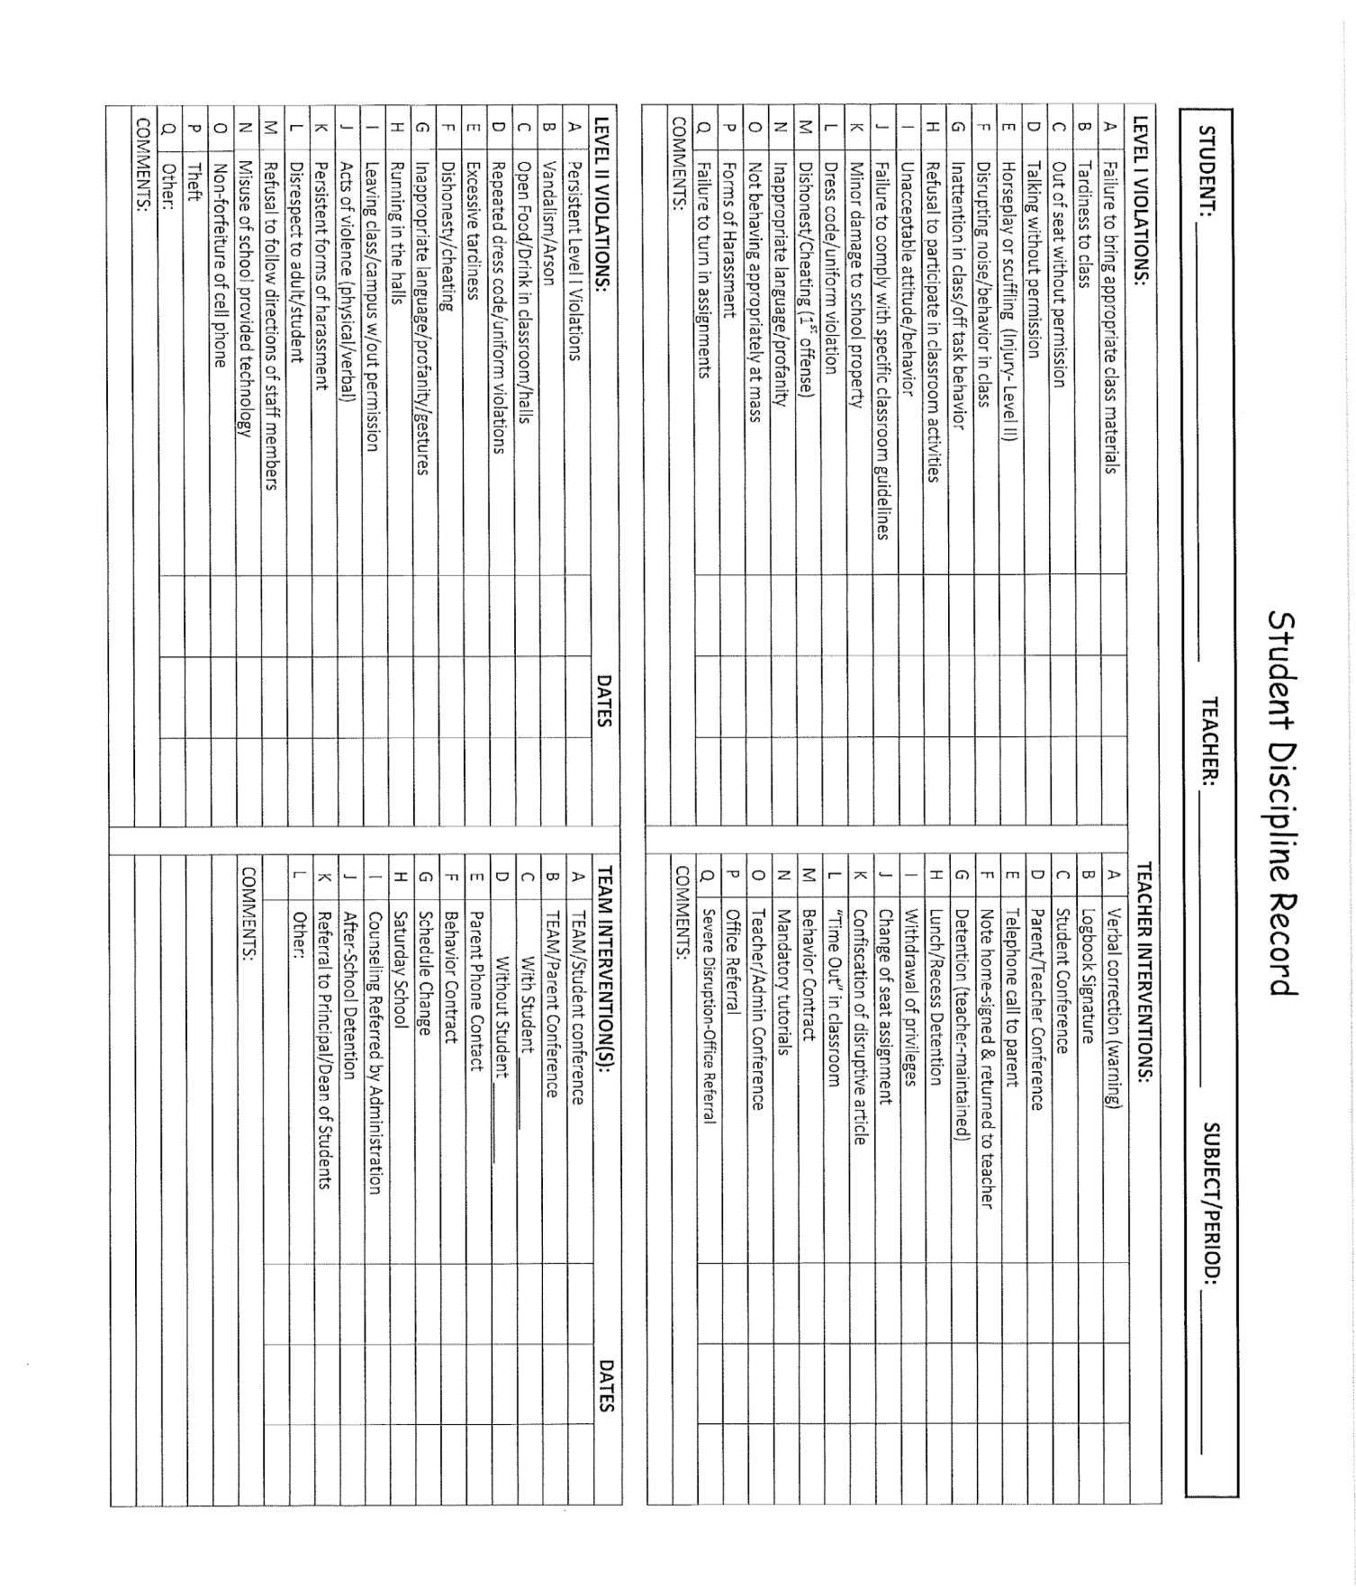

Academic Honesty
Students at Sts. Peter and Paul Catholic School need to understand the importance of the virtue of integrity. They should strive to uphold the highest standards of academic honesty and be willing to provide appropriate help to their peers. It is the student’s duty to abide by the teacher’s instructions both inside and outside the classroom, and to avoid any unauthorized use of sources that could constitute cheating or plagiarism. Cheating on tests, copying homework, and all forms of plagiarism constitute serious offense against academic honesty. A student who is caught cheating will be assigned an academic penalty by the teacher and will be referred to the office.

Plagiarism
Students caught plagiarizing shall be assigned a grade of zero (0).

Copyright Law Overview
Fair use limitations on the exclusive rights of the owner of copyright is discussed and defined by Section 107 of Title 17, United States Code. Fair use of a copyrighted work is defined in part as use by reproduction in copies or by any other means “for purposes
such as … teaching (including multiple copies for classroom use), scholarship, or research, [and] is not an infringement of copyright.”

Guidelines for what is permissible and not permissible as fair use is discussed below. The information contained herein offers a basic introduction to common copyright issues for educators. It is neither comprehensive in scope nor intended to substitute for professional legal advice specific to the needs or situation of a school.
_______________________________________________________________________

Per the United State House of Representative’s Agreement on Guidelines for Classroom Copying in Not-For-Profit Educational Institutions:

The purpose of the following guidelines is to state the minimum and not the maximum standards of educational fair use under Section 107 of Title 17, United States Code. The parties agree that the conditions determining the extent of permissible copying for educational purposes may change in the future; that certain types of copying permitted under these guidelines may not be permissible in the future; and conversely that in the future other types of copying not permitted under these guidelines may be permissible under revised guidelines.

Moreover, the following statement of guidelines is not intended to limit the types of copying permitted under the standards of fair use under judicial decision and which are stated in Section 107 of the Copyright Revision Bill. There may be instances in which copying which does not fall within the guidelines stated below may nonetheless be permitted under the criteria of fair use.

Guidelines with respect to books and periodicals.

I. Single Copying for Teachers
A teacher may copy for the purpose of research, use in teaching or preparation for teaching any of the following:
A. A chapter from a book
B. An article from a periodical or newspaper
C. A short story, short essay, or short poem, whether or not from a collective work
D. A chart, graph, diagram, drawing, cartoon, or picture from a book, periodical or newspaper.
II. Multiple Copies for Classroom Use
Copying in multiple units for student use in a classroom setting (not to exceed in any event more than one copy per student in a class) is allowed provided that certain tests are met.
1) The copying must meet the brevity and spontaneity tests as explained below and,
2) Meets the cumulative effect test, also explained below, and
3) Each copy must include a notice of copyright (i.e., contain the name of the copyright holder and copyright date).
The tests for brevity, spontaneity and cumulative effect are extremely specific and each instance of copying must meet ALL three criteria.
Definitions:
Brevity
i. Poetry: (a) A complete poem if less than 250 words and if printed on not more than two pages or, (b) from a longer poem, an excerpt of not more than 250 words.

ii. Prose: (a) Either a complete article, story or essay of less than 2,500 words, or (b) an excerpt from any prose work of not more than 1,000 words or 10% of the work, whichever is less, but in any event a minimum of 500 words. (Each of the numerical limits stated in i. and ii. may be expanded to permit the completion of an unfinished line of a poem or of an unfinished prose paragraph.)

iii. Illustration: One chart, graph, diagram, drawing, cartoon or picture per book or per periodical issue.

iv. “Special” works: Certain works in poetry, prose or in “poetic prose” which often combine language with illustrations and which are intended sometimes for children and at other times for a more general audience fall short of 2,500 words in their entirety. Paragraph ii. above notwithstanding such “special works” may not be reproduced in their entirety; however, an excerpt comprising not more than two of the published pages of such special work and containing not more than 10% of the words found in the text thereof, may be reproduced.

Spontaneity
i. The copying is at the instance and inspiration of the individual teacher, and

ii. The inspiration and decision to use the work and the moment of its use for maximum teaching effectiveness are so close in time that it would be unreasonable to expect a timely reply to a request for permission.

Cumulative Effect
i. The copying of the material is for only one course in the school in which the copies are made.

ii. Not more than one short poem, article, story, essay or two excerpts may be copied from the same author, nor more than three from the same collective work or periodical volume during one class term.

iii. There shall not be more than nine instances of such multiple copying for one course during one class term. (The limitations stated in ii. and iii. above shall not apply to current news periodicals and newspapers and current news sections of other periodicals.)

III. Prohibitions as to I and II Above
Notwithstanding any of the above, the following shall be prohibited:
- Copying shall not be used to create or to replace or substitute for anthologies, compilations or collective works. Such replacement or substitution may occur whether copies of various works or excerpts therefrom are accumulated or reproduced and used separately.

- There shall be no copying of or from works intended to be “consumable” in the course of study or of teaching. These include workbooks, exercises, standardized tests and test booklets and answer sheets and like consumable material.

C. Copying shall not:
a. substitute for the purchase of books, publishers' reprints or periodicals;
b. be directed by higher authority;
c. be repeated with respect to the same item by the same teacher from term to term.

D. No charge shall be made to the student beyond the actual cost of the photocopying.

Agreed March 19, 1976.
Ad Hoc Committee on Copyright Law Revision:  By Sheldon Elliott Steinbach. | Author-Publisher Group:  Authors League of America:  By Irwin Karp, Counsel. | Association of American Publishers, Inc  By Alexander C. Hoffman,  Chairman,Copyright Committee.

.:

Copyright and Audiovisual Materials (e.g., movies or music) in the Classroom

Limitations on the exclusive rights of the owner of copyright in the cases of “performances and displays” is discussed and defined by Section 110 of Title 17, United States Code. The following is not considered infringement of copyright: “performance or display of a work by instructors or pupils in the course of face-to-face teaching activities of a nonprofit educational institution, in a classroom or similar place devoted to instruction, unless, in the case of a motion picture or other audiovisual work, the performance, or the display of individual images, is given by means of a copy that was not lawfully made under this title, and that the person responsible for the performance knew or had reason to believe was not lawfully made.” 17 U.S. Code § 110 (1).

Said in a different way, to qualify for this exemption, the work must: be shown in a classroom (“or similar place devoted to instruction”). The teacher must be there in person, engaged in face-to-face teaching activities and be at a non-profit educational institution.

If these conditions are met then the exemption gives both teachers and students broad rights to perform or display any works. Teachers can play movies and music at any length for their students. Teachers can show students images, or original artworks. Students can perform arias, read poems, and act out scenes.

Copies personally owned by school staff or students may be used as long as the copies were legally obtained. Rented materials and items carrying the designation “for home use only” may also be used as long as they meet all conditions noted above.

Schools must purchase public performance rights to use audiovisual materials, including movies and videos, for any non-instructional purpose.

Some practices which are never acceptable with film or video include:
- making an anthology or collection from clips or excerpts;
- transferring the work to another medium; and
- using a program for recreation or reward without acquiring public performance rights.
A copyrighted work cannot be adapted or altered without permission. For example, taking an artist’s illustration, a cartoon character, a cartoon, or other graphic material and modifying, enlarging, or otherwise altering it for bulletin boards, posters, wall decorations, etc., is not allowed without previous written permission.

Common Practices That Violate Copyright Law

A teacher copies pages from a consumable workbook, sample test, etc. This violates “the effect of the use upon the potential market for or value of the copyrighted work.”

A teacher copies a poem, article, short story, or other print item for use every semester. This violates the test for “spontaneity.” The first time a teacher comes across this item, sees it as a valuable addition to the work students are currently doing, and wants to reproduce a copy, s/he is within the law. If that teacher plans to use the item in future classes, a reasonable time is assumed to acquire permission from the copyright holder.

A teacher collects stories, poems, articles, etc. and then combines them in a notebook for classroom use. This violates one of the specific prohibitions regarding print materials, which prohibits the creation of “anthologies or compilations of collective works.”

A librarian notices that a television program relates to a class that one of the teachers at her school will be conducting. The librarian records the program knowing that the teacher will be thrilled at this addition to her course. This violates the stipulation that applies to video reproduction and specifies that the teacher must request that a program be taped.

All of the students in grade four returned their library books on time for an entire semester. The librarian and fourth grade teachers felt that this warranted a special reward. They rented the movie The Lion King to show on Friday afternoon but the school has not acquired a public performance license. Without such a license, entertainment, incentive, or reward viewing is strictly prohibited.

How to Get Permission to Use Copyrighted Materials

The first step is to identify the copyright holder(s). Some works, especially those in the arts and music often have multiple layers of copyright. You must then contact the copyright holder or holders and request permission for all the specific purposes you intend to use the copyrighted material in your classroom, school performance, etc. You can contact the authors or creators directly or you can go through a clearinghouse.

It is recommended that you keep written documentation for all requests and responses. It is also recommended that you do not ask for “blanket permission” to copy or use the material.

Liability for Copyright Infringement

Penalties for copyright infringement are not a minor inconvenience. The copyright owner may be entitled to damages such as actual damages, loss of profit, and statutory damages as a result of someone, whether an individual, school or parish, who has infringed upon their rights as the copyright owner.

Notification of Disciplinary Action

Parents or guardians will normally be notified of a disciplinary action via an e-mail from the school’s RenWeb school management software. The e-mail will be generated by a staff member to document an incident and notify the parent or guardian. Generally, the nature of the violation, any details deemed relevant, and the consequence assigned to the student will be communicated to the parent or guardian. Parents and guardians
should monitor their email accounts for important school communications. Parents should also review weekly behavior sheets that come home at the different grade levels.

In-School Suspension
A student who is assigned in-school suspension (ISS) will be placed in isolation from the rest of the student body where he or she will continue to work on his or her assignments. Students should bring all the books and supplies they need to complete their assignments to in-school suspension. Students who are deliberately disruptive or do not cooperate with the monitor, will face further disciplinary action.

A student who is serving a suspension or assigned to in-school suspension is not eligible to participate in practice for or compete with any school-sponsored sports team or extracurricular activity that day. The burden of notifying the coach rests on the student. Failure to notify the coach and participating in one of these activities will result in further disciplinary action, including possible suspension from the extracurricular activity for the rest of the season.

Disciplinary Probation
The Principal of Sts. Peter and Paul Catholic School may, at his or her discretion, place a student on disciplinary probation. In such cases, the parent or guardian of the student will be notified that the student has been placed on disciplinary probation. This probation means that any further serious disciplinary action might result in the principal initiating the process to expel the student. The student’s status will be reviewed at the end of the school year to determine whether the school deems it beneficial to allow the student to register for the coming school year. Students on disciplinary probation will be considered and dealt with on an individual basis. Students who have been suspended or assigned an in-school suspension are automatically placed on disciplinary probation for the rest of the school year.

Suspension
Suspension, the temporary prohibition of a student’s attendance, for three school days or less, will be within the jurisdiction of the principal. Parents or guardian(s) must be officially notified in advance. The principal is responsible for deciding whether the suspension is in school or off-campus. Students who have been suspended or assigned an in-school suspension are automatically placed on disciplinary probation for the rest of the school year.

Expulsion
Expulsion, the permanent termination of a student’s enrollment, is a serious act that occurs when other means of discipline have failed or not been sufficient to address the disruption to the learning environment caused by a student’s behavior

A student may be immediately expelled from school for certain very serious reasons and / or after a single violation if, despite his or her previous disciplinary history, the student’s continued presence in the school would be deemed to seriously hamper the school in fulfilling its obligation to other students.

Expulsion is a serious matter and should be invoked only as a last resort. Normally, it will follow a single grave offense or a series of offenses that indicate a hostile attitude towards the school’s mission. When such serious cases arise, the following procedures will be followed:

- There will be a documented conference of principal, teacher and student. If the problem cannot be resolved in this conference, the student is suspended.
- This meeting is followed by a documented conference of the principal, teacher and parent. If no solution is reached, another conference is held with the pastor or his designee present.
- The principal and pastor or his/her designee then decides to either readmit or expel the student. If readmitted, the student is placed on probation for a period of time. If the decision to expel the student is made, the Archdiocesan Superintendent of Schools is notified and given a brief explanation, in writing.

Search and Seizure
The Principal, Dean of Students, or a designee may search a student’s desk, locker, or belongings, including, but not limited to, handbags, briefcases, backpacks and other items in a student’s possession at any time.

Contraband
Sts. Peter & Paul Catholic School is a weapon free zone. It is a crime for any person, student or non-student, to carry a firearm or any other type of dangerous weapon within 1,000 feet of school property, onto a school campus or bus or at school-sponsored athletic, social, or extracurricular activities. The person who does this should be immediately reported to the police. The Principal should notify the parents/guardians of any student who is arrested for violation of this statute. 18 U.S. Code § 922 (q)(2)(A). Students should refrain from bringing unnecessary and potentially dangerous items to school. Students possessing items may have them confiscated and could be subject to further disciplinary actions. Items that are confiscated by school personnel will be sent to the office and must be picked up by a parent. Items of a clearly immoral or potentially dangerous nature will not be returned and will be disposed of by the school. Should parents wish to reclaim other confiscated items, they should be aware that the school reserves the right to dispose of confiscated items one week after the end of each semester. The school will not be held responsible for lost or damaged items.

Closed Campus

Sts. Peter and Paul Catholic School operates a closed campus. Students must remain on the school grounds and in their designated area from the time they arrive until dismissal.

Any unauthorized absence from campus during school hours is considered a serious infraction of school regulations and will be dealt with accordingly.

If it becomes necessary for a student to go home because of illness, he/she must obtain permission from the office. The office will then assume responsibility for contacting the student’s parents. All withdrawals will be made from the office – not from individual classrooms

Any appointments should be made for Saturdays, holidays, or after school hours if possible. The parent must sign the student out at the office. Any student who is signed out of school early is responsible for any class work missed.

Release of Students to a Law Enforcement Officer
The following procedures will be observed when students are released to a law enforcement officer:
- The school will verify that the person is a law enforcement officer. The officer is not required to present a warrant to speak with a student, but will be requested to wait until the student’s parents are notified and given reasonable time to come to school.
- The parents of the student will be contacted and requested to come to school to be present with the student during the interview. If a parent or guardian cannot come to school promptly, the principal or his / her designee will sit in during the interview, in loco parentis.
- An officer must present a warrant for arrest before removing the student from the school. An exception to this general rule exists, if the student has been involved in some suspected illegal activity immediately prior to the officer’s arrival on campus, or while the officer is present. In either case, the principal will contact the parent or guardian to come to school. If the parent or guardian cannot come to school, the principal or designee will accompany the student.
- The Pastor of Sts. Peter and Paul Catholic School and the Superintendent of Schools for the Archdiocese of San Antonio will be contacted immediately if a student is arrested.

Pregnant Students
The principal, in consultation with the pastor, reserves the right to review individual decisions regarding a pregnant student’s continued attendance at Sts. Peter and Paul Catholic School. Upon verification by a physician that a student is pregnant, she and her parents must schedule a conference with the principal. The father of the child, if he is a student in the school must do the same.

The primary purpose of Catholic education is to guide students’ growth in Christian values and moral conduct. Catholic teaching stresses that the body is the temple of the Holy Spirit and that the sanctity of family life is enhanced through the fulfillment of God’s plan as expressed by a loving and permanent commitment. Premarital sexual activity is contrary to these values. However, when a pregnancy occurs outside of marriage, the total school community seeks to offer support to the pregnant student and the student father so that the pregnancy can be brought to term. The reality of the situation, in all of its dimensions, is to be treated in a Christian and humane manner.

In order to insure the best interests of the students, parents and the school community, the following guidelines will be implemented:

When school personnel becomes aware of the pregnancy, the principal must meet with the pregnant student and her parent or guardian. The student must receive appropriate professional counseling that is consistent with Catholic teaching.

If the father-to-be is a student, he will be dealt with in precisely the same manner.

The school will assist the pregnant student in completing her education by either allowing her to continue attending classes or by referring her to an appropriate alternative program. If the student is to remain in school, she will be allowed, with a doctor’s written approval, to participate in all activities to the extent that her condition and the common good of the school dictate.

If the student desires to return to the school after the birth of the child, the school will facilitate her continuance only with appropriate documentation from a healthcare provider.

Abortion
Abortion, which disregards innocent human life, is incompatible with and contradictory to the fundamental teachings of the Church, the mission of the Catholic school, and the values that ought to permeate Catholic education. Catholic teaching does not accept that anyone may justifiably arrange for or procure an abortion for oneself or for another person, be forced or pressured into having an abortion or influence or coerce another person to have an abortion.

Therefore, the involvement of any student in procuring or assisting in the procurement of an abortion is cause for such student to be dismissed from school.

If it becomes known to any member of the school community that a student is contemplating or planning an abortion, all reasonable encouragement must be given to the student to save the life of her unborn child. In all circumstances, the mother of the unborn child must be treated with respect.

Harassment
Sts. Peter and Paul Catholic School does not condone harassment of any kind, including, but not limited to physical harassment, verbal harassment, and sexual harassment. All students at our school are to be treated with dignity and respect.

Sexual harassment is defined as unwelcome sexual advances, requests for sexual favors, and other verbal or physical conduct of a sexual nature, when:
- Submission to such conduct is made either explicitly or implicitly a term or condition of a student's academic success or achievement of any other nature.
- Submission to or rejection of such conduct by an individual is used as the basis for decisions affecting the student
- Such conduct has the purpose or effect of unreasonable interference with a student's school performance or of creating an intimidating, hostile, or offensive school environment.
Verbal harassment includes derogatory remarks, jokes, or slurs, and can include belligerent or threatening words spoken to another.
Physical harassment includes unwarranted physical touching, contact, assault, deliberate impeding or blocking movements, or any intimidating interference with normal school work or movement.

It is the responsibility of every student to:
- Conduct himself or herself in a manner that contributes to a positive school environment.
- Avoid any activity that may be considered discriminatory, intimidating, or harassing.
- Consider immediately informing anyone harassing him or her that the behavior is offensive and unwelcome.
- Report all incidents of discrimination or harassment to the Principal, Dean of Students or other school personnel.
- Discontinue any personal conduct that he or she has been notified as being perceived as engaging in discriminatory, intimidating, harassing or unwelcome conduct. The student is subject to detention or other disciplinary measures.

Investigating Claims of Harassment
The following procedures are followed for filing and investigating any harassment claim:
- The person chooses to tell the individual causing the harassment that the conduct is offensive and must stop. If the objectionable behavior does not cease immediately, the person must report the harassment to the Principal.
- If the complaint is against the Principal, the person reports the incident to the Pastor or the Superintendent of Catholic Schools.
- As soon as the verbal report has been given, the school reports the incident to the Parent and Superintendent of Catholic Schools.
- The person alleging harassment is asked to complete a formal, written complaint. The claim is investigated thoroughly, involving only the necessary parties. Confidentiality is maintained as much as possible. The investigation includes a meeting with the person alleged to have harassed, sharing with that person the nature of the allegations and the name of the person bringing the allegation.
- When the facts of the case have been gathered, the Principal, in consultation with the Pastor and Superintendent of Catholic Schools, decide what, if any, disciplinary action is warranted. The disciplinary action relates to the nature, context, and seriousness of the harassment and includes disciplinary actions up to and including expulsion.
- If the complaint is against a non-employee such as a parent, parishioner, volunteer or vendor, the school takes steps, within its limited power, to investigate and eliminate the problem.

Substance Abuse Policy
Students may not possess, use, or attempt to possess, or be under the influence of any of the following substances on school premises during any school term or off school premises at a school-related activity, function, and event:
- Any controlled substance or dangerous drug as defined by law, including but not limited to marijuana, any narcotic drug, hallucinogen, stimulant, depressant, amphetamine, or barbiturate
- Alcohol or any alcoholic beverage
- Any glue, aerosol paint, or any other volatile chemical substance for inhalation
- Any other intoxicant, or mood-changing, mind-altering, or behavior-altering drug

A student caught using, distributing, or possessing any forbidden substances will be expelled from Sts. Peter and Paul Catholic School. Further, the student could be reported to the authorities.

Definitions
"USE" means a student has smoked, ingested, injected, imbibed, inhaled, drunk, or otherwise taken internally a prohibited substance recently enough that it is detectable by the student's physical appearance, actions, breath, and speech.
"UNDER THE INFLUENCE" means a student's faculties are noticeably impaired, but the student need not be legally intoxicated.
Students who violate the Student Standards of Conduct policy are subject to disciplinary action including expulsion. Lockers and other personal property may be searched by administration at any time.

PARENT PARTICIPATION
All volunteers who want to assist with school activities MAY NOT ASSIST on campus in anyway until they have completed OVASE (Office of Victim and Safe Environment) training, a Criminal Background Check and have signed and returned the Code Of Conduct Acknowledgement form (which is located at the end of the Parent/Student handbook) as required by the Archdiocese of San Antonio.

To register for this training
- Go to archsa.org
- Click on the Child Protection page
- Click on the Safe Environment Training tab
- Click on the Protecting God’s Children link
- Create a login and password
- Enter your personal information
- Select your ministry location
- Select any alternate locations
- Select your ministry and identify your position
- Click “No” for already attending a Virtus Protecting God’s Children
- Select a training date or scroll to the bottom and select the online option

Upon completion of the training, you will need to contact the OVASE coordinator at the school office to sign and authorize a criminal background check. Once this has been completed, you will receive a handbook from the Archdiocese of San Antonio. Your signature will be required to verify receipt.

Once training is complete and your record has been approved (within 24 hours), you will be able to print your certificate. For questions on training or on the registration process, contact the Victim Assistance & Safe Environment at (210) 734-7786 or ovase@archsa.org.

It is imperative that anyone planning to assist in campus activities complete this training

Without current OVASE training volunteers may not serve as room parents, assist in the cafeteria, open doors as students arrive on campus or do any of the other tasks that volunteers perform on campus. Once OVASE training has been completed, it is valid for three (3) years. If you have a question as to whether or not your training is up to date, please contact an Administrative Assistant.

Use of School Grounds & Buildings
Use of school grounds and buildings must be approved by the parish Facilities Manager.

FINANCIAL & SERVICE OBLIGATIONS

Tuition
The Sts. Peter & Paul Catholic School Advisory Council sets and reviews tuition rates each January for the following school year. Tuition may be paid in full by July 1st or be paid out in equal installments over ten (10) months. Families who pay their tuition in full by July 1st will receive a 3% discount per student. The first tuition payment for those families who pay in installments over ten (10) months is due July 1st. Monthly statements are sent to families, as a courtesy, but payment should not be contingent upon the receipt of a statement. It is the responsibility of the parent or guardian to pay tuition on time. If a student’s tuition or other school account is in arrears, the student may not be admitted to class on the opening day.
It is the policy of Sts. Peter & Paul Catholic School to manage tuition accounts in a fair, just and timely manner in order to ensure the financial well being of the school. Sts. Peter and Paul Catholic School has partnered with FACTS to assist the school in managing accounts receivable. All families are required to enroll in the FACTS program. If a parent has questions regarding FACTS, contact the Director of Admissions, Finance and Human Resources for information.
If a payment is returned for insufficient funds or payment is not made, monthly late fees will be accrued. Non-payment of a family’s tuition may result in the termination of a student’s enrollment and the student’s dismissal from school.
Delinquent accounts may be turned over to a collection agent or attorney to assist the school in collecting the tuition and fees owed. In this event, the parents will be held responsible for the payment of attorney’s fees and the costs associated with collecting the tuition and fees owed. Families should be aware that one avenue for the school to pursue in these cases includes sending a letter to the Internal Revenue Service (IRS) reporting the tuition as unreported income.
Mandatory Parent Teacher Club fundraisers and service hour substitution fees are considered part of a family’s tuition obligation. Failure to complete all service hours required by the school will result in a fee being charged to a family’s account. This fee is payable to the school the month following its assessment.

Registration Fees
The Sts. Peter and Paul Catholic School Advisory Council sets school fees at the same time as tuition rates. The registration fee is currently $400 per student plus a $50 per family yearly enrollment fee. A student’s admission and / or enrollment is not finalized or guaranteed until the registration fee is paid in full. Fees are utilized to forecast staffing needs, cover the cost of building maintenance, and the procuring of instructional materials. The registration fee also serves to hold a child’s place in a given class. The school will make decisions regarding the number of students it can admit to a given class based on the number of students who have paid their registration fees. All registration fees and specials fees are submitted to the school through the family’s FACTS account. The registration fee is not refundable and may not be transferred to another school.

Application fees are also non-refundable. If a student’s registration fee has not been paid, that student may not be admitted to the opening day of classes. This fee is separate and distinct from tuition. There is a $50 discount for all registration fees that are paid in full before February 28th. All registration fees must be paid in full before enrollment can be assured. Certain courses might require a fee in addition to regular school fees.

After School Care
Sts. Peter & Paul Catholic School offers After School Care (ASC) on school days from dismissal of school until 6:00 P.M. Some school holidays and teacher in-service days are also offered through the school’s ASC, provided school families demonstrate adequate interest. The principal is in charge of the After School Care program. A director has been appointed to oversee the operation of the program. Billing and the collection of all payments are charged through the family’s FACTS account.
Students registered to attend regularly are provided with a snack and are supervised for homework/study time. Young students also may have the opportunity to play on the playground with supervision. The Student Code of Conduct will be enforced during the After School Care program. Students may be removed from the After School Care program on a temporary or permanent basis based upon misconduct, failure to follow rules, or disruptive behavior.
Policies (including fees) and rules are available in the school’s registration information.
Any student who is not picked up within fifteen (15) minutes of dismissal will be sent to After School Care. The student’s parent or guardian FACTS account will be billed accordingly.

FAMILY SERVICE HOURS
Sts. Peter & Paul Catholic School administers a Service Hours program. Prior to completion of any service hours, all volunteers must have completed OVASE training in order for volunteer hours to be credited, completed a criminal background check through the Archdiocese of San Antonio and signed and returned the Code of Conduct Acknowledgement form. This program encourages parents of our school children to stay active in their child(ren)’s school life by requiring participation in activities associated with the school. Parents are needed to serve as homeroom parents, a volunteer for a day to help with classroom or teacher needs, serve as a cafeteria monitor or assist the school in other valuable ways. Parent involvement helps keep school tuition and fees low and it makes for happier and better-disciplined students. This program also helps keep parents aware of their child’s academic life and school happenings, and lends to camaraderie between parents and the staff.

Hours Required
Each St. Peter & Paul Catholic School family is required to provide a minimum of 22 service hours to the school community during each school year. Two (2) of the twenty two (22) hours must be completed by volunteering at a non related school community service and must be approved by the office. Family service hours can be earned by a parent or other family member who is 18 years of age, or older. An individual not related to the family or another school family who has service hours in excess of the required hours cannot “donate” hours to another school family. Likewise, Family Service Hours cannot be earned by students of Sts. Peter & Paul Catholic School. This program is specifically designed to encourage a parent’s participation in their child’s school activities. A family’s service hours must be completed, approved, and turned in by May 15th.

Non-Completion Fee
Families who do not complete their service hours are charged a fee of $500. (When service hours are not completed and/or the fee is not paid by the first week in June, the family loses its reserved space for the following school year). The fee will be charged according to the following weighted formula. The two Day of Service (Community) hours that are required will be valued at $50 per hour, while the remaining 20 will be valued at $20.00 per hour. In cases of extreme hardship, in which a family feels it cannot fulfill the required service hours, the reason for deferment is to be submitted to the principal in writing. No grievance or requests for deferment is heard without written submission. All grievances or deferments are decided on a case-by-case basis. All deferments are reviewed again each April 15th to determine continuation or cancellation
for the next school year. When the principal is not able to make a determination, the pastor is asked to determine.

Service Hour Logs
A master list of each family’s service hours is maintained and these service hours are logged in on a monthly basis. All service hours must be completed, approved and turned in by May 15th.
Each Sts. Peter & Paul Catholic School committee, activity, or event has a chair or person in charge. It is the parent’s responsibility to have the chairperson in charge verify and sign-off on each volunteer log following each event or activity. When volunteering in a classroom or for a teacher, the teacher is the person in charge and should verify the service hour log. If service hours are provided by assisting with cafeteria supervision, volunteers must sign in as they arrive and leave campus. The office staff will verify service hour log utilizing the campus sign in records.
All service hour sheets are turned into the school office to be logged in to each family’s account. These forms are available through the school website, at the school office and are also sent home monthly in the weekly folder. When hours worked are in dispute, the principal makes the final determination.
Each family is notified in early January of their accumulated service hours to facilitate verification. Families receive notification in April of service hour progress. Families who have earned “extra hours” cannot ‘roll over’ these hours for the next school year. The donation of hours is not permitted. In other words, service hours accrued by those who are not the parents or other family members who are eighteen (18) years of age or older will not be calculated as meeting part of a family’s service hour obligation. Donations of items are not accepted in lieu of service unless approved by the school office.

Ways to Earn Service Hours
The following are some of the ways in which service hours may be earned:
- Attendance at a general PTC Meeting (1 service hour)
- Serving on a PTC committee, sub-committee and planning meetings (1 service hour per hour of meeting time)
- Volunteer for work in a fundraising activity

All parents who serve as teachers or staff of Sts. Peter and Paul School are exempt from their service hour commitments with the exception of the 2 required Day of Service (Community) hours.

*Please note that attending a class party or contributing food for a party does not count as service hours.

*Please note that working for CYO does not count towards service hours.

*Please note that volunteering at any church does not count towards service hours.

Additional Examples of Meeting Service Hour Requirements

- Field Trip Chaperone
- Cafeteria Monitor (excluding time when eating with your child)
- Classroom Volunteer Assistance as requested by a teacher
- Booster Club Participation
- Serving on the School Council
- Scouting Activities that directly impact Sts. Peter and Paul School
- Grounds Maintenance
- Assist with school activities such as Meet the Teacher Night or Grandparents Breakfast
- First Friday Social Committee
- Catholic Schools Week Gala Committee
- Silent/Live Auction Donation Committee
- Catholic Schools Week Committees
- Used uniform sales committee
- PSIA or CAAC academic competitions
- Or other principal approved special activities

Fundraisers
Tuition is unable to cover the total cost of the quality education offered at Sts. Peter & Paul School. The Parish and School sponsors fundraisers to raise money for specific projects and general operation. Sts. Peter & Paul Parish and Sts. Peter & Paul Catholic
School partner in fundraisers to limit the number of fundraisers held. The PTC also coordinates a limited number of school fundraisers.
It continues to be important for Sts. Peter & Paul Catholic School parents to support the fundraising efforts of the school so we can ensure quality programs and services for students.

One of the schools fundraising events is the Spring Raffle. Each family is required to sell or purchase 35 raffle tickets. Any unsold raffle tickets will be charged to the families FACTS account.

FINANCIAL EXPECTATIONS

Tuition

  - Payment is due the first day of every month.
  - If a parent has not made a full payment by the end of each month FACTS will assess financial penalties.
  - If a parent still has not made a full payment by the end of the month, the following additional steps will transpire: (this includes tuition and all incidental charges)
    - The parent will be blocked from accessing their child’s grades on RenWeb.
    - The child will be restricted from participating in any extracurricular activities.
    - The family must make immediate payment of all past due amounts, or contact the principal to sign up for a 60-day payment plan to the past due balance.
    - A family’s failure to honor the terms of a written payment plan with the school will result in a student remaining out of school until balance is brought to current.
  - If a family is experiencing unusual or unforeseen financial circumstances, the parent should contact the principal.
  - If there is a question regarding refunds, please contact our Director of Admissions, Finance & Human Resources.
  - Tuition Assistance applications are available online for Hope For The Future. You have to fill out application to be eligible for Hope For The Future. Also, there is a Guardian Angel Fund available.

After School Care
- Payment is due 10 days after the invoice date.
- If full payment is not received by the 10th day, an additional $30 late fee will be assessed.
- If full payment has not been received by the end of the month, the following steps will transpire:
  - The parent must make immediate payment of all past due amounts or their child will not be allowed to utilize After School Care.
  - The parents of children who are not allowed to participate in After School Care and who leave their children unattended at school may be reported to Child Protective Services.

Cafeteria Charges
The school cafeteria offers hot, nutritious meals under contract from a third party vendor. Prices for these meals are very reasonable. The menu will be posted on the school website and copies are available in the school office. Students have the option of paying for meals in the cafeteria on a day-by-day basis or of being billed through FACTS for lunches every two weeks. If payment is not received by FACTS within 15 days of the posting of the lunch bill, the student may lose his/her charging privileges until the account is current. Milk is provided for purchase for all students, as are assorted snack items. Students need to eat lunch every day to stay healthy and alert. As always, please notify the principal if there is a special circumstance warranting exemption.

GRIEVANCES

Composition of the Grievance Committee
St. Peter & Paul Catholic School Grievance Council Composition:
- Three members appointed by the School Council.
- Individuals appointed to this Council are persons of integrity with some expertise in education, human relations, and conflict management when possible.
- One member is generally a parent or former School Council member. The other two members have no direct relationship to the school.
- The appointment to the Grievance Council is for one year and is renewable.

Duties and Process of Grievance Council
- Both parties to the grievance prepare a complete written statement of the nature of the grievance and the remedies sought. The Grievance Council reviews these statements and the procedures followed and decide if additional steps need to be taken or if it will uphold the decision of the Principal.
- If the decision of the Grievance Council is to uphold the Principal’s decision, the process moves to Number 8.
- If the decision of the Grievance Council is that an additional airing of the situation needs to take place, it calls a meeting of both parties to the grievance.
- Each party to the grievance is accompanied by one other individual who is not an attorney and who acts as observer/advisor. This individual does not directly address the Grievance Council.
- Both parties appear before the Grievance Council together and make an oral presentation of the written statements presented. The aggrieved party makes the first presentation. At no time is there cross-examination or direct discussion between parties to the grievance.
- After both presentations have been completed, the Grievance Council moves to a closed session to consider the oral and written presentations.
- The Grievance Council may recall, together, both parties to the grievance for clarification of the points that may have been raised in either of the written or oral presentations.
- The Grievance Council renders its decision in writing according to the prescribed Grievance Procedure.

Grievance Procedures for Expulsion or Termination issues
Grievances may be heard from individuals, parents and parent organizations. However, in all cases, the opportunity to be heard shall be forfeited if the procedures outlined below are not followed precisely. This policy and procedure shall apply only to instances of student expulsion and employee termination.

If there is not a satisfactory resolution of the complaint, the following are steps in the formal grievance procedure.
- Prepare a written statement of the complaint (including to initiate a grievance) to include a brief summary of the initial conference and file it with the School Council Secretary within (3) three school days of the conference, or decision resulting there from, whichever is later. The date and time of filing is recorded on the original of the complaint.
- The School Council Secretary will, within 24 hours of filing, inform and forward the grievance to the Local Grievance Council who will review the grievance. If it deems necessary, the Grievance Council may hear further statements, evidence or arguments within (7) seven school days of its receipt of the grievance. The Grievance Council will render a decision within (10) ten school days of its receipt of the grievance.
- If the aggrieved party is not satisfied with the decision of the Grievance Council, an appeal may be made to the Pastor within (3) three school days of the decision of the Grievance Council. The Pastor reviews all documentation of the grievance procedure and sets a date for hearing the grievance with all parties of the initial grievance in attendance. This meeting takes place within (7) seven school days of the Pastor’s receipt of such an appeal. The Pastor then renders his decision within (5) five school days.
- If the aggrieved party remains unsatisfied with the decision of the Pastor, the avenue of further appeal is the Archdiocesan Council of Conciliation. Such an appeal must be sent in writing within (5) five school days of the Pastor’s decision.
- Pending outcome of the formal grievance, only the Principal or Pastor may, with or without condition, abate the expulsion or termination.

Grievance Process for Non-Expulsion/Non-termination issues
Complaints that do not result in expulsion or termination are resolved at the local school level. Neither the Grievance Council nor the Archdiocesan Council of conciliation hears these matters.
There must be an attempt on the part of the individual lodging the complaint to resolve the problem at its lowest level.
- Complaints against a student for a specific incident should be addressed with the teacher prior to approaching administration.
- Complaints against a student for a history of misbehavior should be addressed with the Principal.
- Complaints against students for acts that occur outside the regular school day should be addressed with the child’s parent or guardian.
- Complaints against a teacher must be addressed with the Principal prior to approaching the Pastor.
All complaints should be made within (3) three days of the event or the point at which the parent/individual is made aware of the situation.

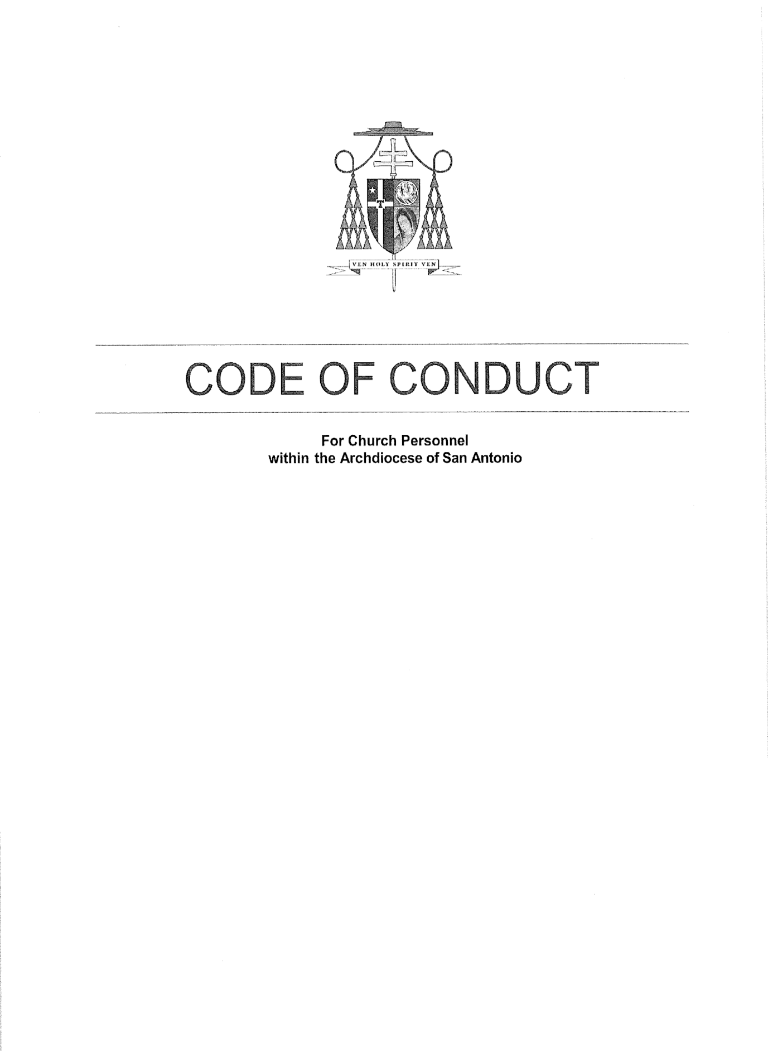
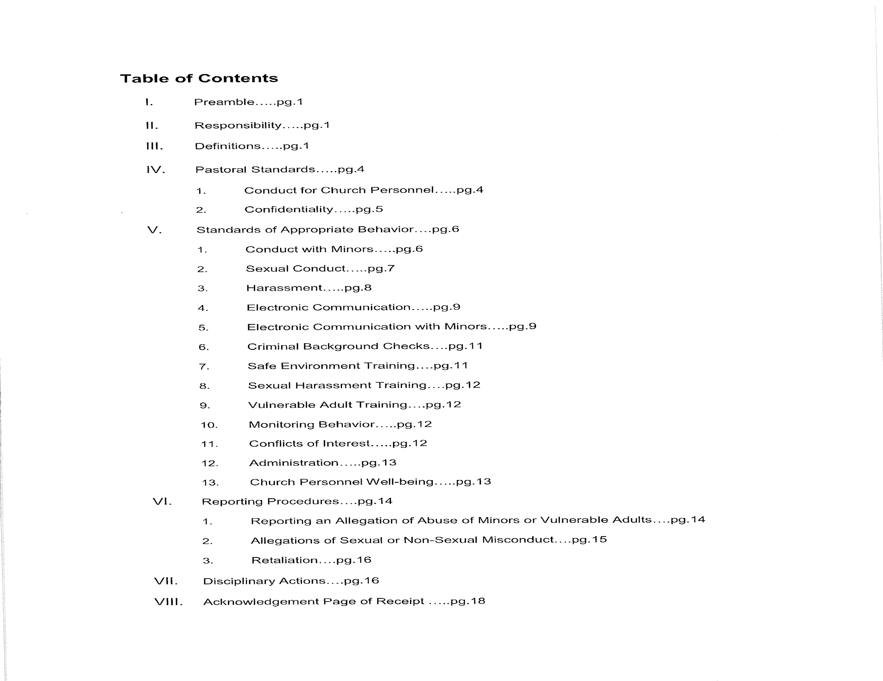

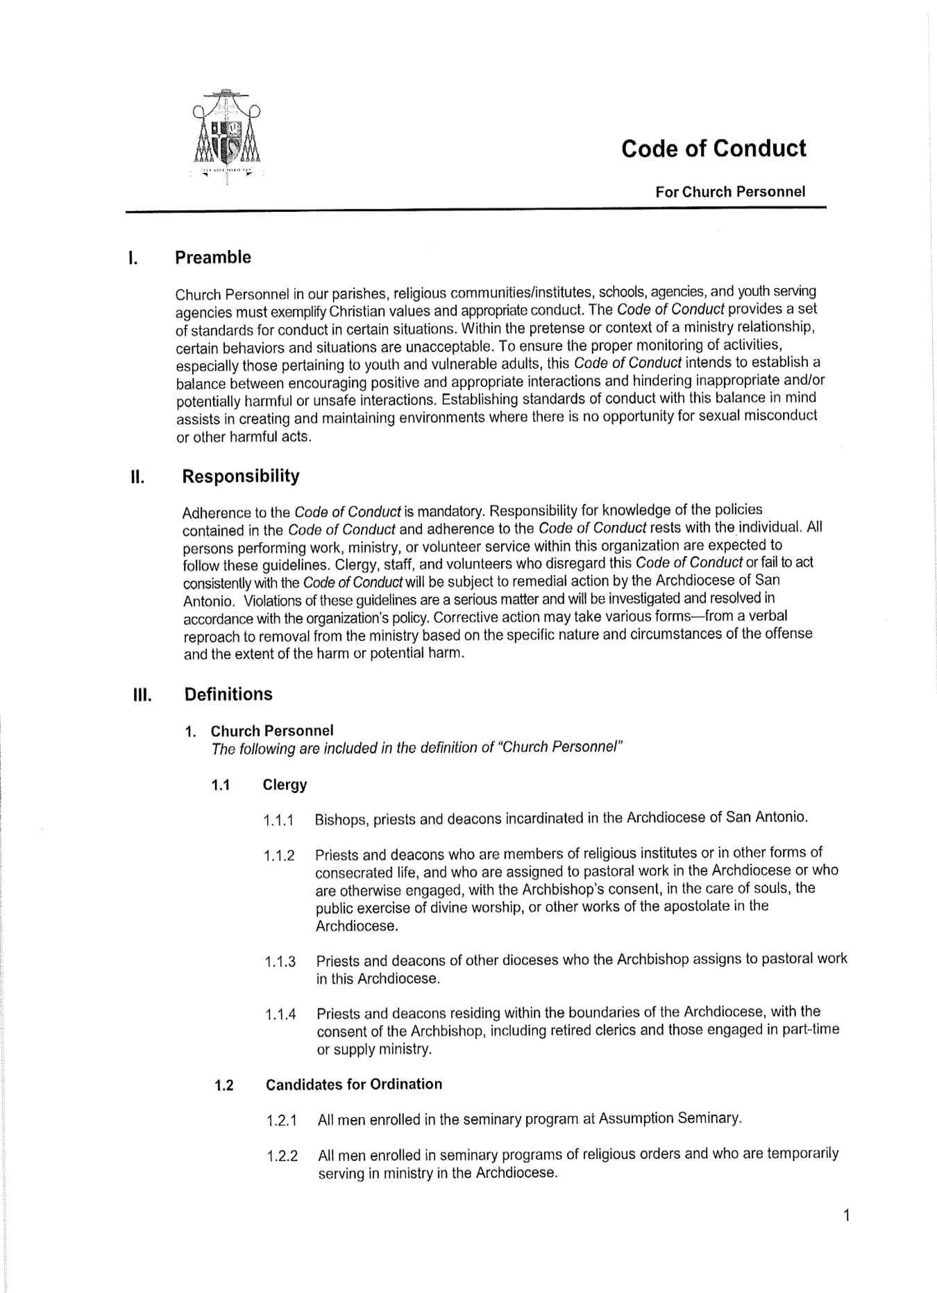

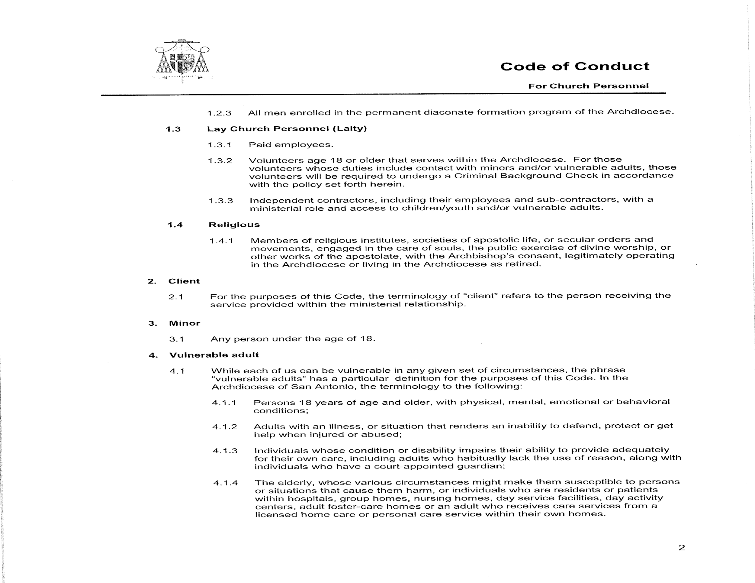

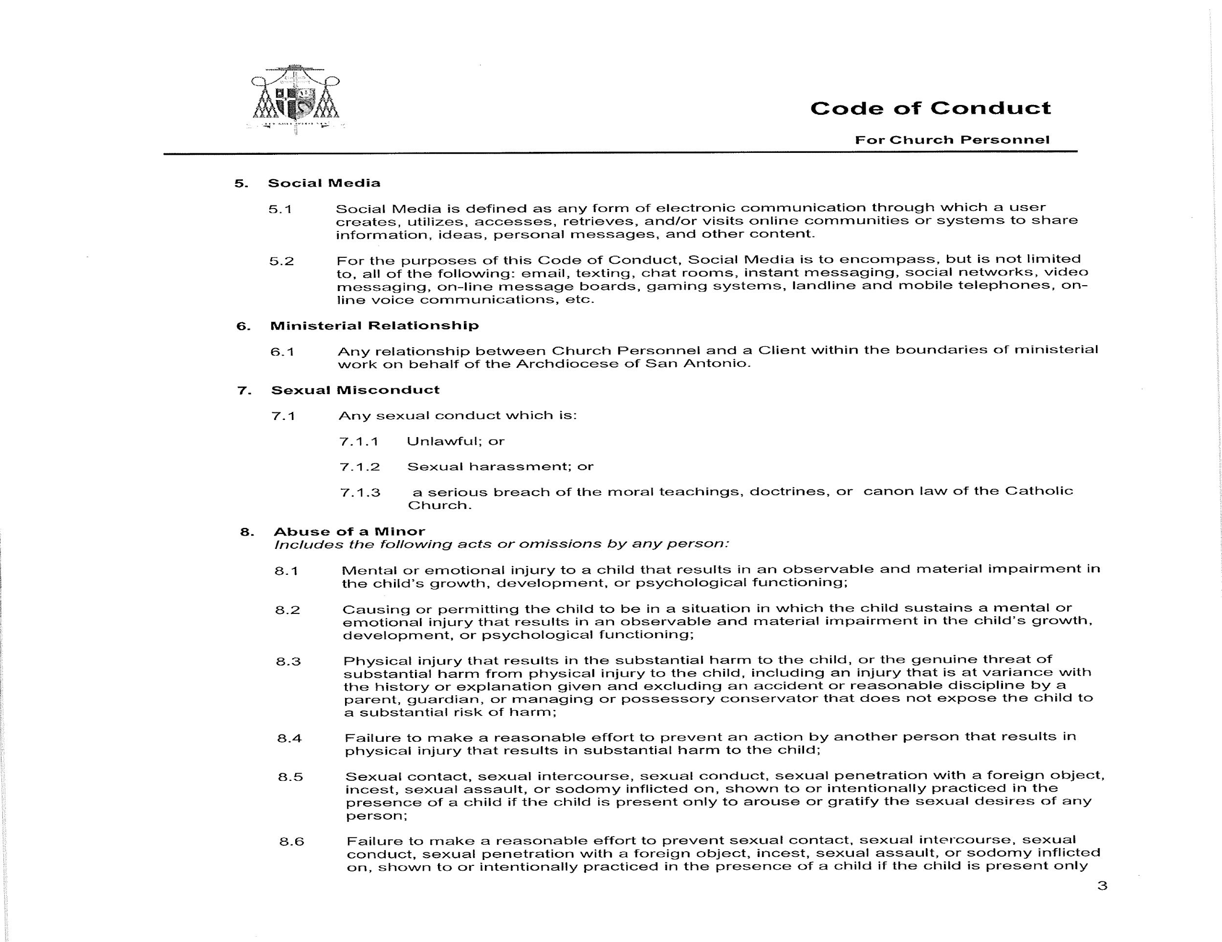

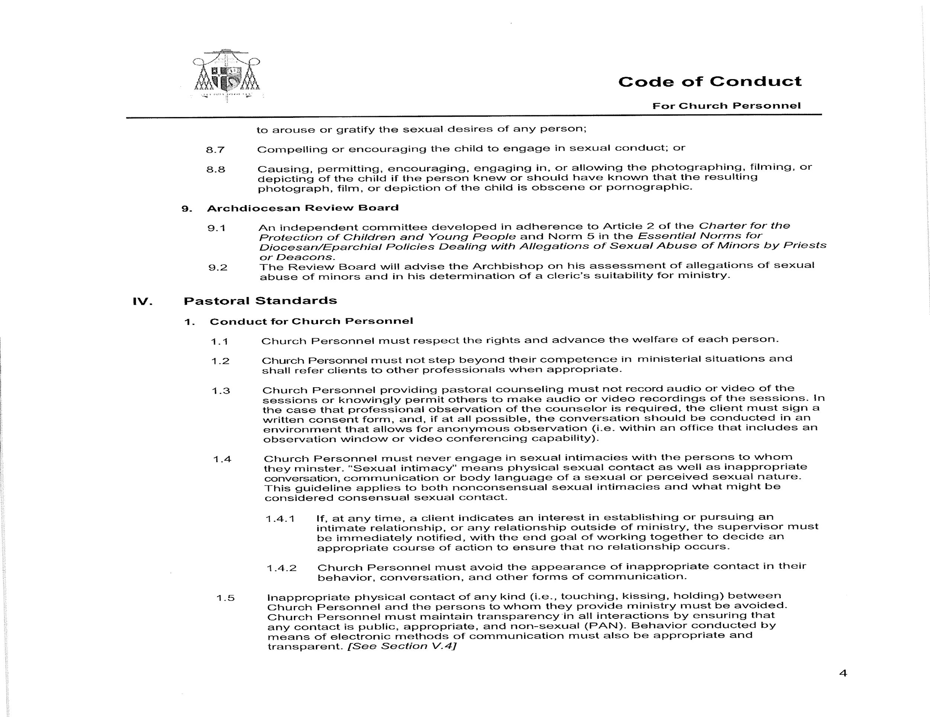

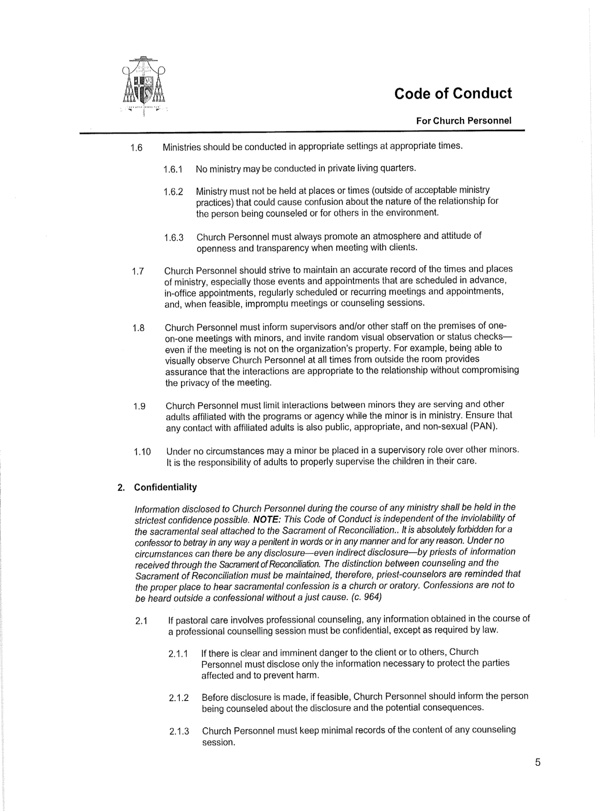

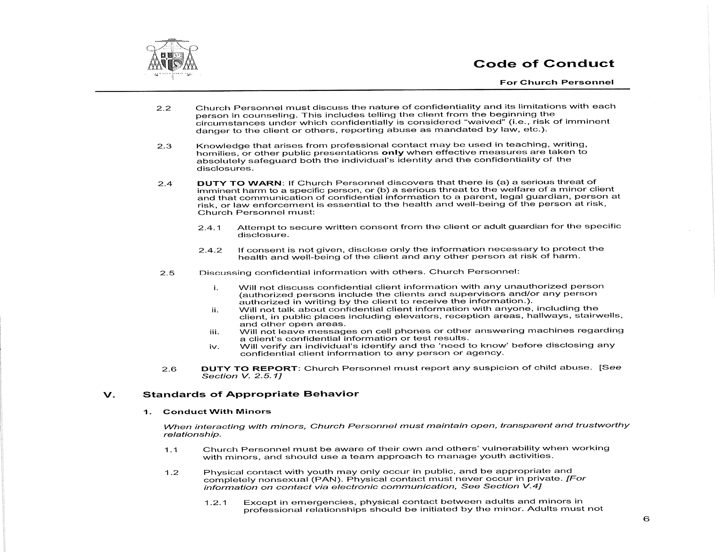

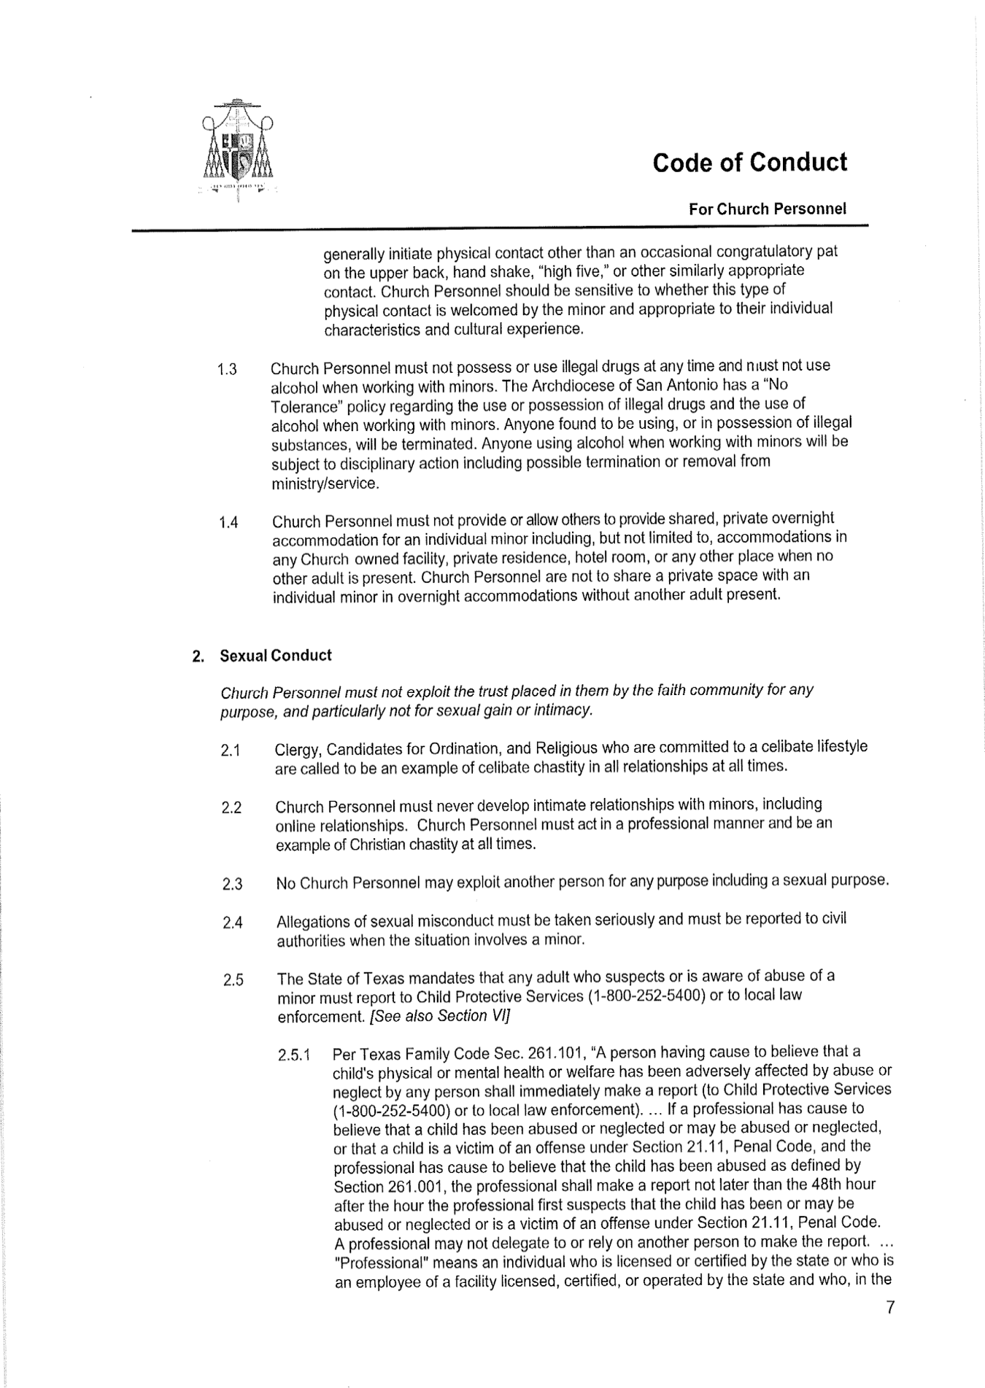

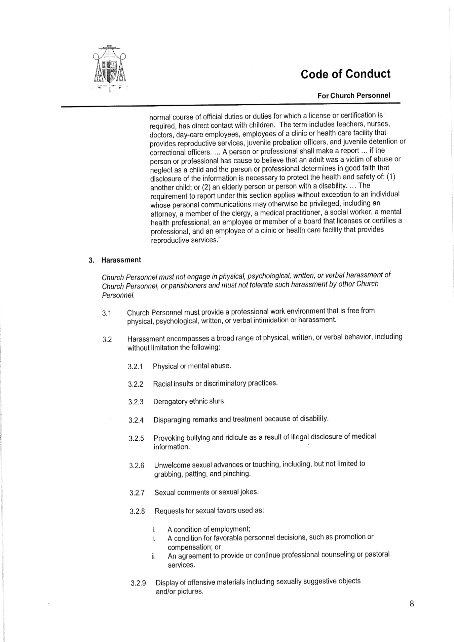
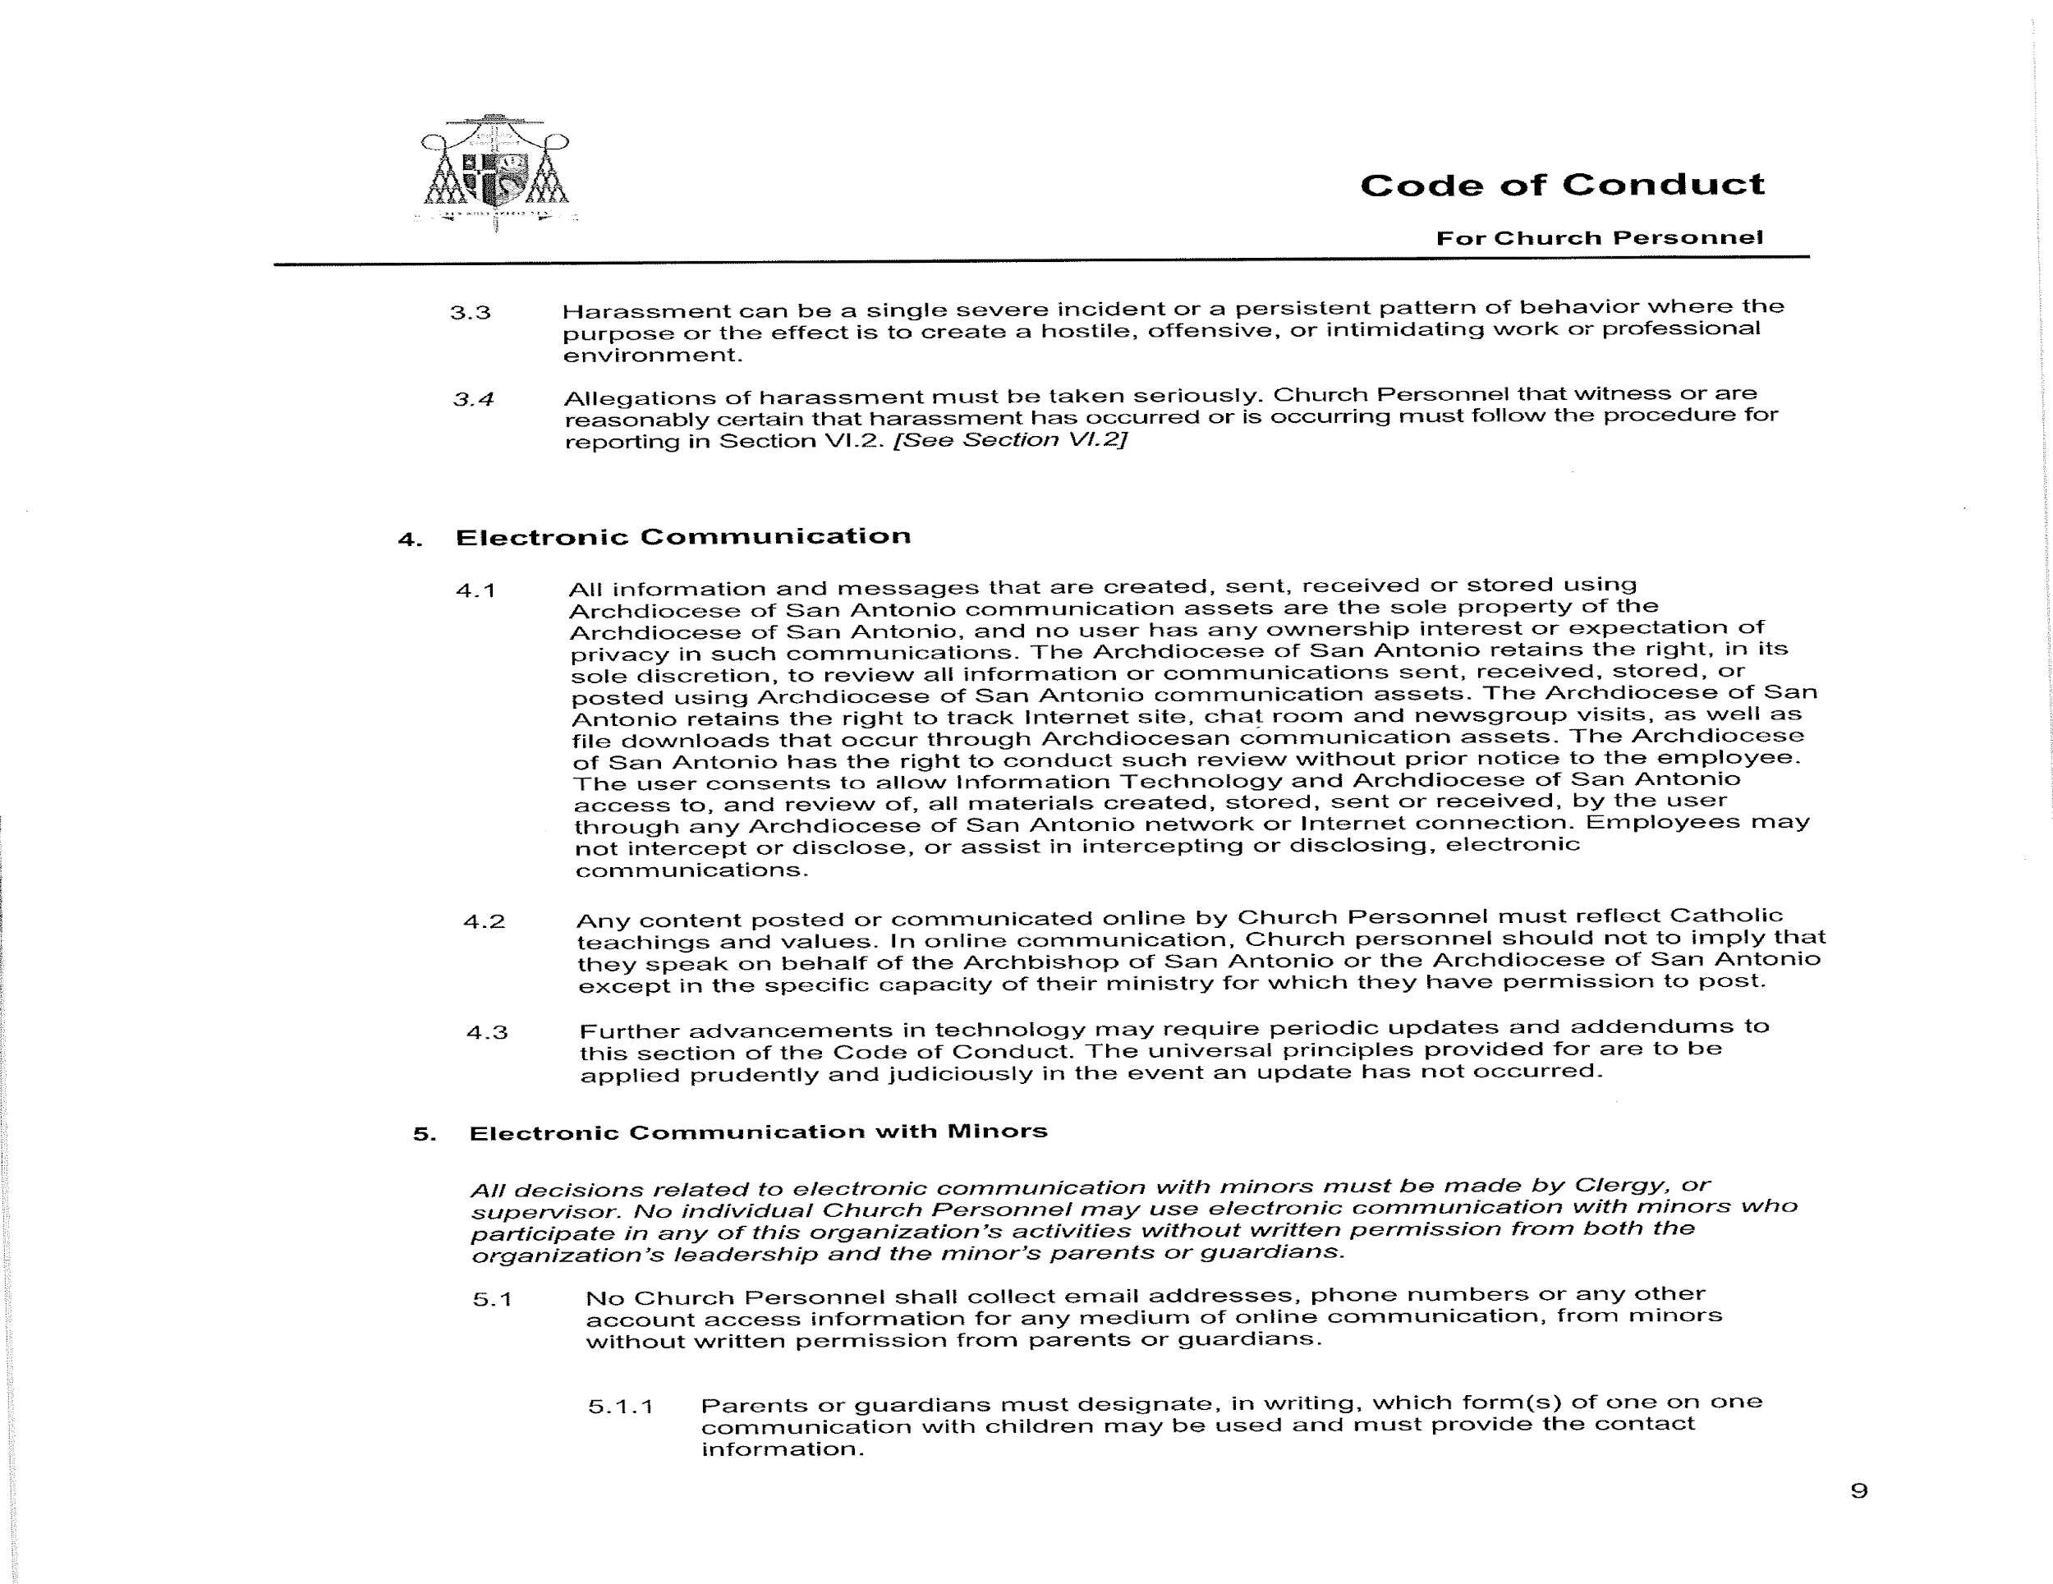
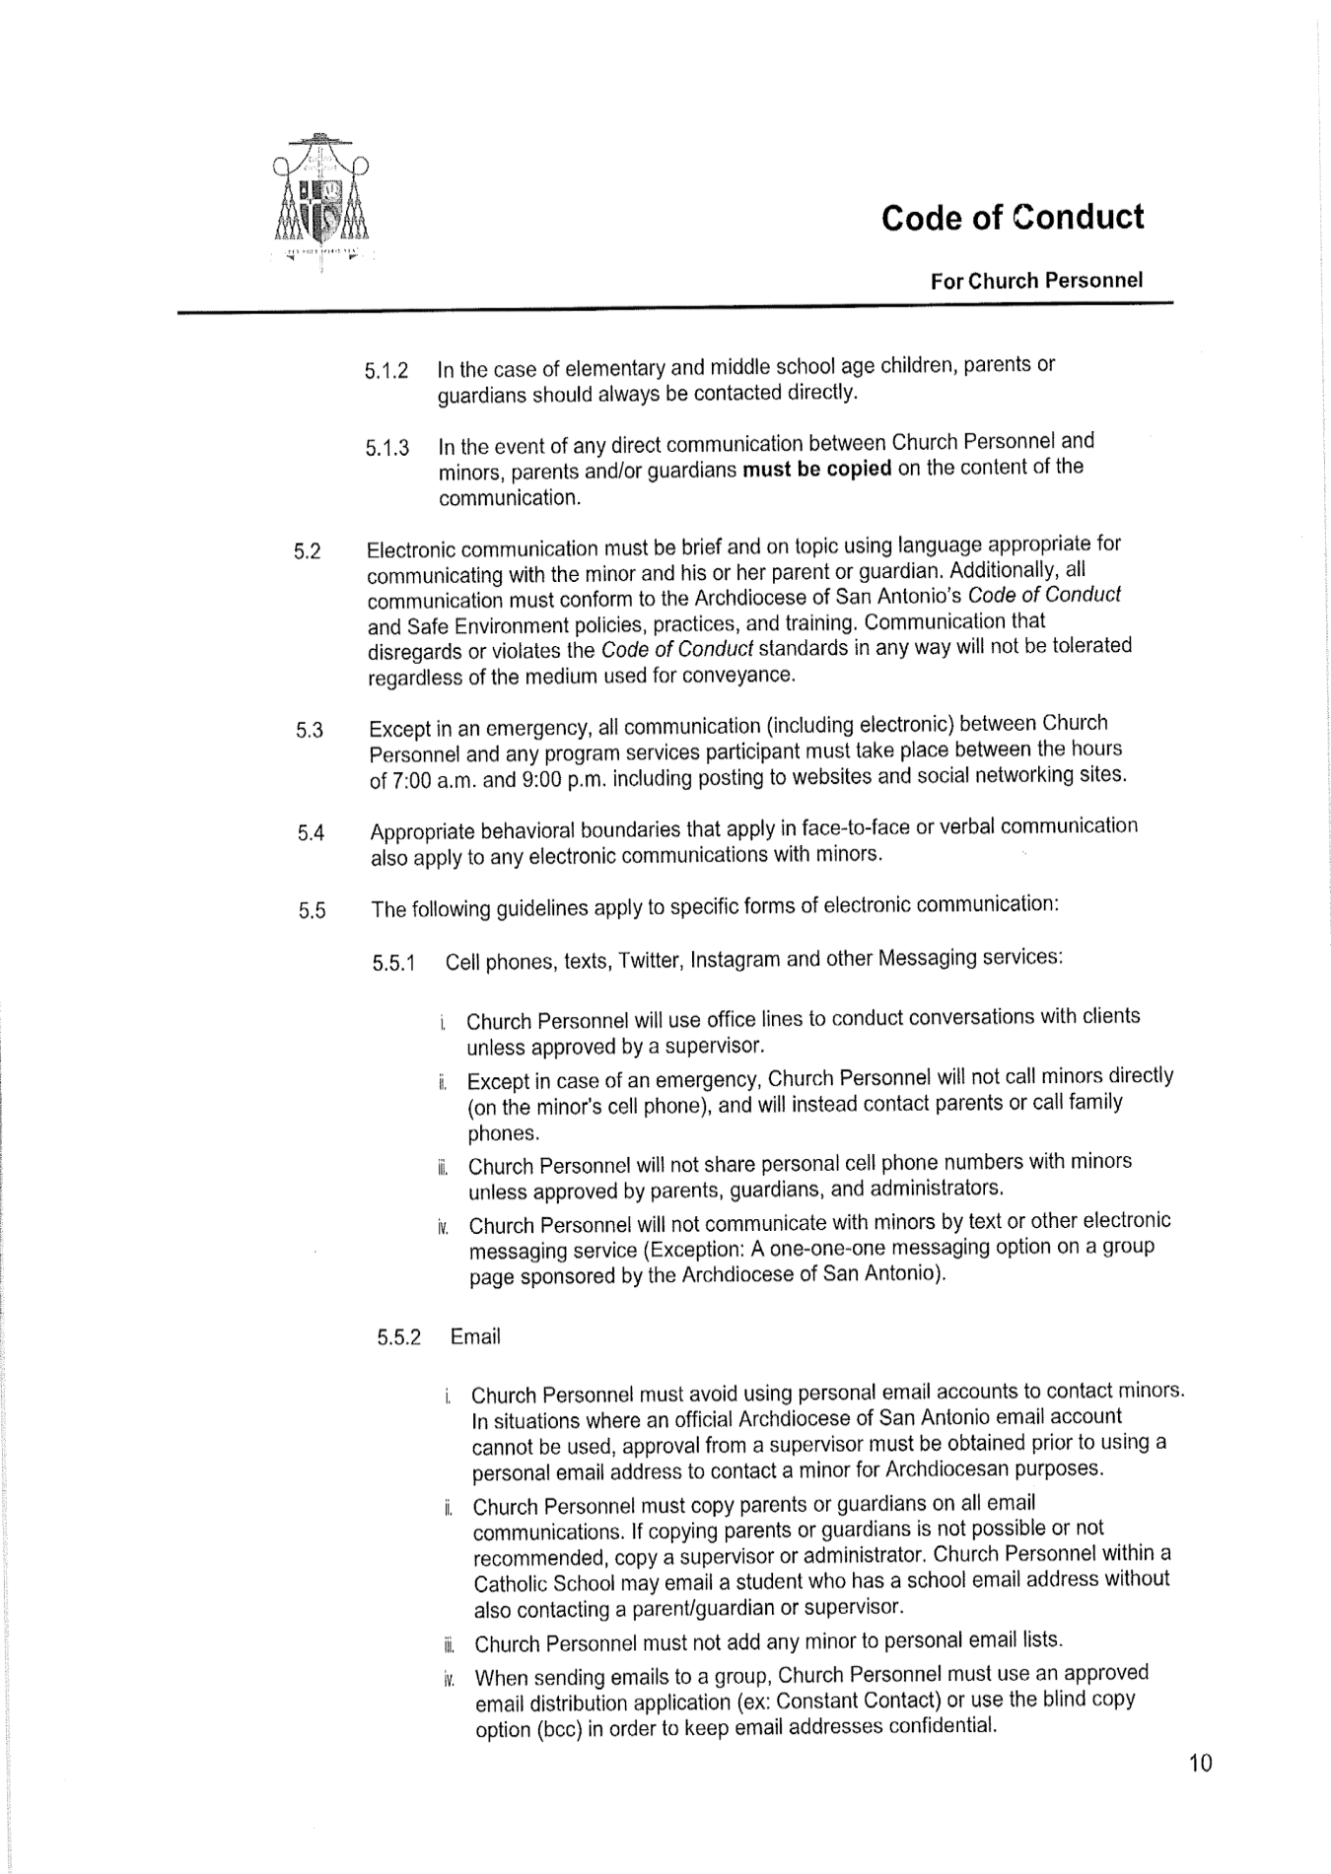
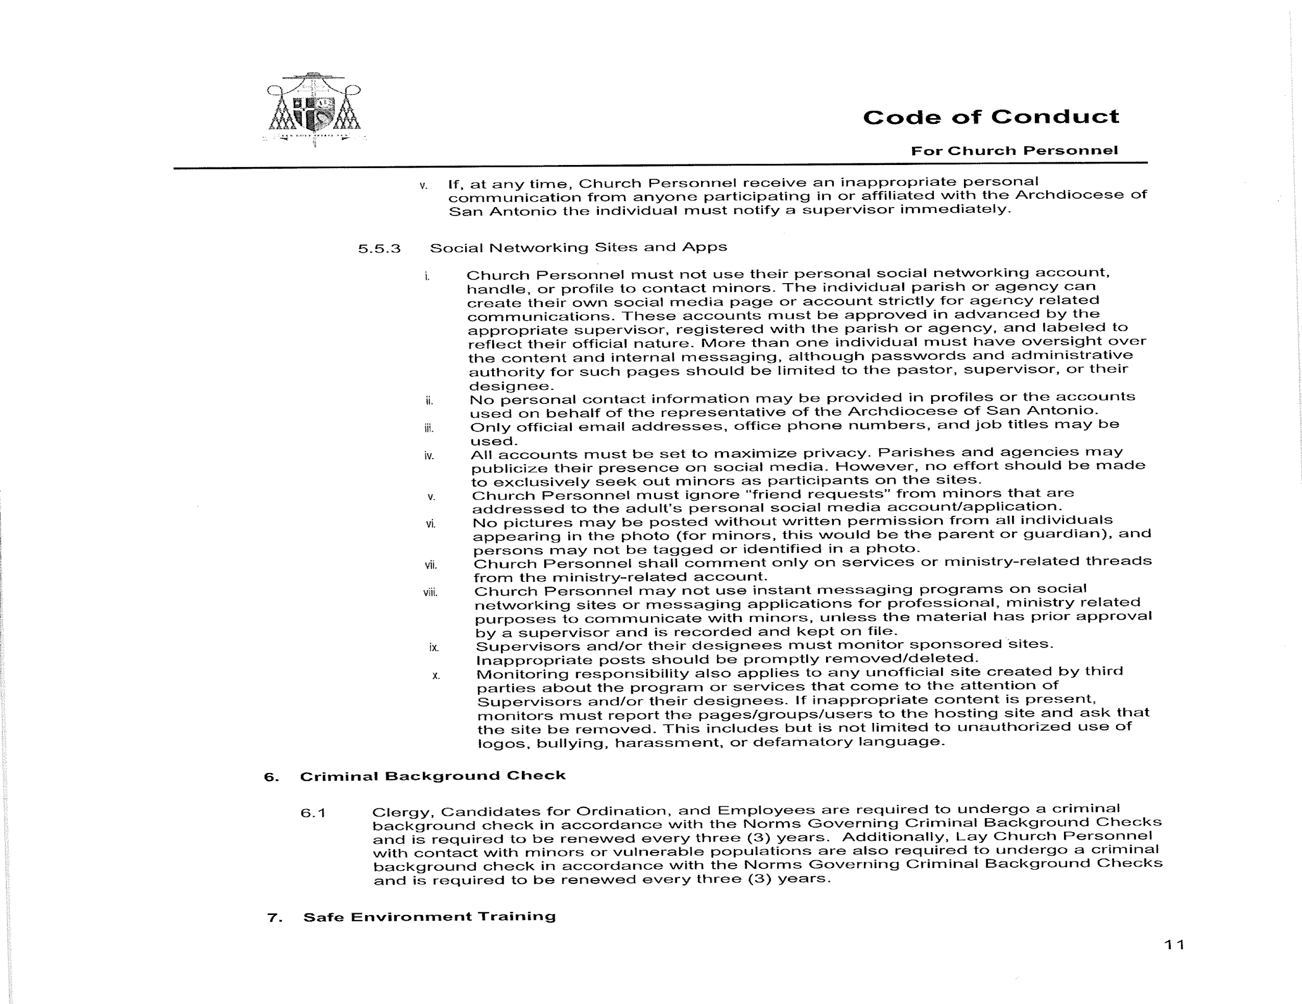
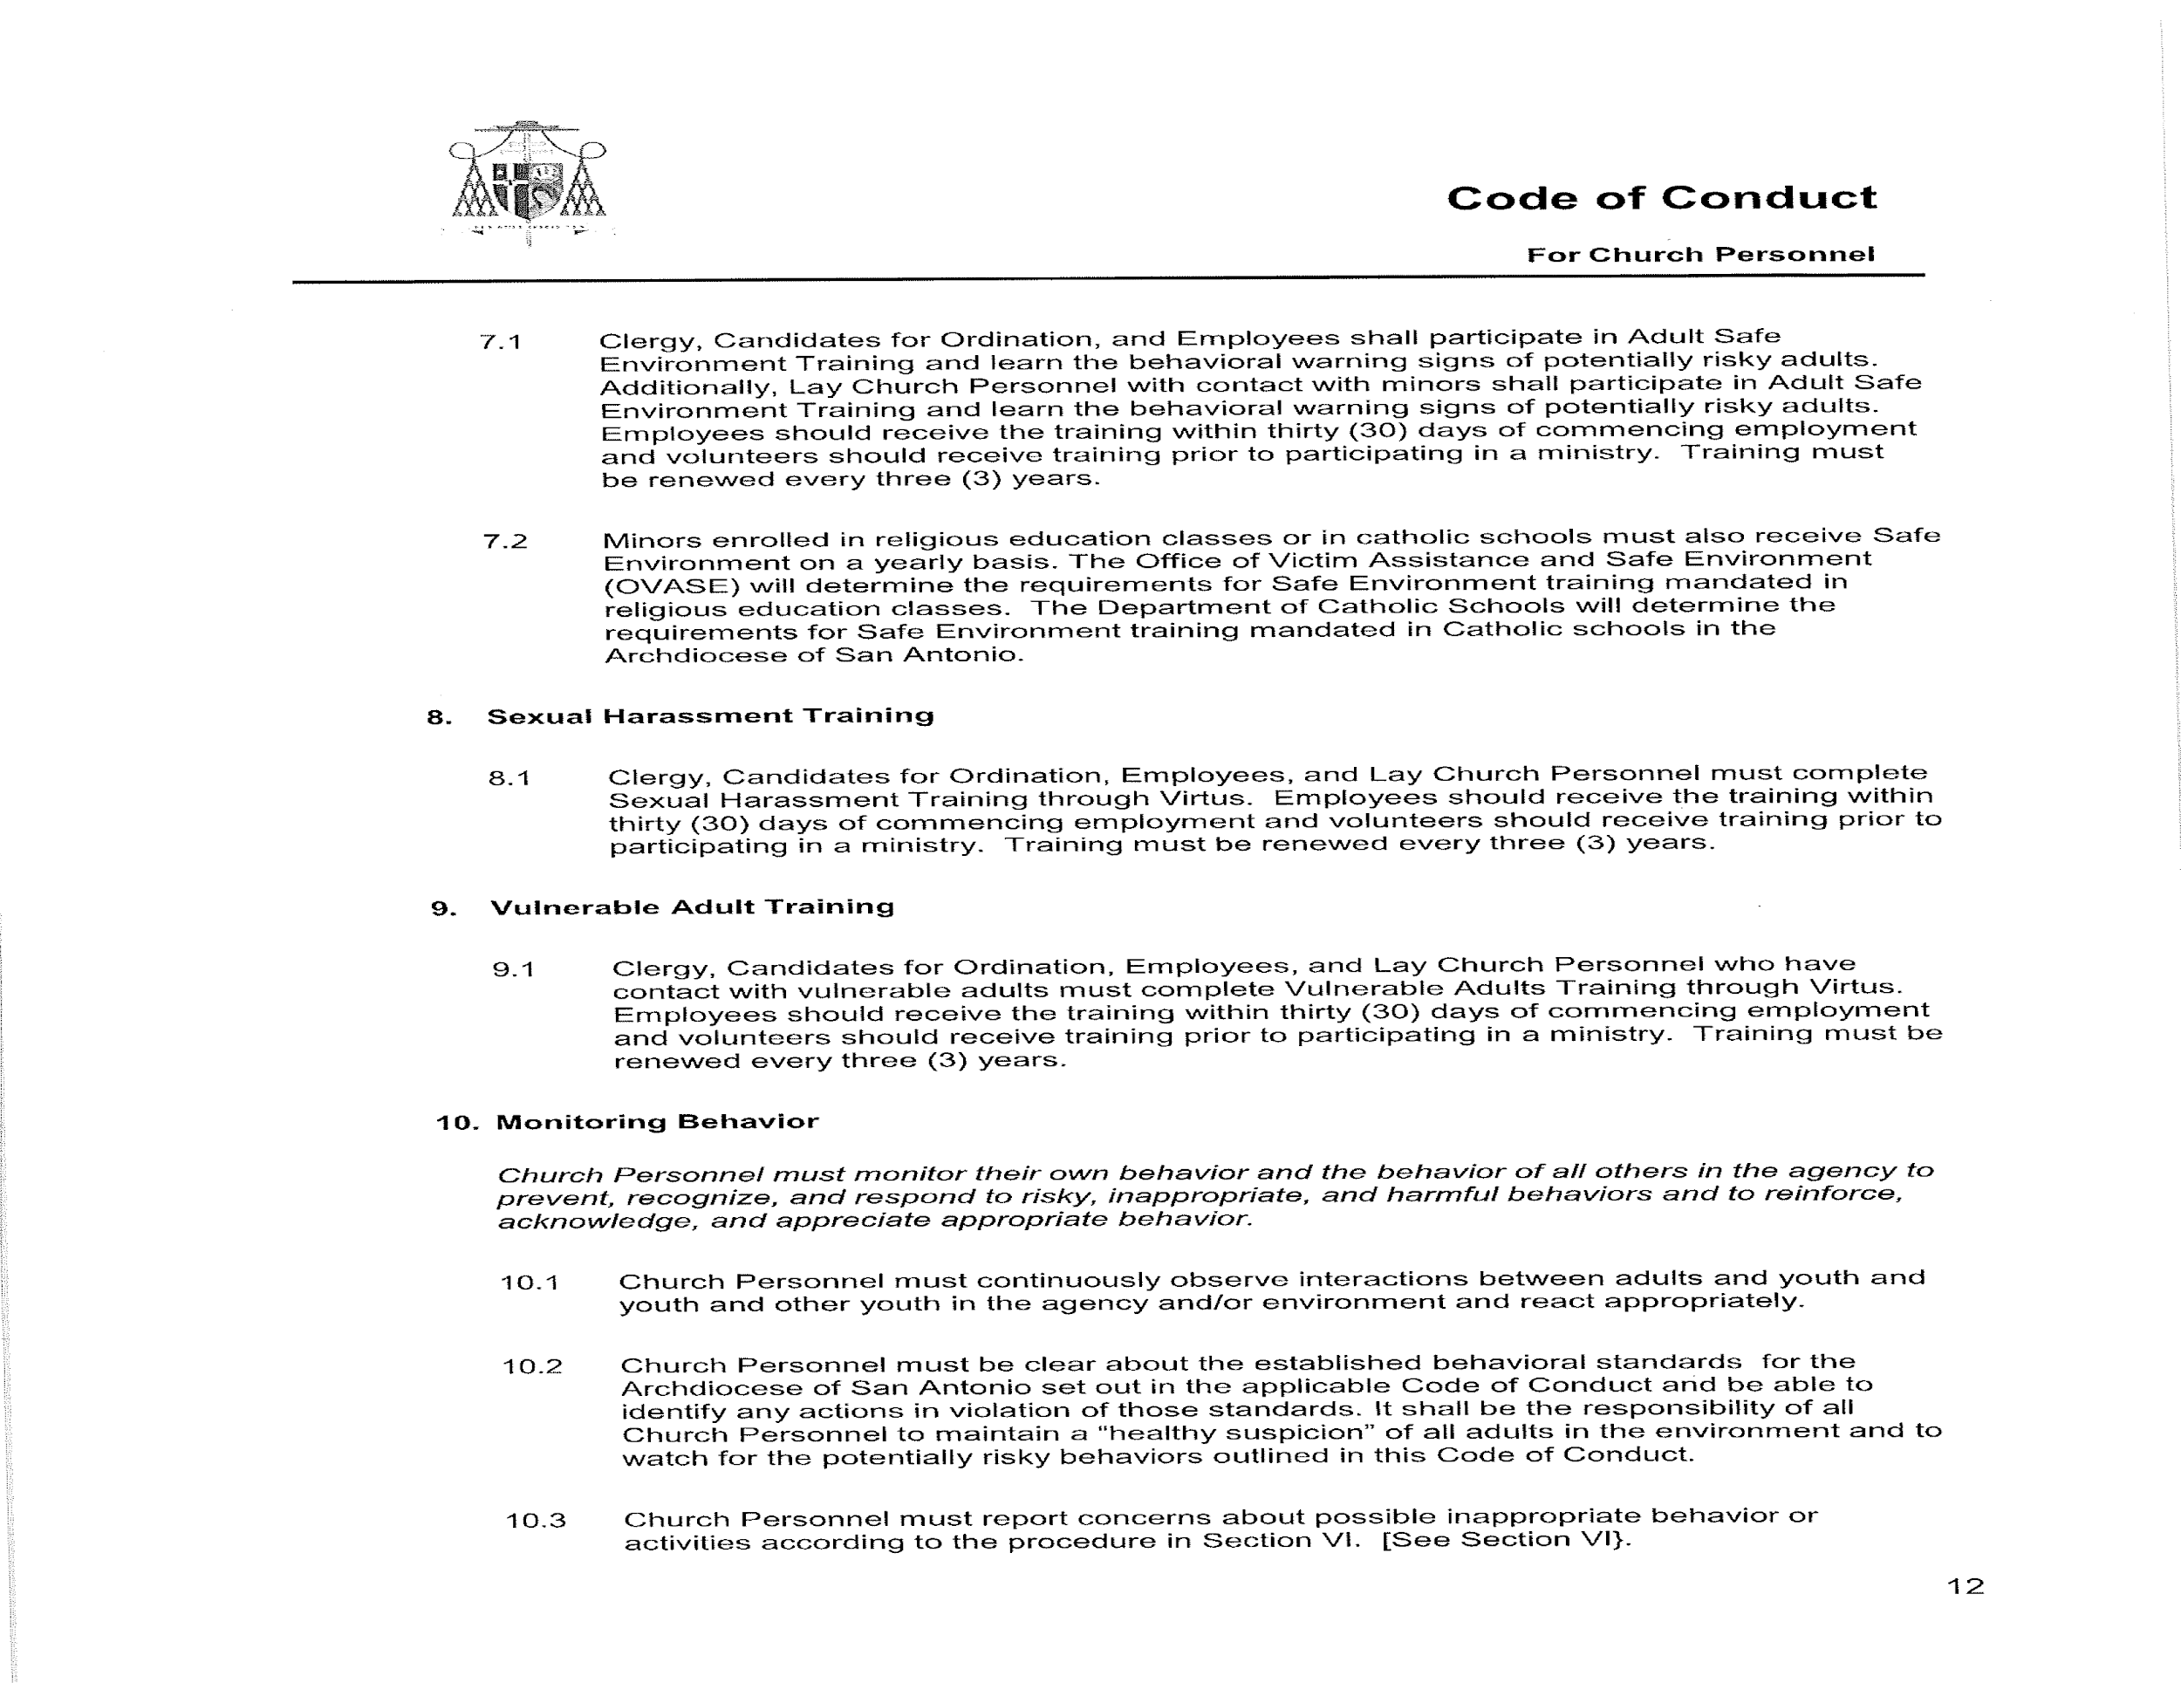
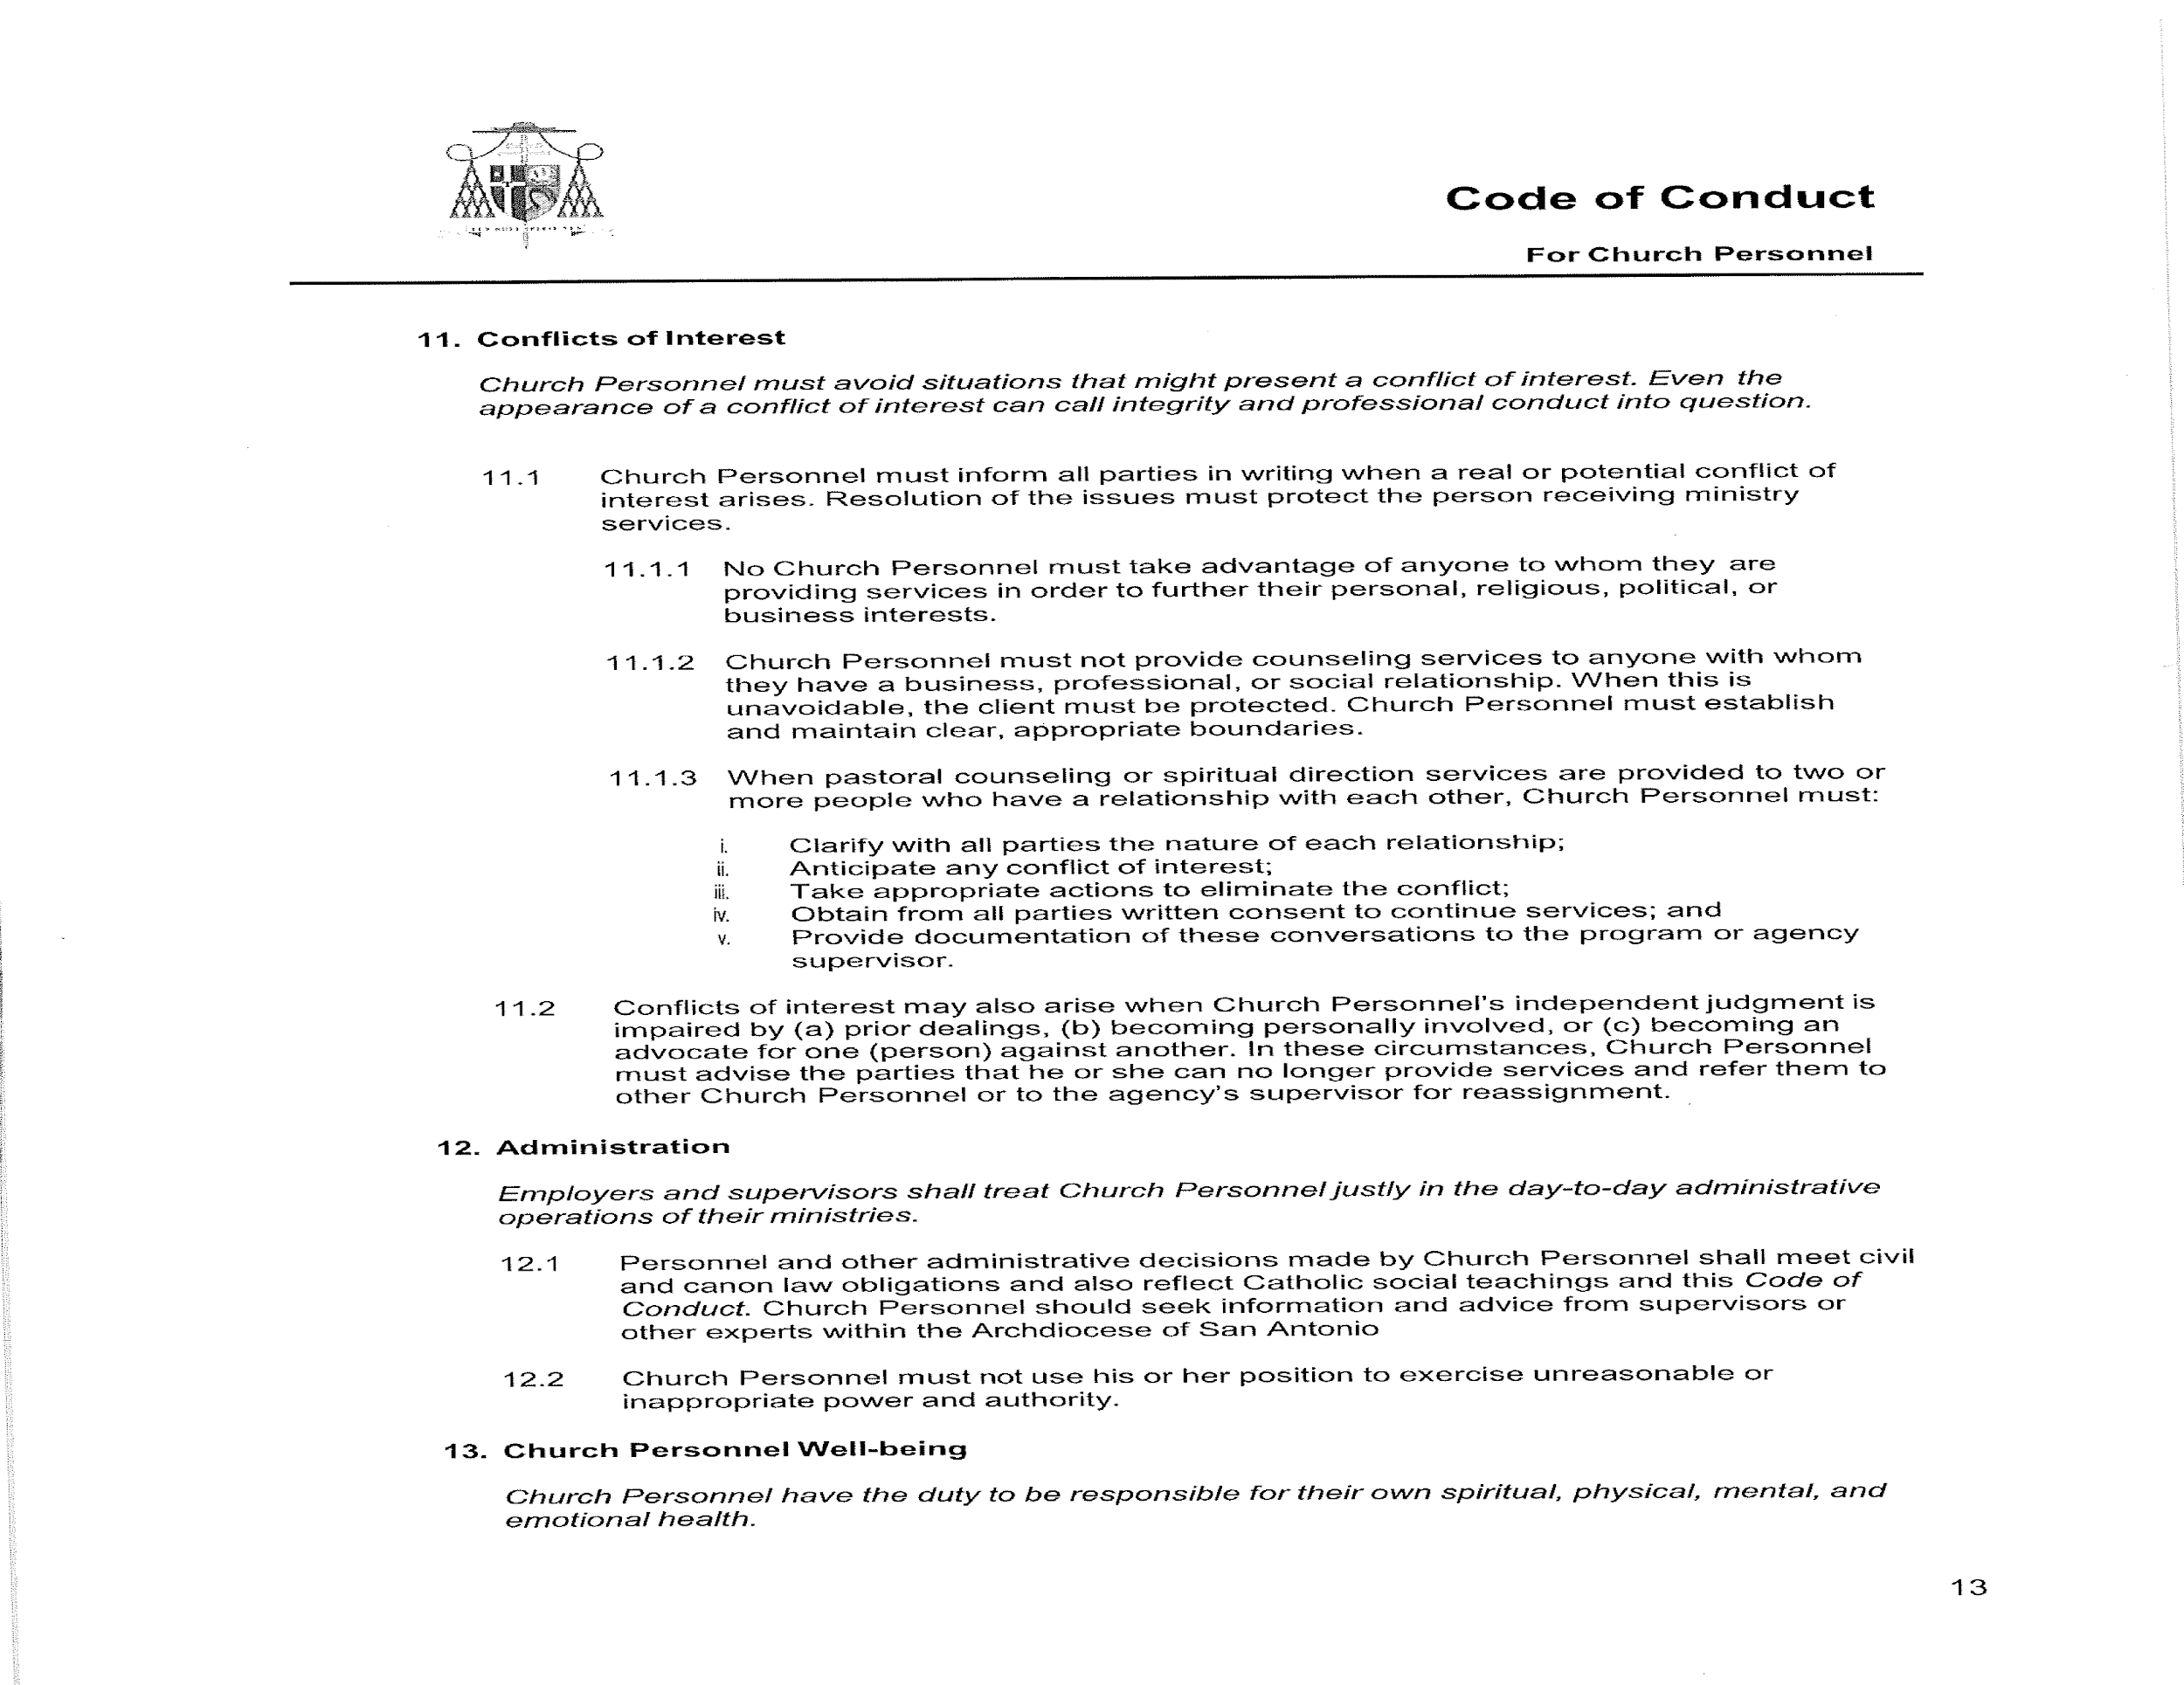
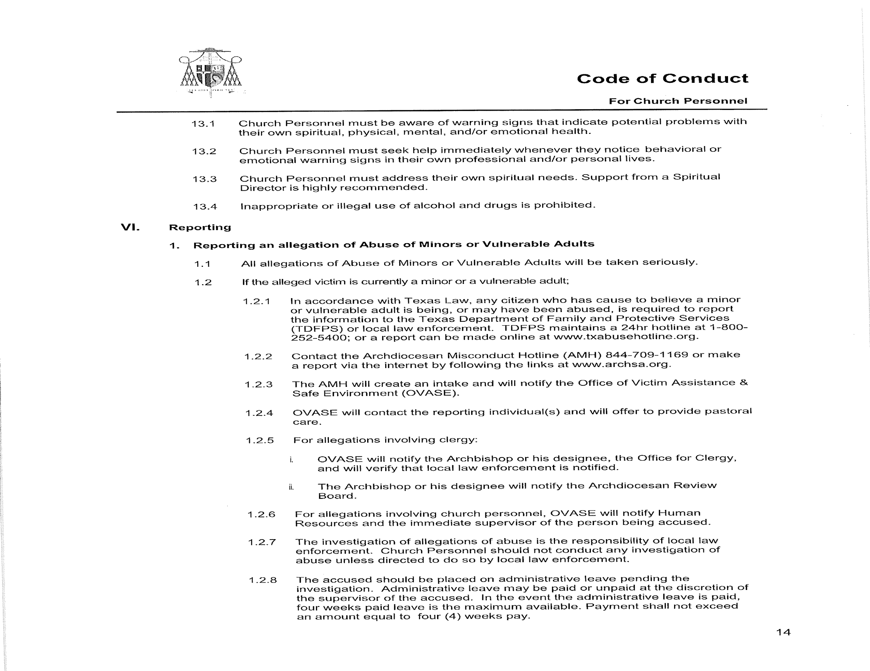
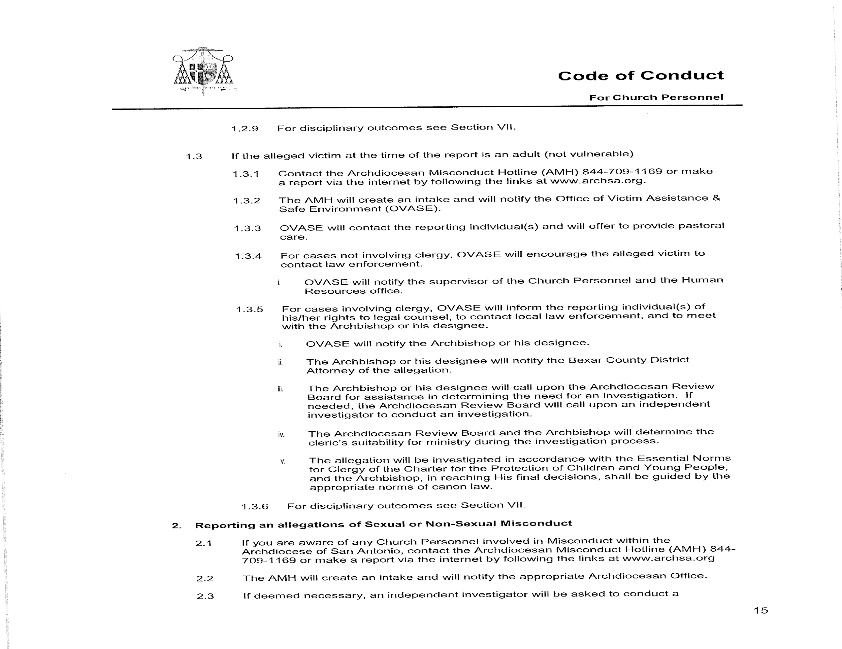
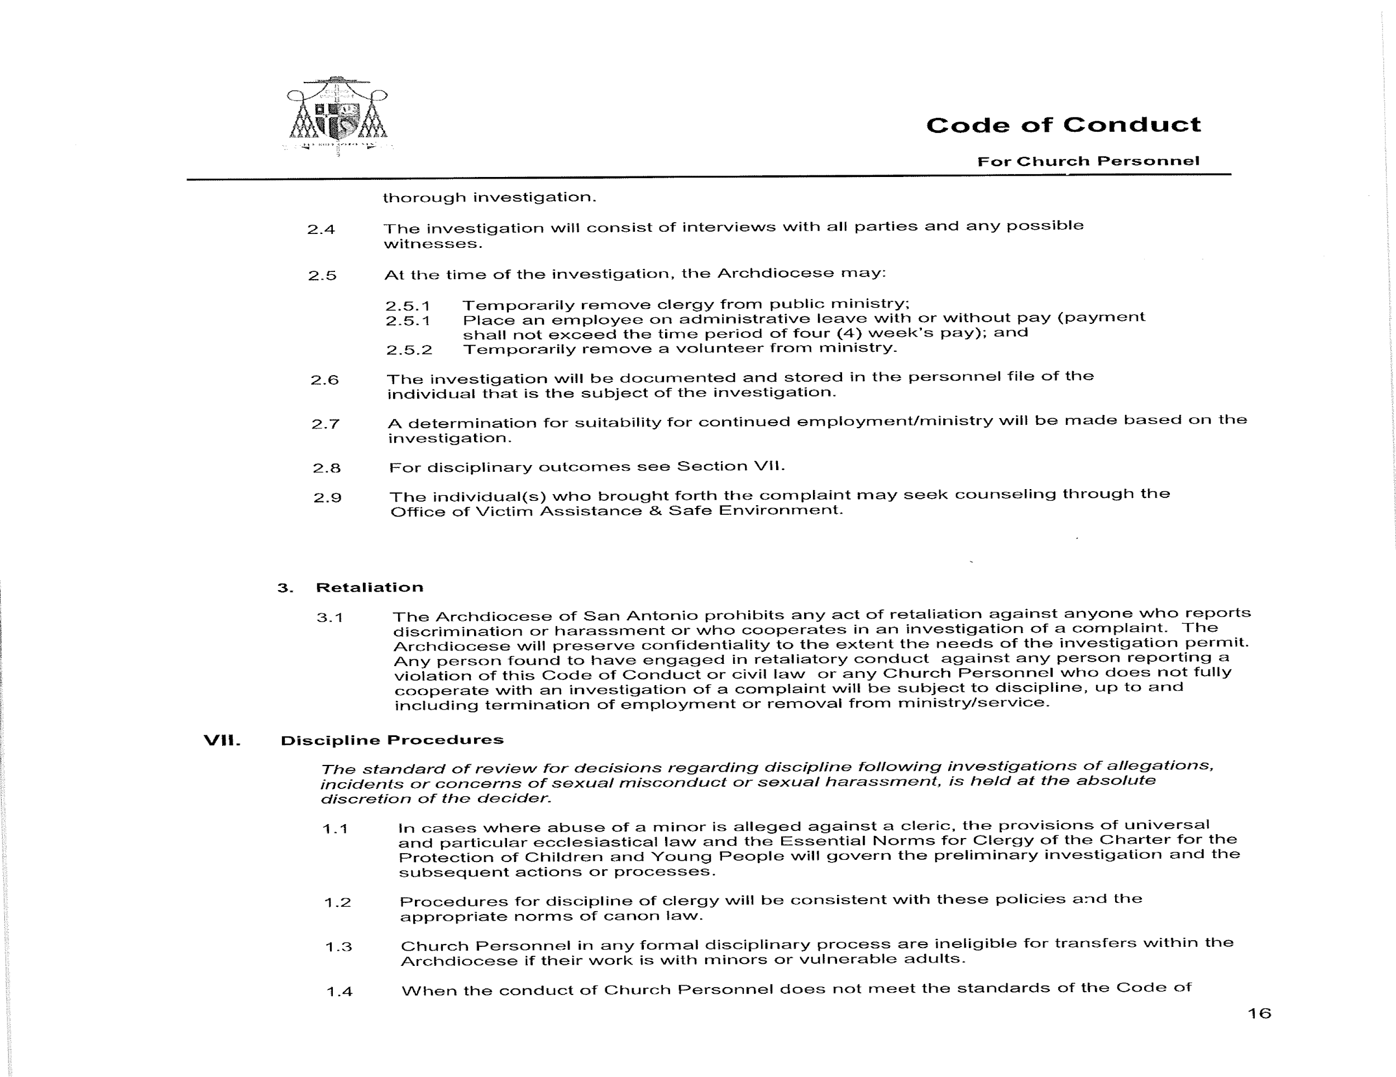
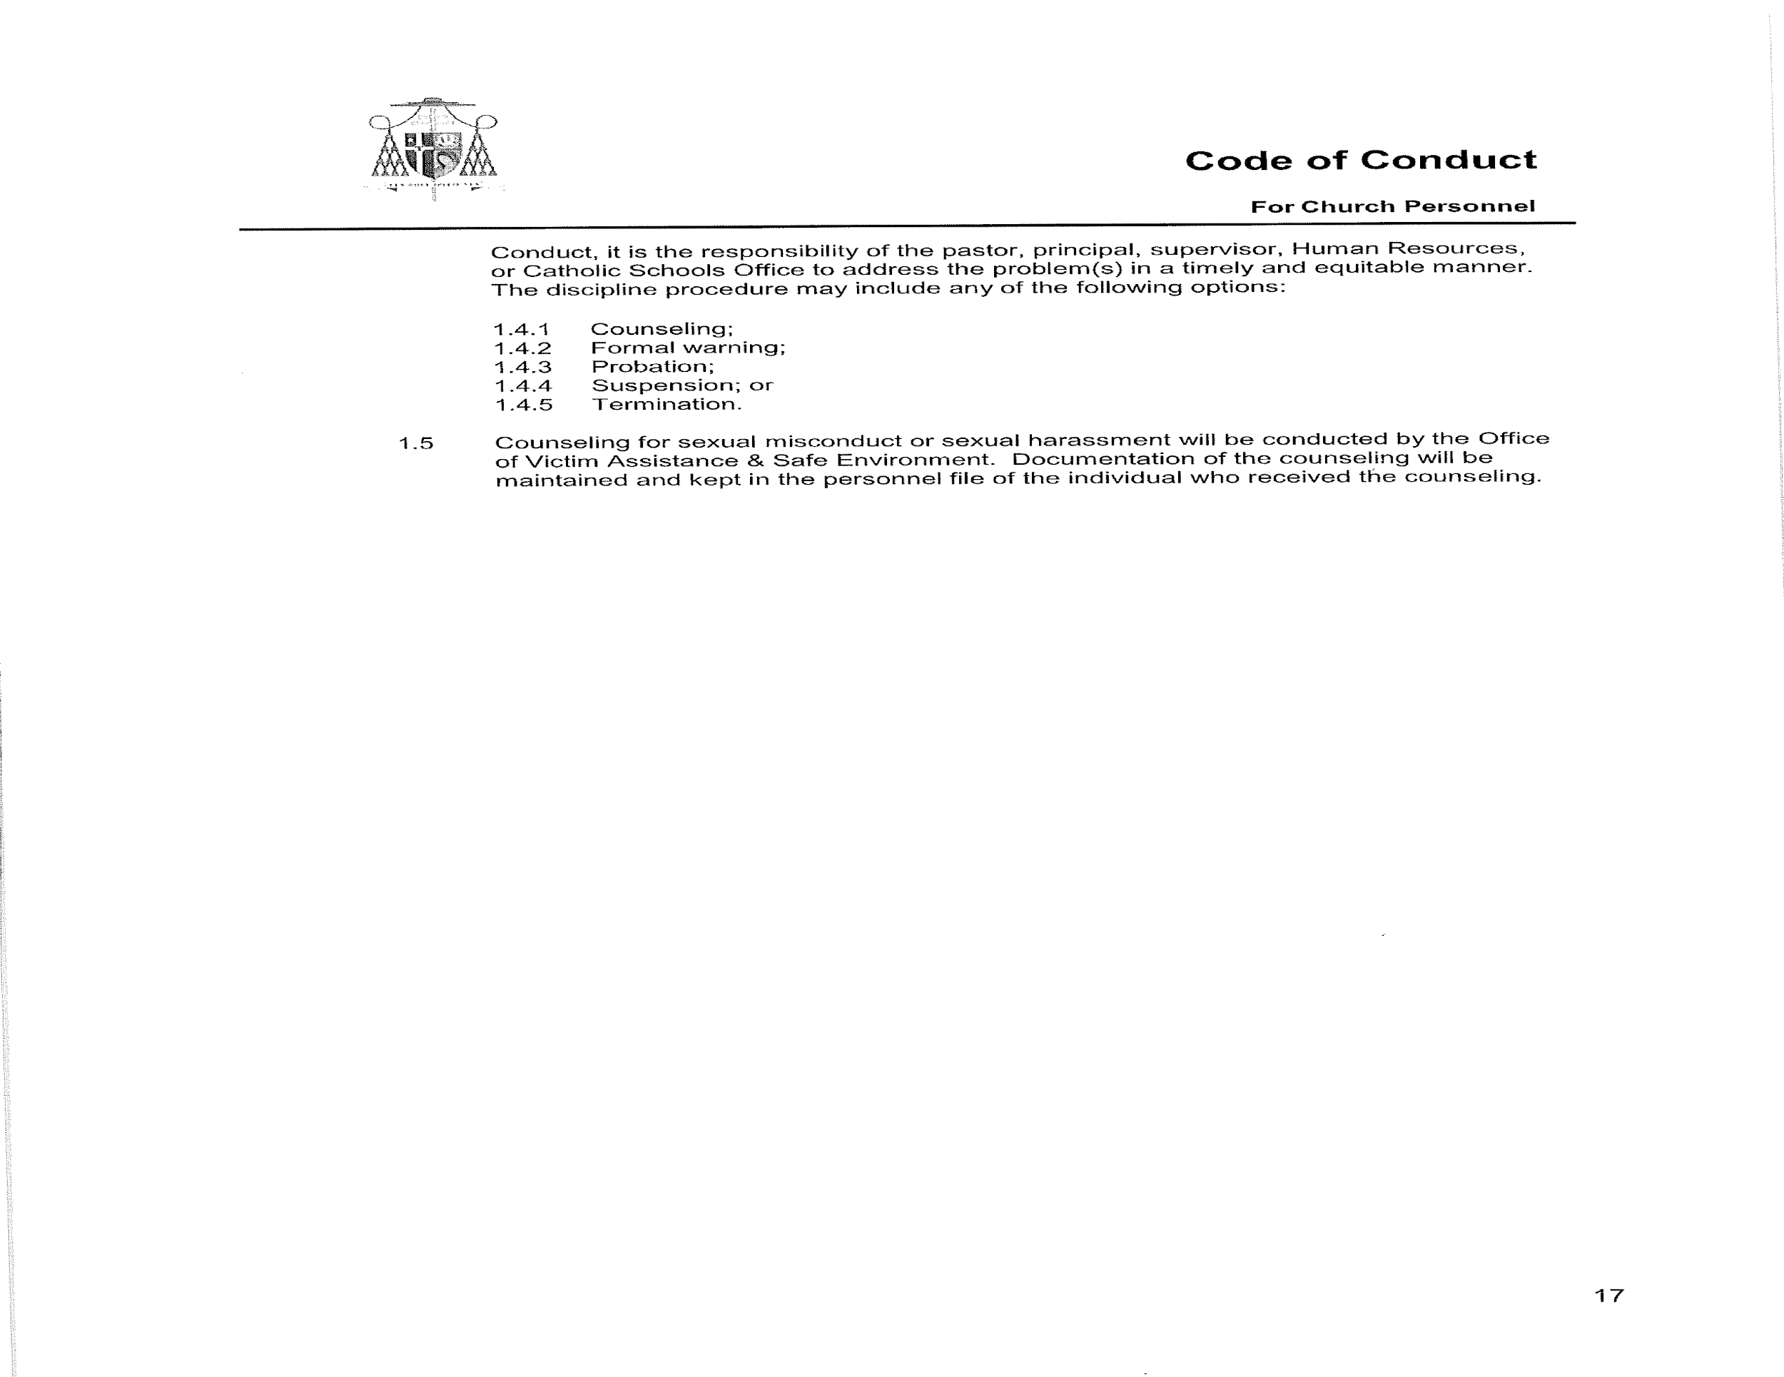
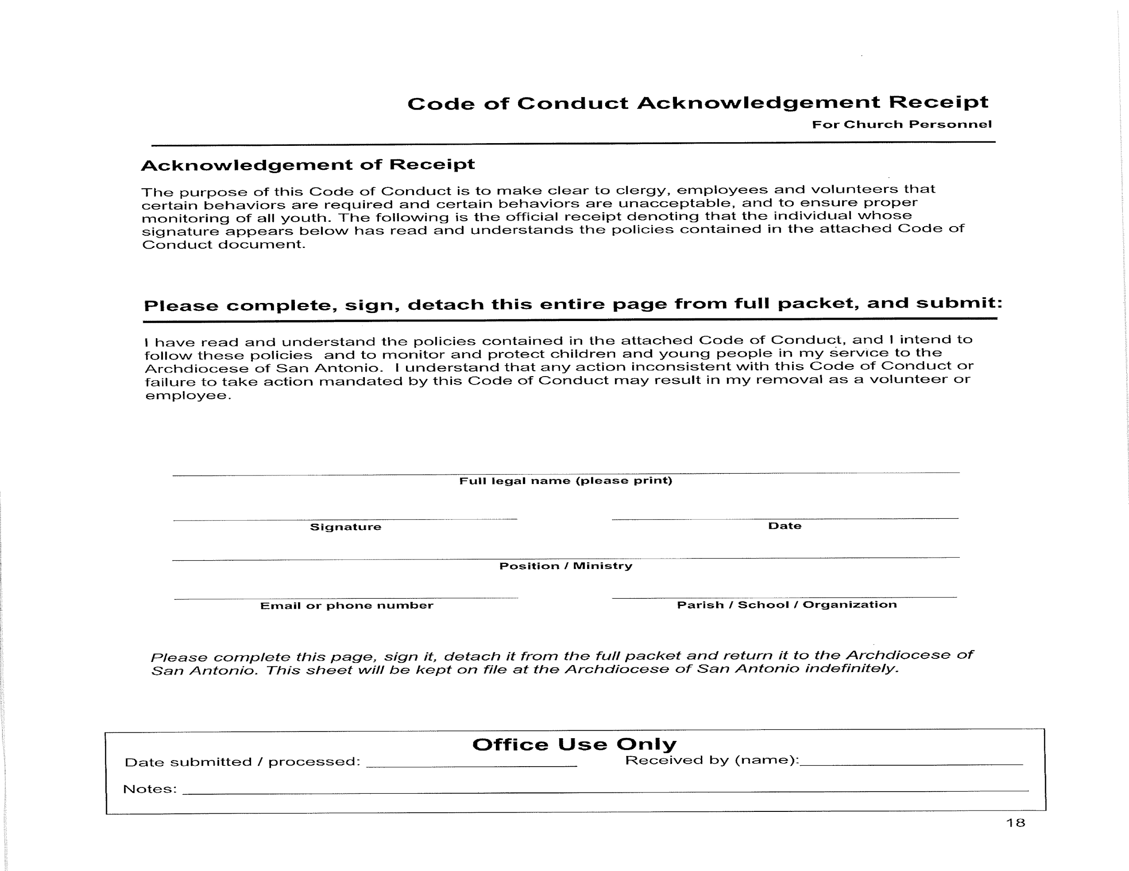

STS. PETER & PAUL CATHOLIC SCHOOL

HANDBOOK ACKNOWLEDGEMENT

The handbook agreement must be signed by all parents and all students in grades 3-8.
This agreement may be signed and submitted to the school electronically on ParentsWeb or a printed document may be submitted. This agreement must be completed within one week of the first day of school.

A refusal to sign or submit the Sts. Peter and Paul Catholic School Handbook Acknowledgement by the due date assigned shall be understood by the school to indicate a parent’s desire to withdraw their child from Sts. Peter and Paul Catholic School. Should the school fail to receive the signed Sts. Peter and Paul Catholic School Handbook Acknowledgement by the due date, the school may unilaterally withdraw the student from the school program.

I have received a copy of the Sts. Peter & Paul Catholic School Handbook of School Policies and Guidelines and have read it carefully. I understand the policies, procedures, and regulations of Sts. Peter & Paul Catholic School including: Financial and Service Obligations, School Supplies and Uniforms, the Acceptable Use Policy of Technology as outlined in the Technology section of the handbooks and the Code of Student Conduct.

St. Peter and Paul Catholic School Handbook Agreement

I hereby agree to abide by and adhere to the policies, procedures and regulations described herein as a condition of my child(ren)’s enrollment in Sts. Peter and Paul Catholic School.
As a student I will follow the “Acceptable Use” policy and regulations governing Internet access as stated in this handbook, and, as a parent, I am aware of the “Acceptable Use Policy” and I will support the school in enforcing this policy to ensure the cybersecurity of my child and the students at Sts. Peter and Paul.

Date:____________ Parent/Guardian Signature: __________________________
Printed Last Name ________________________________________________

Date:____________ Parent/Guardian Signature: __________________________ Printed Last Name ________________________________________________

Children registered at St. Peter & Paul Catholic School (please print):
Name:____________________________________________Grade ________
Signature of student in Grades 3-8 ___________________________________

Name:____________________________________________Grade ________
Signature of student in Grades 3-8 ___________________________________

Name:____________________________________________Grade ________
Signature of student in Grades 3-8 ___________________________________

Name:____________________________________________Grade ________
Signature of student in Grades 3-8 ___________________________________

Upon enrollment, this printed form or submission of this form electronically through ParentsWeb is due within one week of the first day of school.

